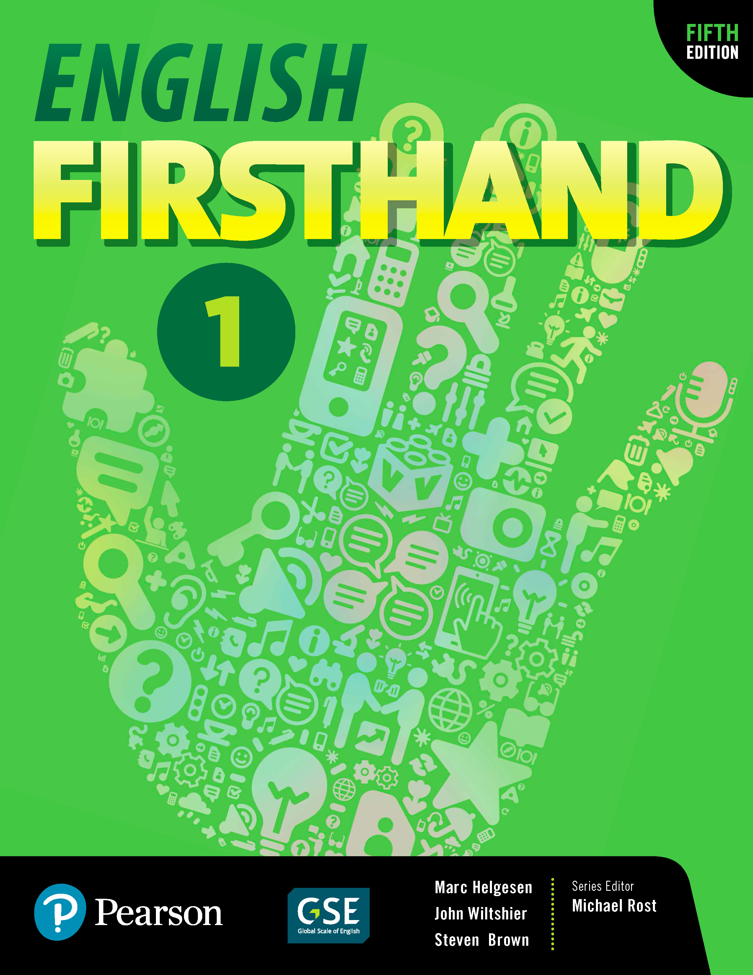
English Firsthand 1 | Sixteen-week overview

Many schools require a 16-week (or 15-week) overview of what will be covered in the course. This is a plan for English Firsthand 1. It usually assumes two weeks per unit.

• During the first week, cover the Vocabulary, Listening, Conversation and Pair Work.
• During the second week, review the Conversation, do the Group Work and the Real Stories page (including the Presentation Model).

Of course, you may want to have students do some of the activities on their own using MyMobileWorld.

After every two units, do the Practice Test from the back of the book. Have students check their own or a partner’s test and hand it in. You can use that score as part of their grade. During the rest of the class, either do one of the extra activities in the Teacher’s Manual or one of the “fluency frame” activities outlined in Unit zero of the Teacher’s Manual. Note that we avoided tests in the last two weeks—students have a lot of tests then and if they are absent, make-up tests are a problem, but of course this is an option and you can add them if necessary.

First semester
1. Class overview: Learning goals and strategies (Unit zero)
2. Meeting people/introducing yourself. (Unit 1)
3. Meeting people/asking about other people (Unit 1)
4. Describing people – physical appearance (Unit 1)
5. Describing people – personality and character (Unit 2)
6. Review, mini-test: Units 1 & 2 + fluency expansion
7. Schedules and frequency – personal schedule (Unit 3) • (Only 1 class for this unit)
8. Stating locations - describing differences between two places (Unit 4)
9. Stating locations - personal space (Unit 4)
10. Review, mini-test: Units 4 & 5 + fluency expansion
11. Giving directions – following map directions (Unit 5)
12. Giving directions – giving and understanding directions (Unit 5)
13. Talking about past events
14. Review, mini-test: Units 5 & 6 + fluency expansion
15. Describing personal experiences (Unit 6)
16. Review/reflection/feedback

Second semester
1. Abilities and interests – exchanging job skills information (Unit 7)
2. Abilities and interests – describing jobs (Unit 7)
3. Invitations and preferences – identifying entertainment information (Unit 8)
4. Plan an event and invite people (Unit 8)
5. Review, mini-test: Units 7 & 8 + fluency expansion
6. Future plans and predictions – identifying vacation plans and activities (Unit 9)
7. Future plans and predictions – predicting future events (Unit 9)
8. Shopping – understanding prices and inferring shopping decisions (Unit 10)
9. Shopping – talking about shopping preferences and experiences (Unit 10)
10. Review, mini-test: Units 9 & 10 + fluency expansion
11. Describing processes – food and cooking (Unit 11)
12. Describing process – following instructions (Unit 11)
13. Music – Giving opinions about music (Unit 12)
14. Review, mini-test: Units 11 & 12 + fluency expansion
15. (Unit 12) Music – talking about one’s music history and preferences
16. Review/reflection/feedback

