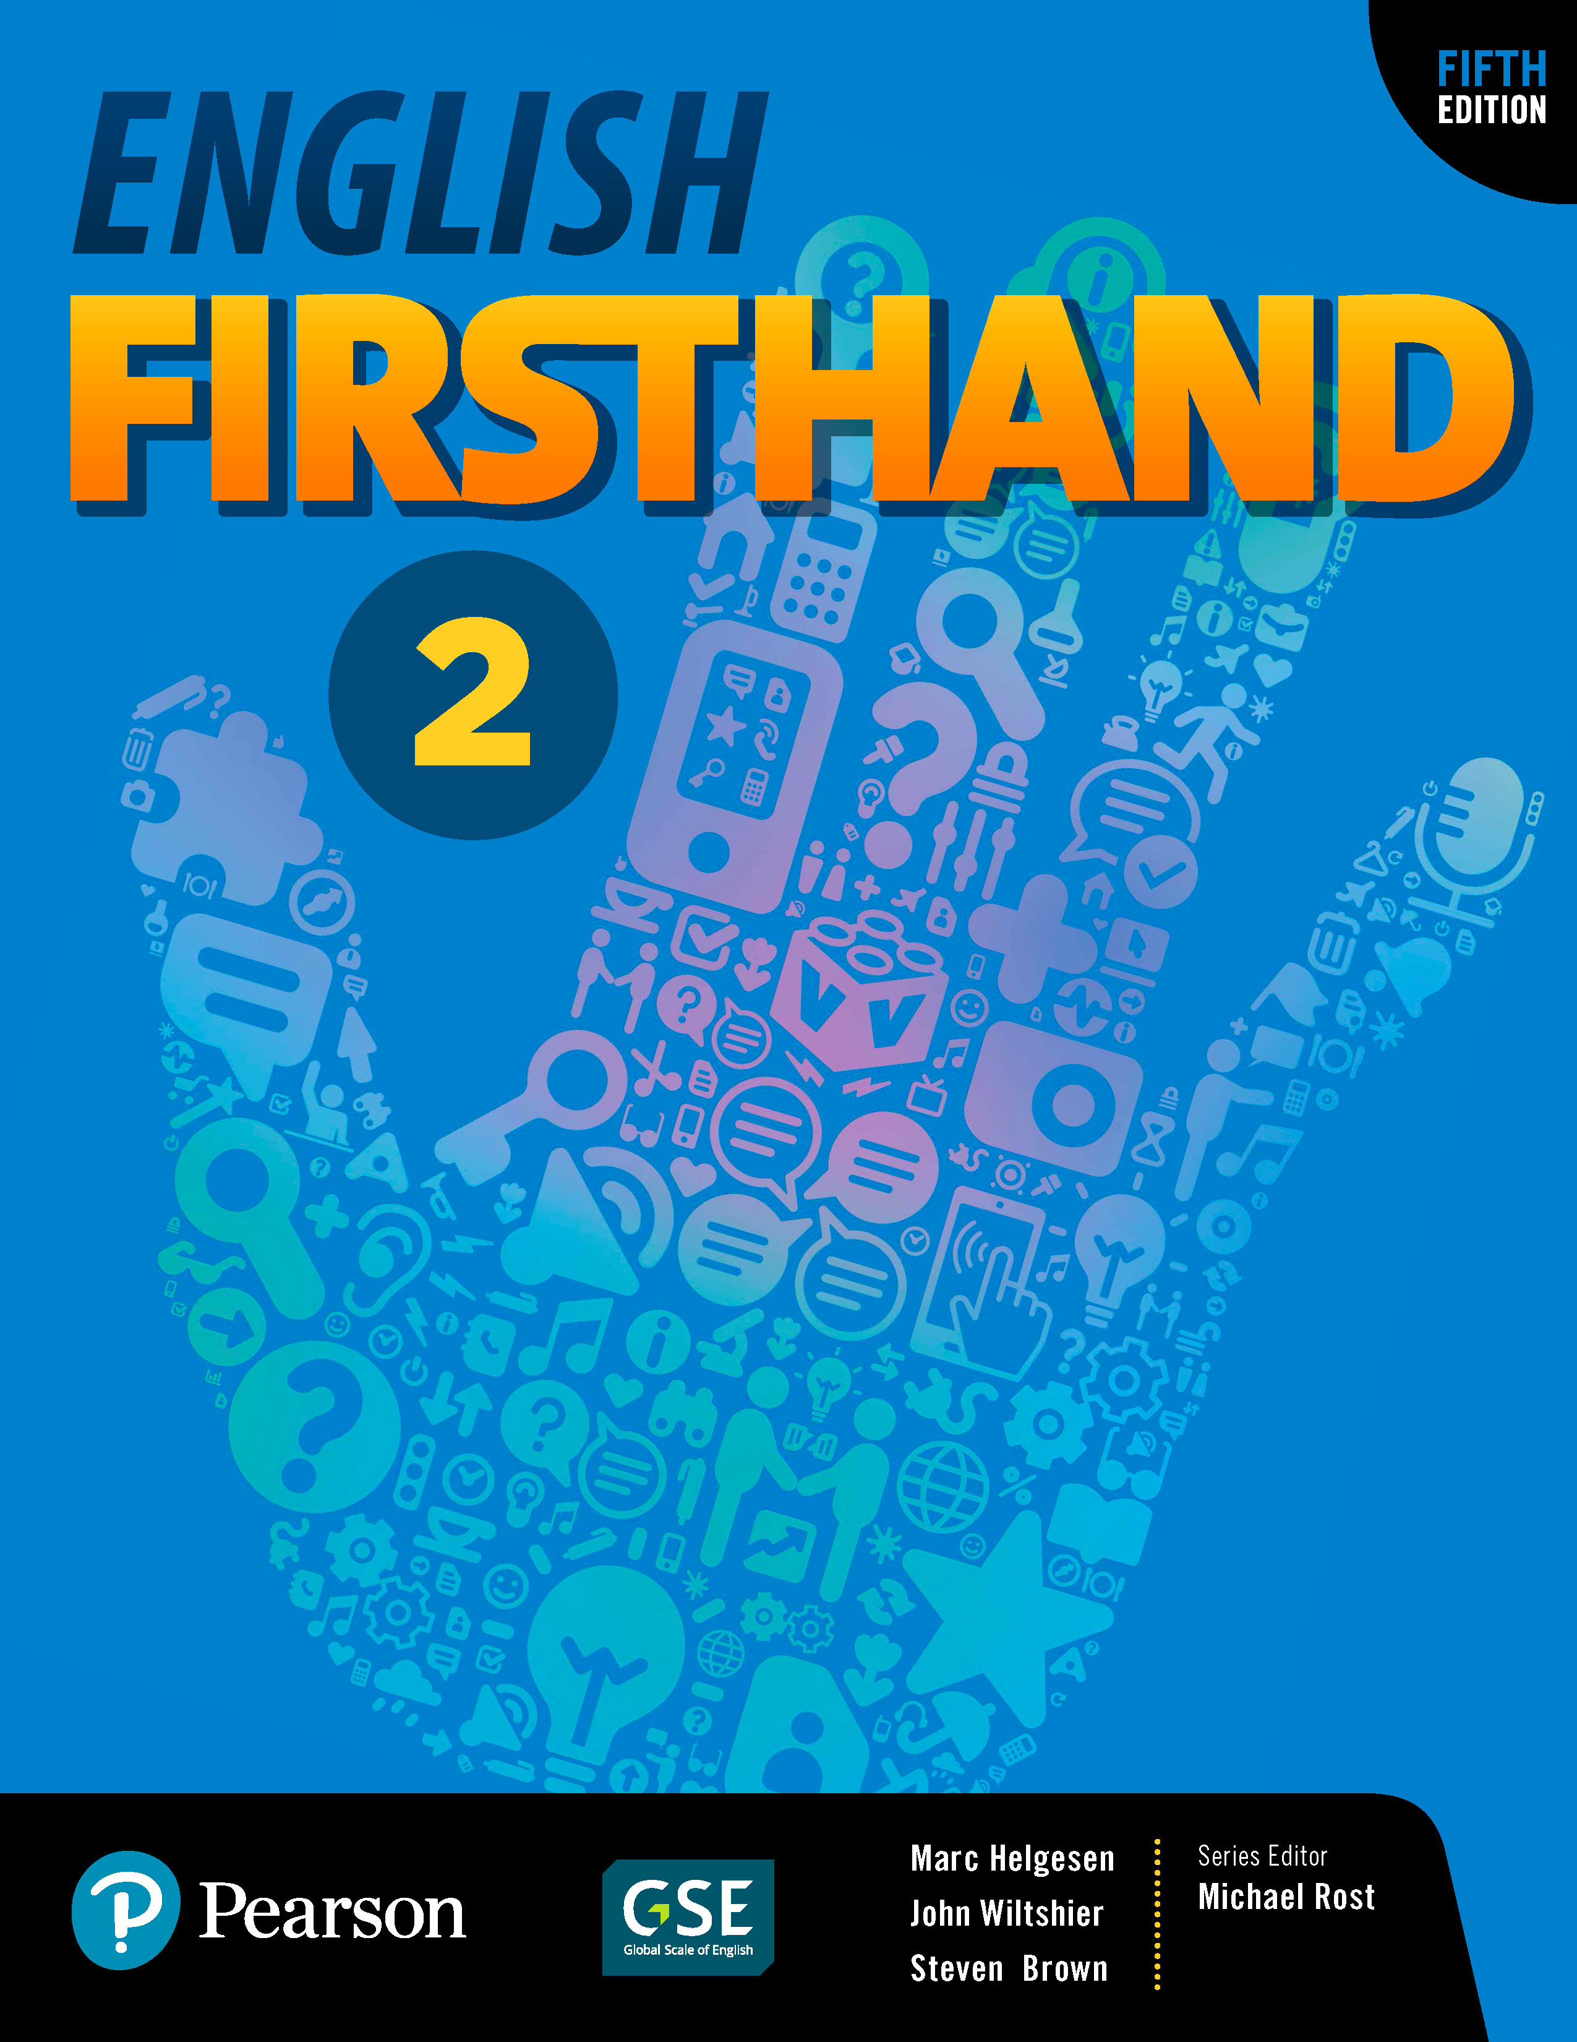
English Firsthand 2 | Sixteen-week overview

Many schools require a 16-week (or 15-week) overview of what will be covered in the course. This is a plan for English Firsthand 2. It usually assumes two weeks per unit.

• During the first week, cover the Vocabulary, Listening, Conversation and Pair Work.
• During the second week, review the Conversation, do the Group Work and the Real Stories page (including the Presentation Model).

Of course, you may want to have students do some of the activities on their own using MyMobileWorld.

After every two units, do the Practice Test from the back of the book. Have students check their own or a partner’s test and hand it in. You can use that score as part of their grade. During the rest of the class, either do one of the extra activities in the Teacher’s Manual or one of the “fluency frame” activities outlined in Unit zero of the Teacher’s Manual. Note that we avoided tests in the last two weeks—students have a lot of tests then and if they are absent, make-up tests are a problem, but of course this is an option and you can add them if necessary.

First semester
1. Class overview: Learning goals and strategies (Unit zero)
2. Introductions – self and others (Unit 1)
3. Introductions – asking about family, interests and experiences (Unit 1)
4. Talking about emotions – vocabulary and examples (Unit 2)
5. Talking about emotions – personal experiences (Unit 2)
6. Review, mini-test: Units 1 & 2 + fluency expansion
7. Comparing and recommending places (Unit 3)
8. Describing personal experiences (Unit 3)
9. Describing superlative events and places (Unit 4)
10. Building speaking fluency (Unit 4)
11. Review, mini-test: Units 4 & 5 + fluency expansion
12. Asking to borrow things, giving reasons, making excuses (Unit 5)
• (Only 1 class for this unit)
13. Talking about Japanese culture (Unit 6)
14. Review, mini-test: Units 5 & 6 + fluency expansion
15. Describing cultural artifacts (Unit 6)
16. Review/reflection/feedback

Second semester
1. Describing past events (Unit 7)
2. Talking about personal experiences (Unit 7)
3. Making requests (Unit 8)
4. Planning an event – suggesting (Unit 8)
5. Review, mini-test: Units 7 & 8 + fluency expansion
6. Talking about problems and solutions (Unit 9)
7. Asking for/giving advice (Unit 9)
8. Storytelling (Unit 10)
9. Narratives (Unit 10)
10. Review, mini-test: Units 9 & 10 + fluency expansion
11. Asking for/ giving opinions (Unit 11)
12. Using fixed forms for opinions and agreement/disagreement (Unit 11)
13. Future plans and dreams (Unit 12)
14. Review, mini-test: Units 11 & 12 + fluency expansion
15. Goals and making plans to achieve dreams (Unit 12)
16. Review/reflection/feedback

