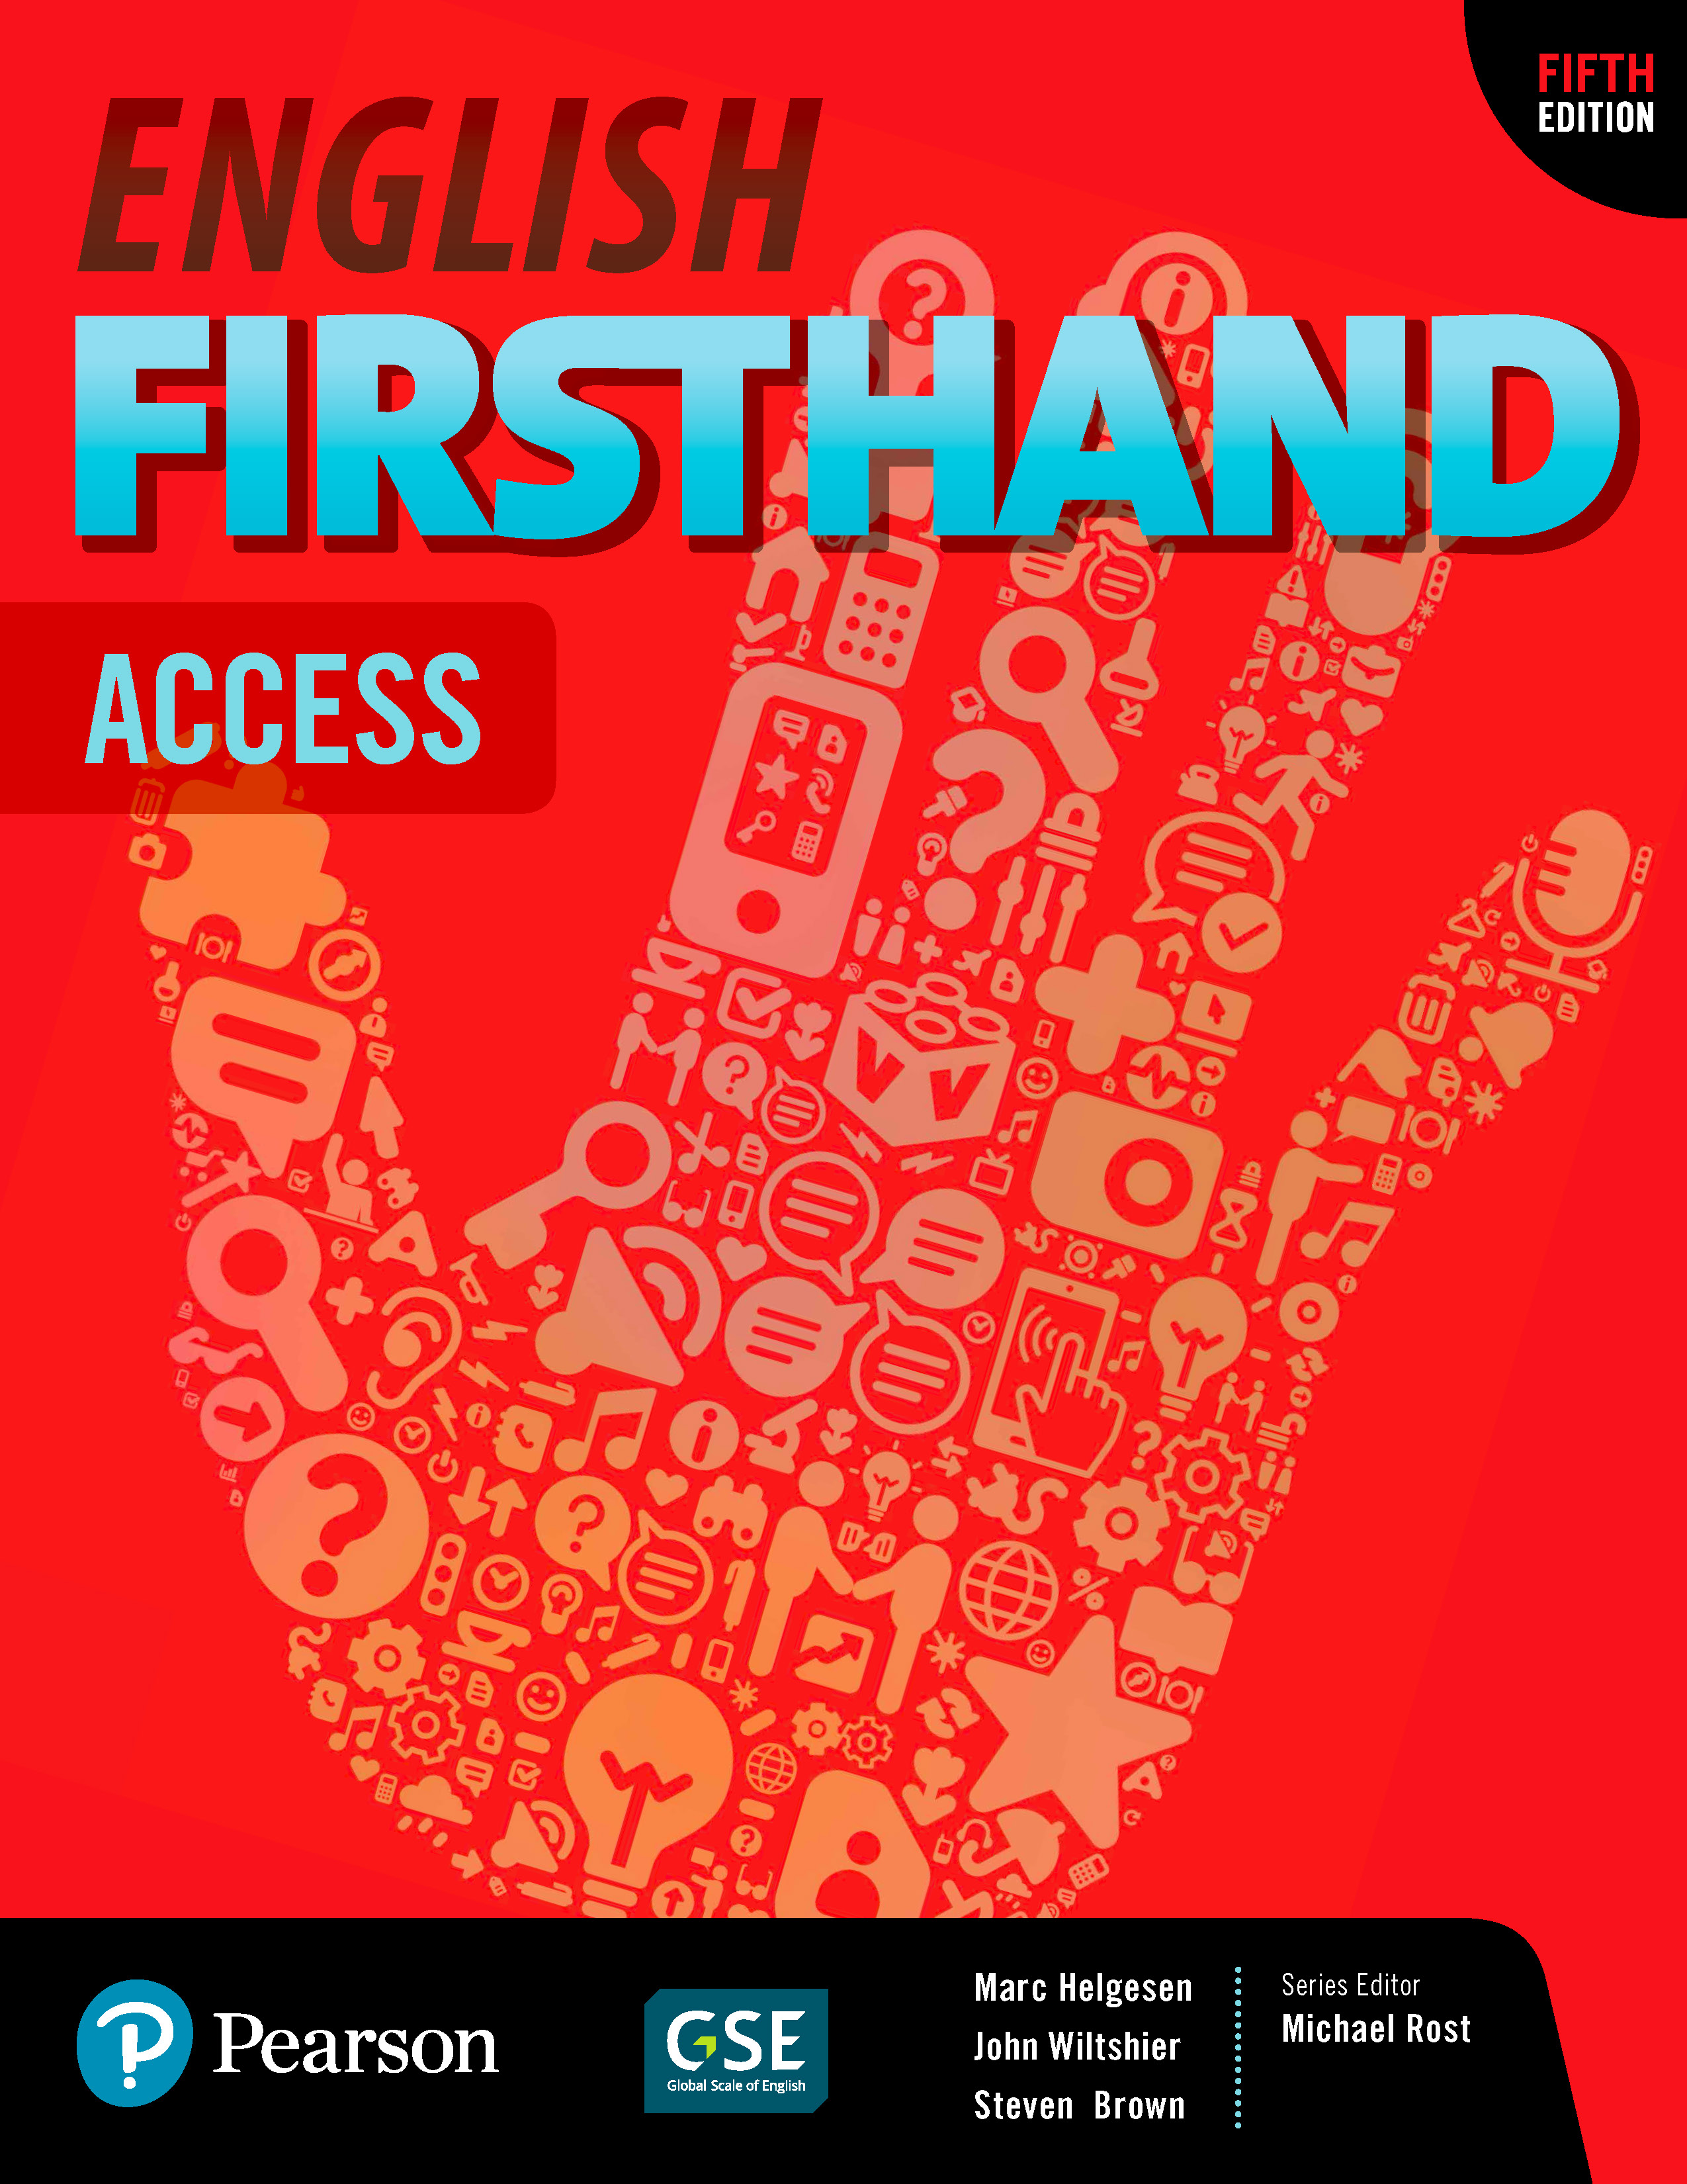
English Firsthand Access | Sixteen-week overview

Many schools require a 16-week (or 15-week) overview of what will be covered in the course. This is a plan for English Firsthand Access. It usually assumes two weeks per unit.

• During the first week, cover the Vocabulary, Listening, Conversation and Pair Work.
• During the second week, review the Conversation, do the Group Work and the Real Stories page (including the Presentation Model).

Of course, you may want to have students do some of the activities on their own using MyMobileWorld.

After every two units, do the Practice Test from the back of the book. Have students check their own or a partner’s test and hand it in. You can use that score as part of their grade. During the rest of the class, either do one of the extra activities in the Teacher’s Manual or one of the “fluency frame” activities outlined in Unit zero of the Teacher’s Manual. Note that we avoided tests in the last two weeks—students have a lot of tests then and if they are absent, make-up tests are a problem, but of course this is an option and you can add them if necessary.

First semester
1. Class overview: Clarification language and classroom interaction. (Unit zero)
2. Asking/Giving personal information (Unit 1)
3. Asking about classmates (Unit 1)
4. Following instructions (Unit 2)
5. Giving commands (imperatives) (Unit 2)
6. Review, mini-test: Units 1 & 2 + fluency expansion
7. Personal item vocabulary (Unit 3)
8. Asking about existence/prepositions of location (Unit 3)
9. Telling time/talking about schedules/common activities (Unit 4)
• (Only 1 class for this unit)
10. Review, mini-test: Units 4 & 5 + fluency expansion
11. Family relationship vocabulary (Unit 5)
12. Describing one’s family (Unit 5)
13. Describing clothing / shopping (Unit 6)
14. Review, mini-test: Units 5 & 6 + fluency expansion
13. Talking about clothing preferences. (Unit 6)
16. Review/reflection/feedback

Second semester
1. Talking about frequency (Unit 7)
2. Talking about weekend activities (Unit 7)
3. Food/asking about availability (Unit 8)
4. Food/talking about favorites (Unit 8)
5. Review, mini-test: Units 7 & 8 + fluency expansion
6. Talking about current activities (Unit 9)
7. Sports and free-time activities (Unit 9)
8. Household rooms and items (Unit 10)
9. Prepositions of location/describing rooms and buildings (Unit 10)
10. Review, mini-test: Units 9 & 10 + fluency expansion
11. Talking about past activities (Unit 11)
12. Describing experiences (Unit 11)
13. Talking about future events (Unit 12)
14. Review, mini-test: Units 11 & 12 + fluency expansion
15. Describing long-term and short-term plans (Unit 12)
16. Review/reflection/feedback

