Making Pictographs Behaviours/Strategies
Student has difficulty translating the information from the tally chart to the pictograph. | 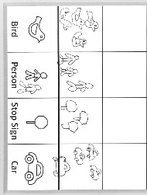  Student bunches pictures together on the graph. | 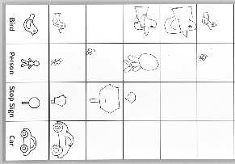  Student draws pictures in lines, but pictures are of different sizes and are not equally spaced and aligned. | Student draws pictures in lines, all pictures are about the same  size, and there is one picture in  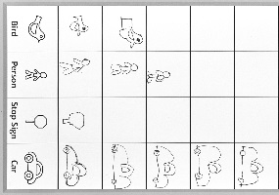  each space.
Observations/Documentation
Reading Pictographs Behaviours/Strategies
Student has difficulty counting the number of pictures in a column. | Student draws and counts the pictures but has difficulty reading data from the graph (e.g., “Which column has the most pictures?”). | Student reads data from the graph but has difficulty comparing the data. | Student answers “how many” questions about the graph and compares data using terms such as “more,” “fewer,” “most,” and “least.”
Observations/Documentation

