Sorting Solids Behaviours/Strategies
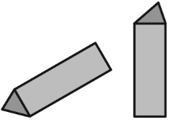  Student identifies some faces but doesn’t rotate the solid to see the different faces (shapes). | 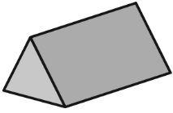  Student focuses on one shape and doesn’t realize that more than one shape can be a face of a solid. | Student recognizes some shapes but doesn’t recognize a shape when it doesn’t match her or his mental image of the shape.  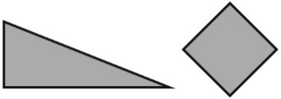 | Student sorts solids with ease.
Observations/Documentation
Identifying Sorting Rules Behaviours/Strategies
Student cannot identify the sorting rule. | 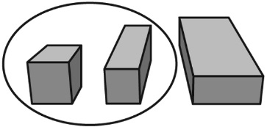  Student focuses on only two of the solids in the group to identify the rule. | Student identifies the sorting rule but has difficulty identifying a solid that doesn’t fit the rule. | Student identifies the sorting rule, identifies a solid that does not fit the rule, and explains why the solid does not fit.
Observations/Documentation

