Constructing Solids and Skeletons Behaviours/Strategies
Student names solid but struggles to identify its attributes.  “I know it’s a pyramid, but I don’t know anything about it.” | Student describes attributes but chooses unsuitable materials for building the solid.  “I am going to use cubes to build a model of the pyramid.” | Student chooses suitable materials but has errors in model/skeleton.  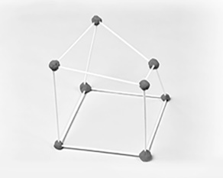
Observations/Documentation
Student constructs model/skeleton but struggles to identify 2-D faces.  “I’m not sure what shapes the faces are.” | Student constructs model/skeleton but struggles to compare them with original solid.  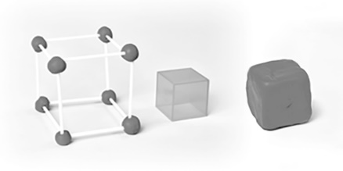 | Student successfully builds model and skeleton, identifies 2-D faces, and makes comparisons.
Observations/Documentation

