Finishing a Symmetrical Design Behaviours/Strategies
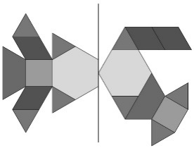  Student randomly places blocks on the right side. | 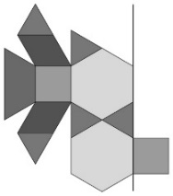  Student places blocks on the same side of the design. | 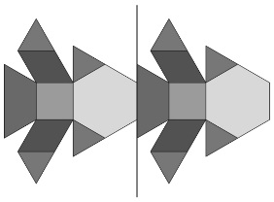  Student places the same blocks with the same orientation on the right side of the line.
Observations/Documentation
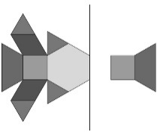  Student places the first block incorrectly and runs out of room to place the remaining blocks. | 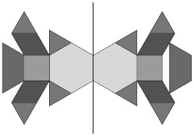  Student places some blocks correctly, but at least one has the wrong orientation. | 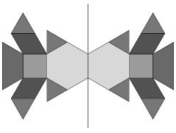  Student completes the symmetrical design and explains why it is symmetrical.
Observations/Documentation

