Building Symmetrical Solids Behaviours/Strategies
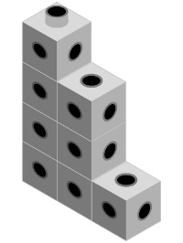  Student creates an object, but it doesn’t have matching halves. | 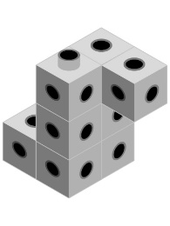  Student creates object with matching halves but doesn’t know whether it is symmetrical.  “Each half is like  the letter L. I don’t  know if it’s symmetrical.” | Student creates object with matching halves and thinks it must be symmetrical.  “The two halves match,  so the object has to  be symmetrical.”
Observations/Documentation
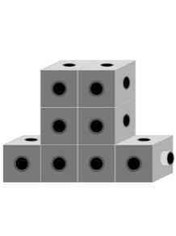  Student creates symmetrical object but struggles to describe or identify matching halves.  “I just know it’s  symmetrical.” | 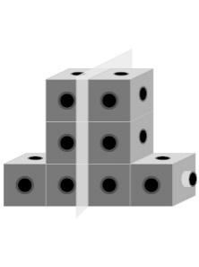  Student creates symmetrical object, identifies matching halves, but can’t justify thinking.  “I’m not sure why  it’s symmetrical.” | Student creates symmetrical object, identifies all matching halves, and justifies thinking.  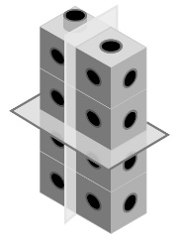  “These two halves match  and those two halves match.”
Observations/Documentation

