**Necklace/Bracelet Templates**

**Master 30a**

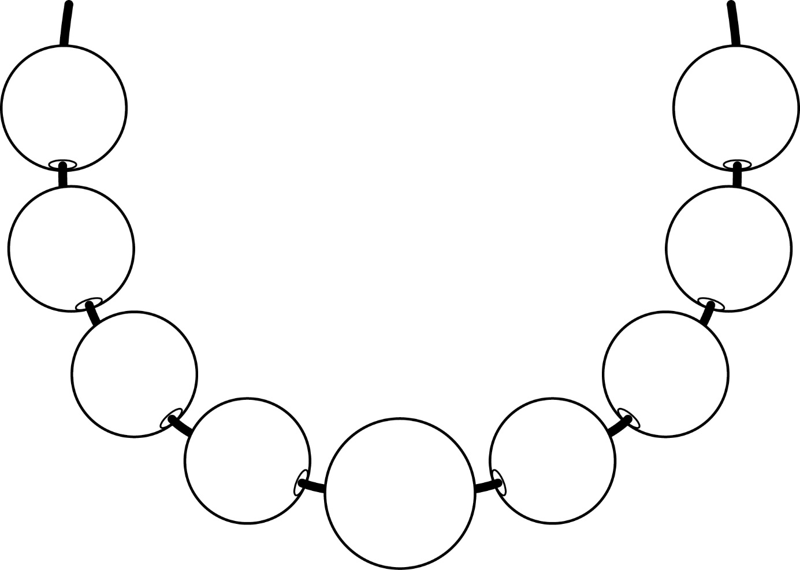

**Necklace/Bracelet Templates**

**Master 30b**

