Identifying Measurable Attributes Behaviours/Strategies
Student describes only one attribute of an everyday object.  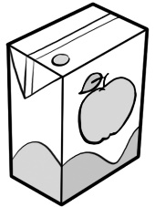  “All I know is that the carton holds juice.” | Student describes multiple attributes of an everyday object.  “The juice box is short and narrow, it has square corners, it holds juice, and it’s not very heavy.” | Student matches description of attributes to their names but struggles to identify matching 3-D solid.  “The juice box holds juice, so it has capacity. It is short, so it has height. It has square corners, so it has angles. I’m not sure which solid it looks like.” | Student successfully describes and names attributes of objects and identifies matching 3-D solid.  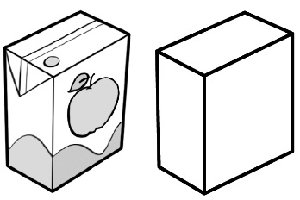  “The juice box is like a prism.”
Observations/Documentation

