**Ordinal Number Cards**

**Master 19a**

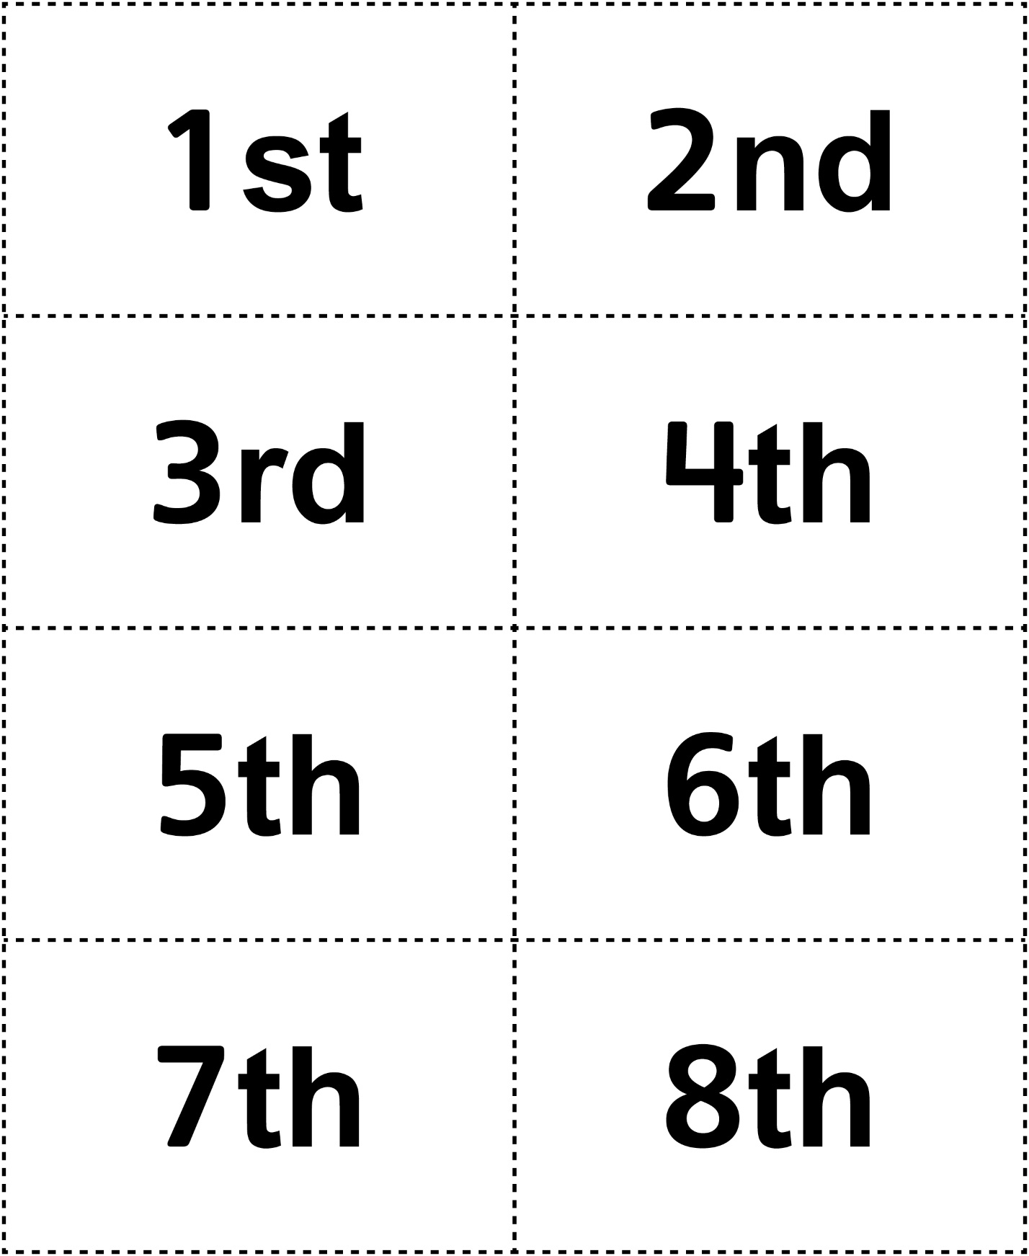

**Ordinal Number Cards**

**Master 19b**

