My Huckleberry (Duje) Story
Master 2

By Pam Spooner and Colin Williams

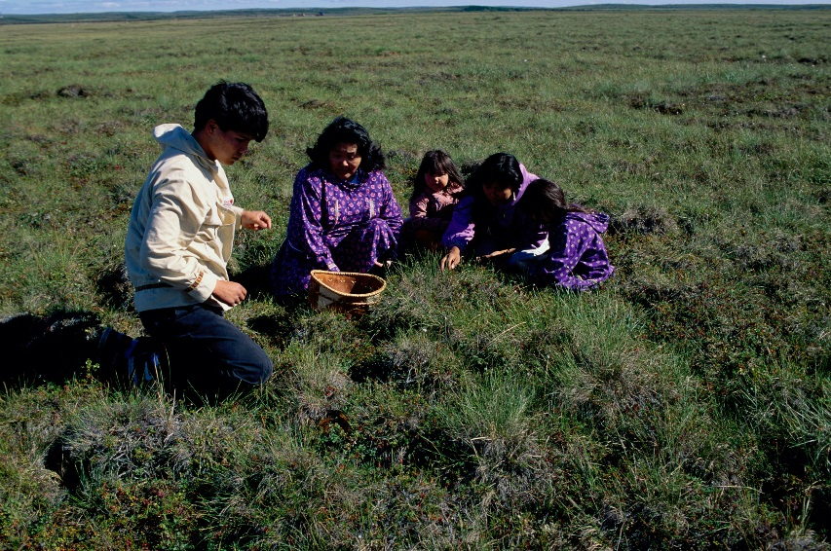
When I was a nyuzki (child), my ‘utsoo (grandmother) and I would look for yuntumai’ (blueberries) in the wild. We would look deep in the forest, knowing that we would find lots of yuntumai’ (blueberries) there.

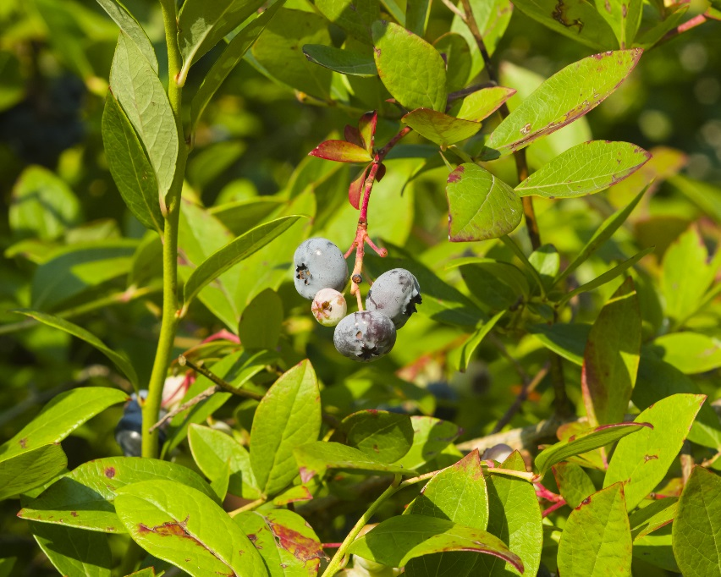
It was the duje (huckleberry) that we really wanted, but few people knew where to find them. Once we found some duje (huckleberries), we would pick them and put them into our buckets.

‘utsoo (grandma) loved duje (huckleberries). She would use them in jams, pies, and bannock.

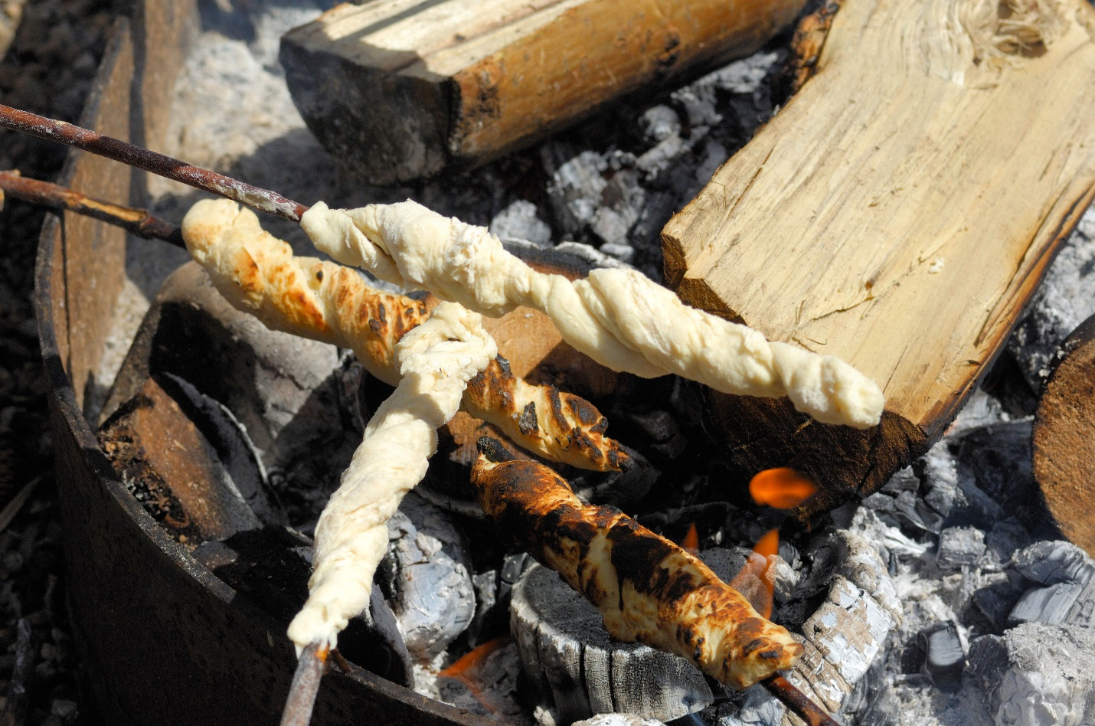

When our buckets were full, we would start our long walk home, being careful not to disturb the animals that lived in the forest. When we got to the edge of the forest, we would stop and say Mussi (thank you) to Mother Earth for everything that she had given us, including the duje (huckleberries).

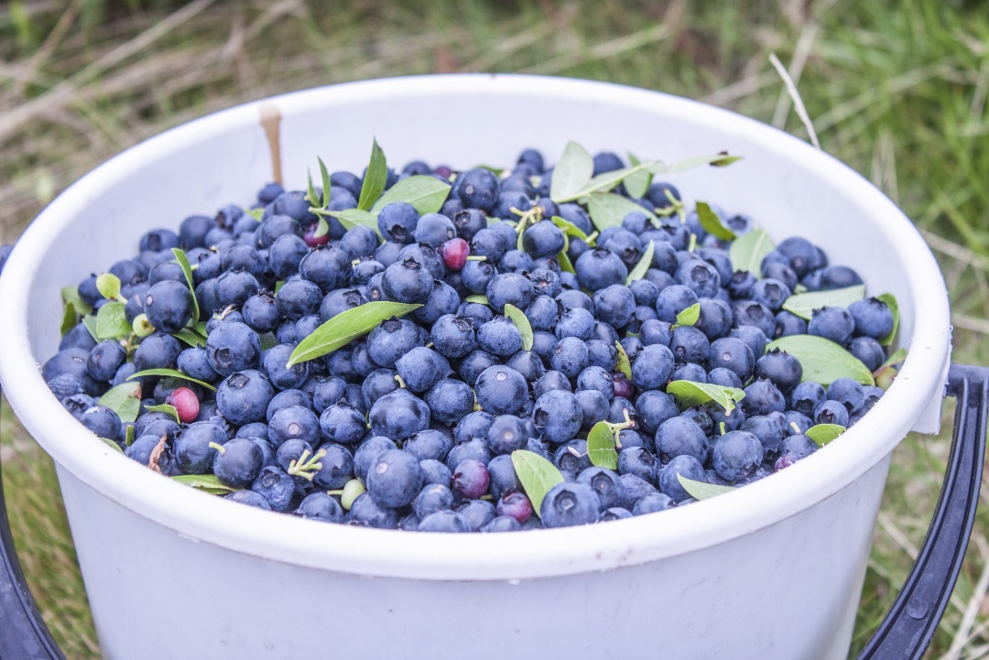

When we got home, we would wash all the berries and use some of them to make warm duje beitle (huckleberry pies). ‘utsiyan (grandpa) would be so happy when he came home. We would eat together and ‘utsiyan (grandpa) would tell us about his hunting trip.

