Counting Behaviours/Strategies
Student has difficulty saying the counting sequence.  “1, 2, 3, 5, 4, 7, 8…” | Student says number word in between “touches” or does not say one number word for each bead counted. | Student loses track of the count, misses beads in the count, or counts more than once.  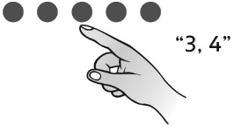
Observations/Documentation
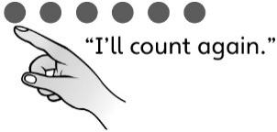  Student recounts when asked “How many?” | Student gets a different number when the beads are counted in a different order.  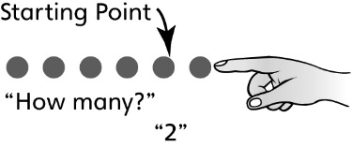 | Student correctly counts the number of beads and realizes that the last number said tells how many (cardinality).
Observations/Documentation

