Counting Behaviours/Strategies
Student does not say the number sequence correctly.  “1, 2, 3, 4, 5, 7, 8, 10, 20…” | Student says a number word in between “touches,” or does not say one number word for each counter counted. | Student loses track of the count, misses counters in the count, or counts more than once.  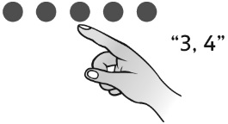
Observations/Documentation
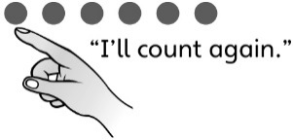  Student recounts when asked “How many?” | 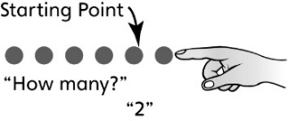  Student gets a different number when the counters are rearranged or counted in a different order. | Student correctly counts the number of objects in a set and realizes that the last number said tells how many are in the set, no matter how they are arranged.
Observations/Documentation

