***Hopping On* Game Boards**

**Master 8a**

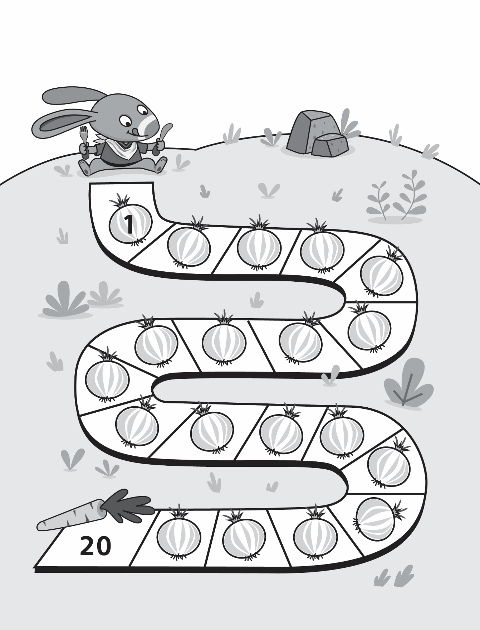

***Hopping On* Game Boards**

**Master 8b**

**(for Accommodation)**

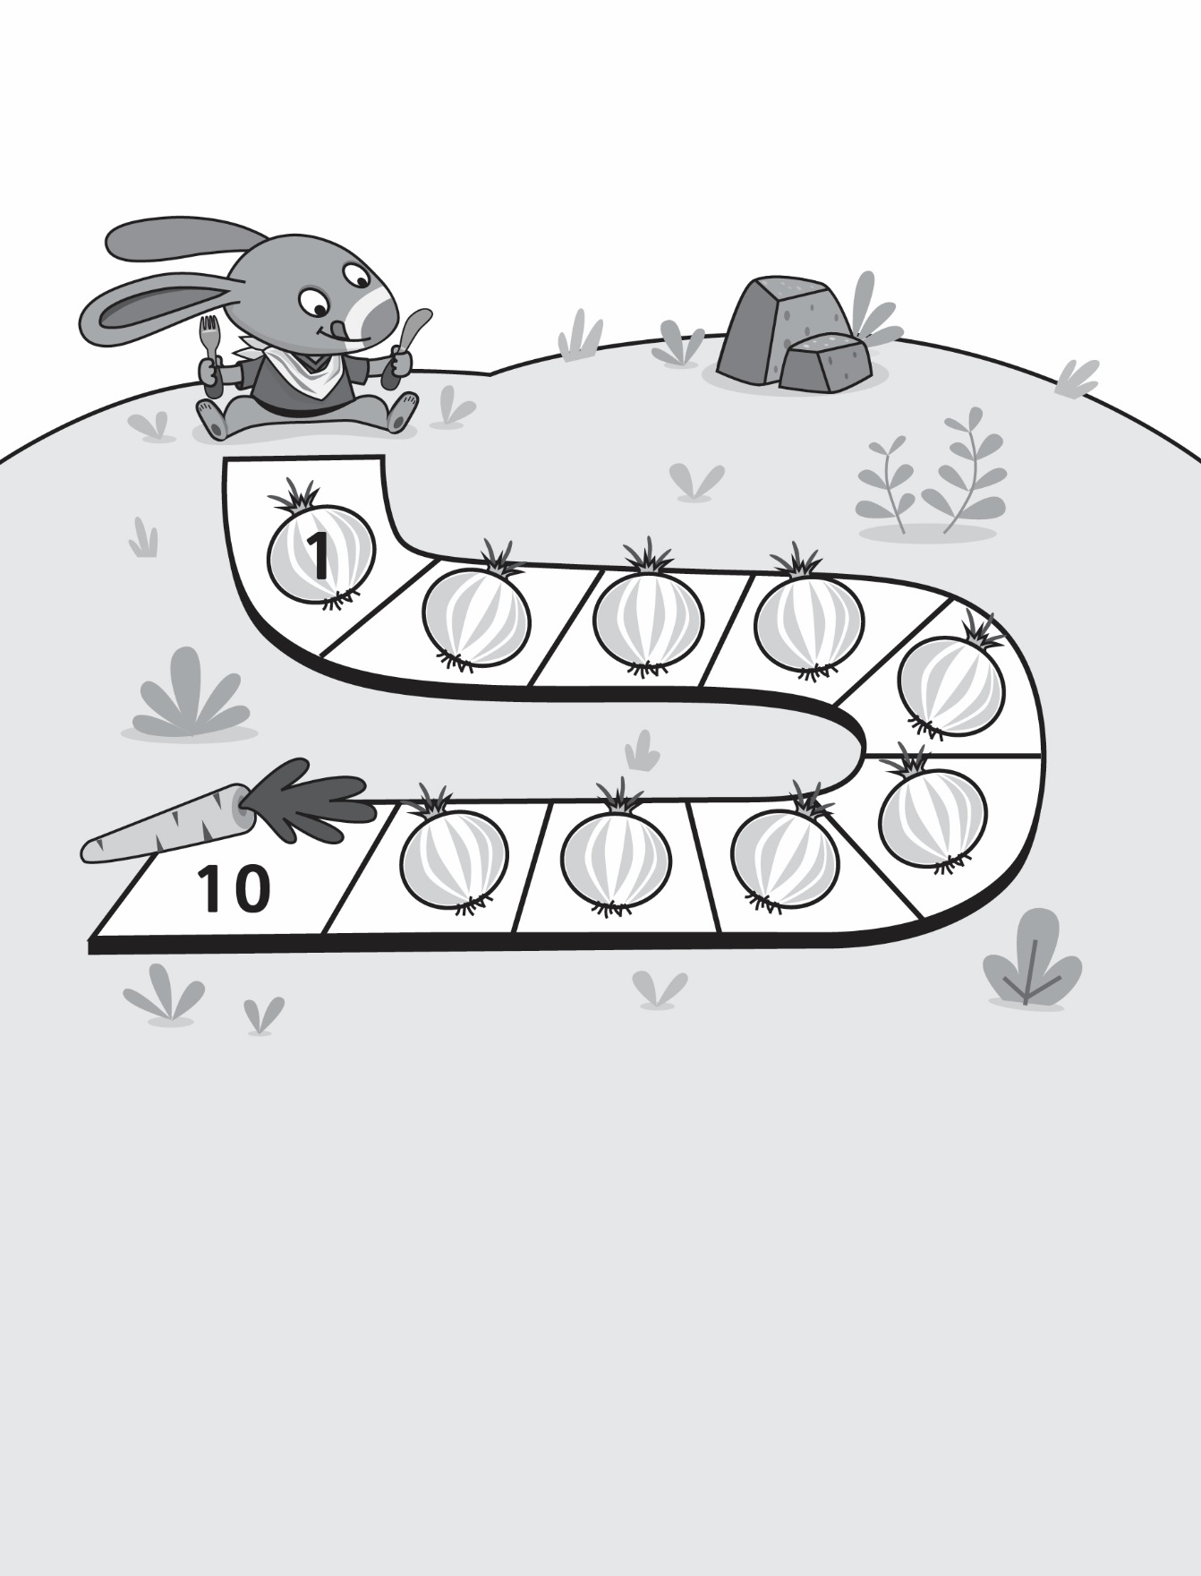

***Hopping On* Game Boards**

**Master 8c**

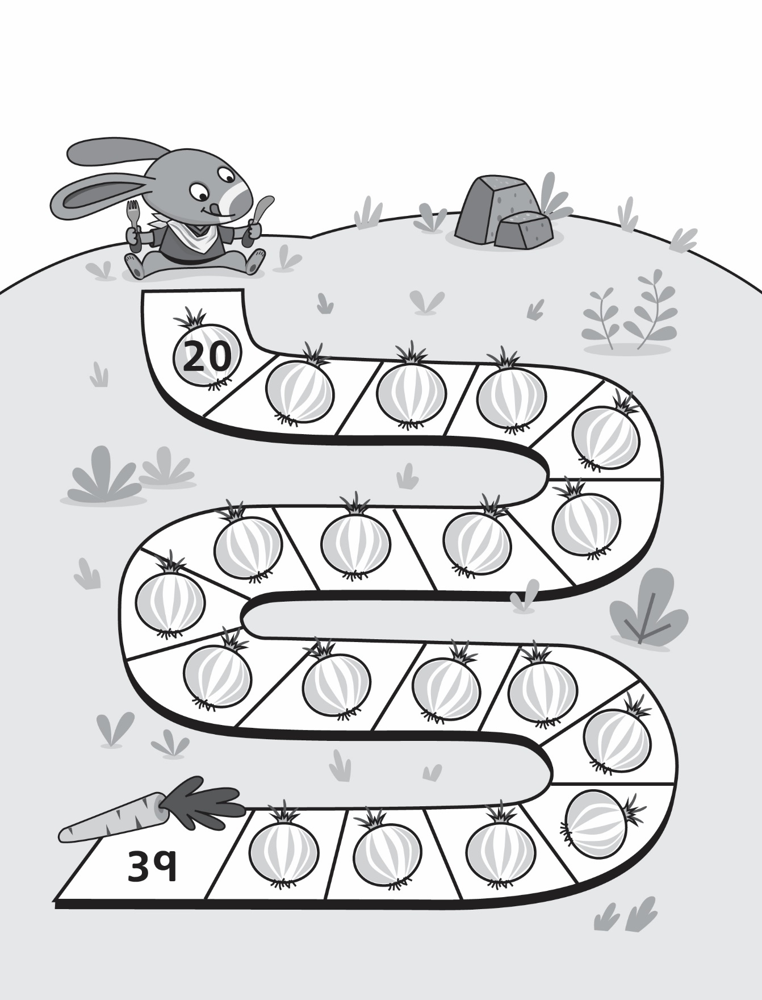

***Hopping On* Game Boards**

**Master 8d**

***Hopping On* Game Boards**

**Master 8e**

**(for Extension)**

