Counting and Comparing Sets Behaviours/Strategies
Student does not say the number sequence correctly when counting bananas.  “1, 2, 3, 5, 7, 8, 10” | 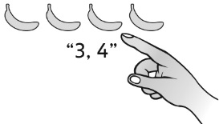  Student loses track of the count, misses bananas in the count, or counts bananas more than once. | 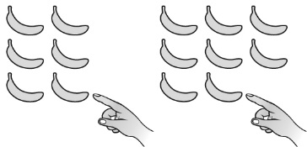  Student compares the sets using one-to-one matching. | Student compares the sets using counting.  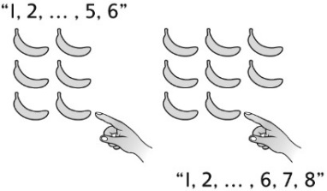
Observations/Documentation
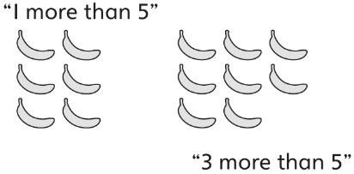  Student uses number relationships to compare sets. | 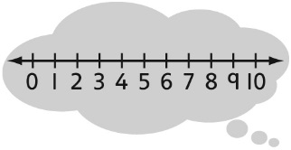  Student uses mental strategies to compare sets (e.g., 8 comes after 6 on a number line). | Student determines which set has more but has difficulty determining how many more. | Student is able to determine which set has more and how many more.
Observations/Documentation

