Decomposing 50 Behaviours/Strategies
- Student decomposes 50 into two  parts, but does not know that  rearranging the counters does  not change the quantity  (i.e., conservation of number). | - Student decomposes 50 into  two parts, but arranges counters  randomly or starts again to find  different ways.  “I’ll put the counters back in the bin and start again.” | - Student uses patterns to find  different ways to decompose 50  into two parts (flips counters and  moves them to the other part).  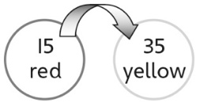 | - Student uses patterns to  systematically find different ways to decompose 50 into two parts (flips one counter at a time and moves it to the other part).
Observations/Documentation
Finding the Unknown Part Behaviours/Strategies
- Student writes numbers on the mat, but mixes up the whole and the part, or adds the whole and the known part to find the unknown part.  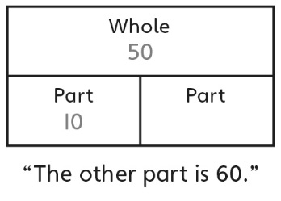 | - To find a part given the whole and another part, student guesses and then uses counters to check.  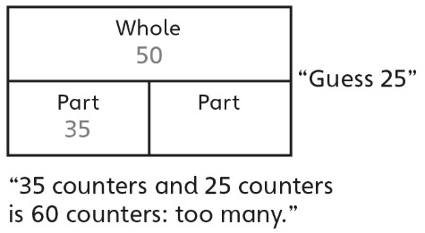 | - To find a part given the whole and another part, student counts on from the part or back from the  whole with counters or fingers.  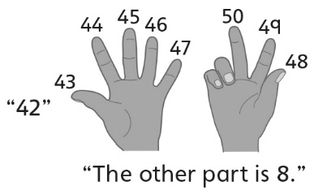 | - Student uses efficient counting strategies, number relationships, or mental strategies to find a part  given the whole and another part.
Observations/Documentation

