Partitioning and Describing Parts of a Whole Behaviours/Strategies
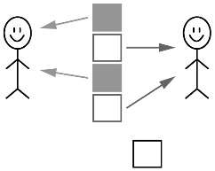  Student shares some items equally but ignores the leftover.  “I shared 5 sandwiches and  each person got 2 sandwiches.” | Student shares some items equally but is not sure how to partition the leftover.  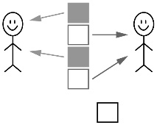  “I’m not sure how to divide  the leftover sandwich.” | 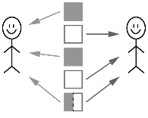  Student shares items equally, including leftovers, but cannot use fractions to name the amount each sharer gets.  “Each person gets 2 plus  a bit more.”
Observations/Documentation
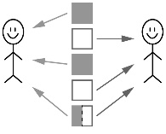  Student shares items equally, including leftovers, and uses fractions to name the amount each sharer gets.  “Each person got two plus  one half.” | 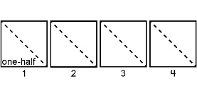  Student partitions a whole into equal parts, but doesn’t consider the whole when discussing fractions.  “8 children got 1 one-half  a sandwich each. I know 2 one-halves make a whole. So, I put 8 one-halves together to make 4 wholes. There were 4 whole sandwiches to start with.” | 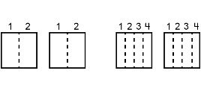  Student shares items equally, including leftovers, solves equal-sharing problems, and recognizes that one-half and two-fourths of the same whole are equal.  “I can divide each leftover  sandwich into 2 equal parts and  give each person 1 one-half. Or,  I can divide each whole into  4 equal parts and give each person 2 one-fourths.”
Observations/Documentation

