Composing and Decomposing Behaviours/Strategies
Student represents a number in only one way. | Student removes all objects and starts fresh to represent a number in different ways. |  | Student makes changes to the current representation to show numbers in different ways. |  | Student uses patterns to systematically find different ways to model a number.
Observations/Documentation
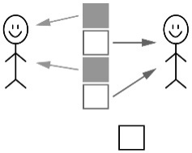  Student shares some items equally but is not sure how to partition the leftover.  “I’m not sure  how to divide  the leftover.” | 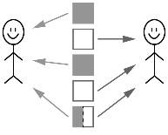  Student shares items equally, including leftovers, but cannot use fractions to name the amount each sharer gets.  “Each person gets  two plus a bit more.” |  | 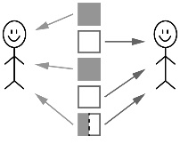  Student shares items equally, including leftovers, and uses fractions to name the amount each sharer gets.  “Each person gets  two plus one half.” |  | Student shares items equally and solves equal-sharing problems where each share is one-half.  “Each celery stalk  serves 2 students.  So, 5 stalks will serve  2, 4, 6, 8, 10 students.”
Observations/Documentation

