**Matching Cards**

**Master 69a**

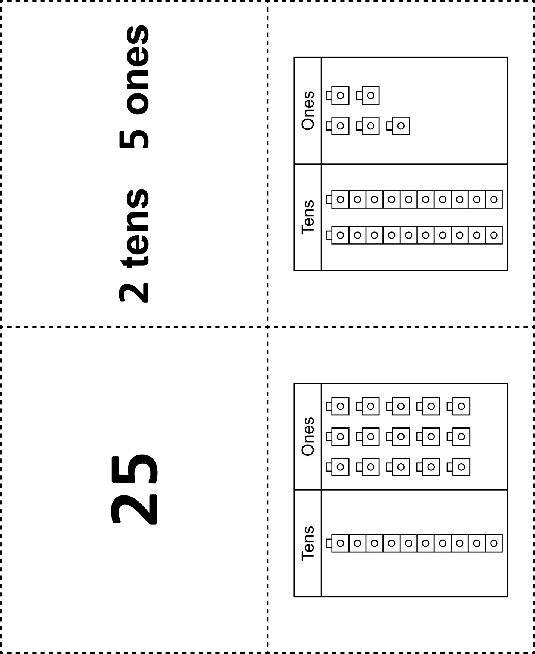



**Matching Cards**

**Master 69b**

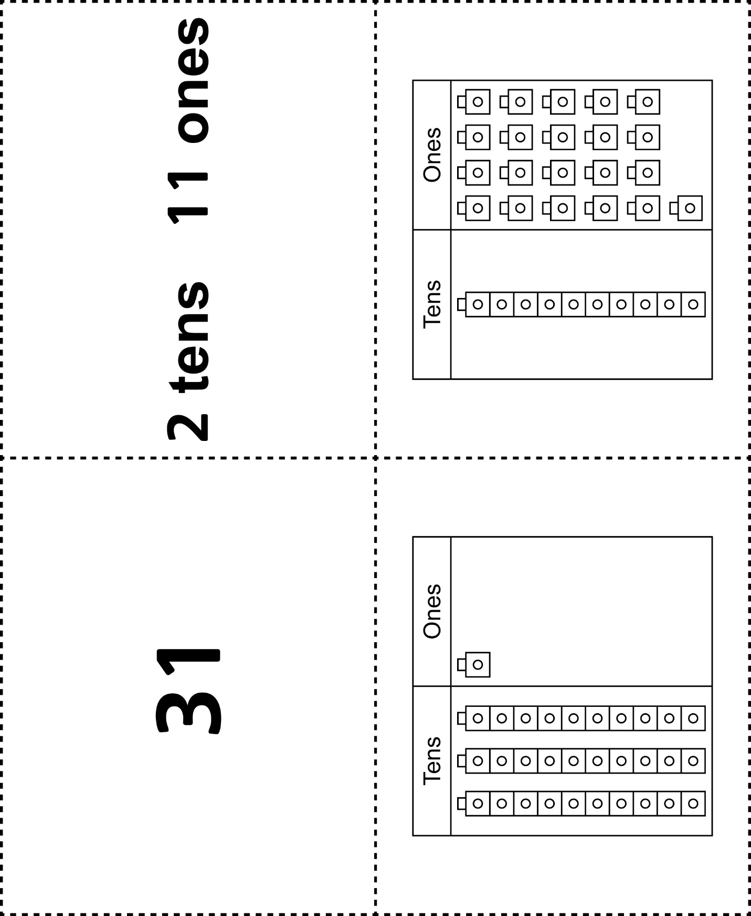

**Matching Cards**

**Master 69c**



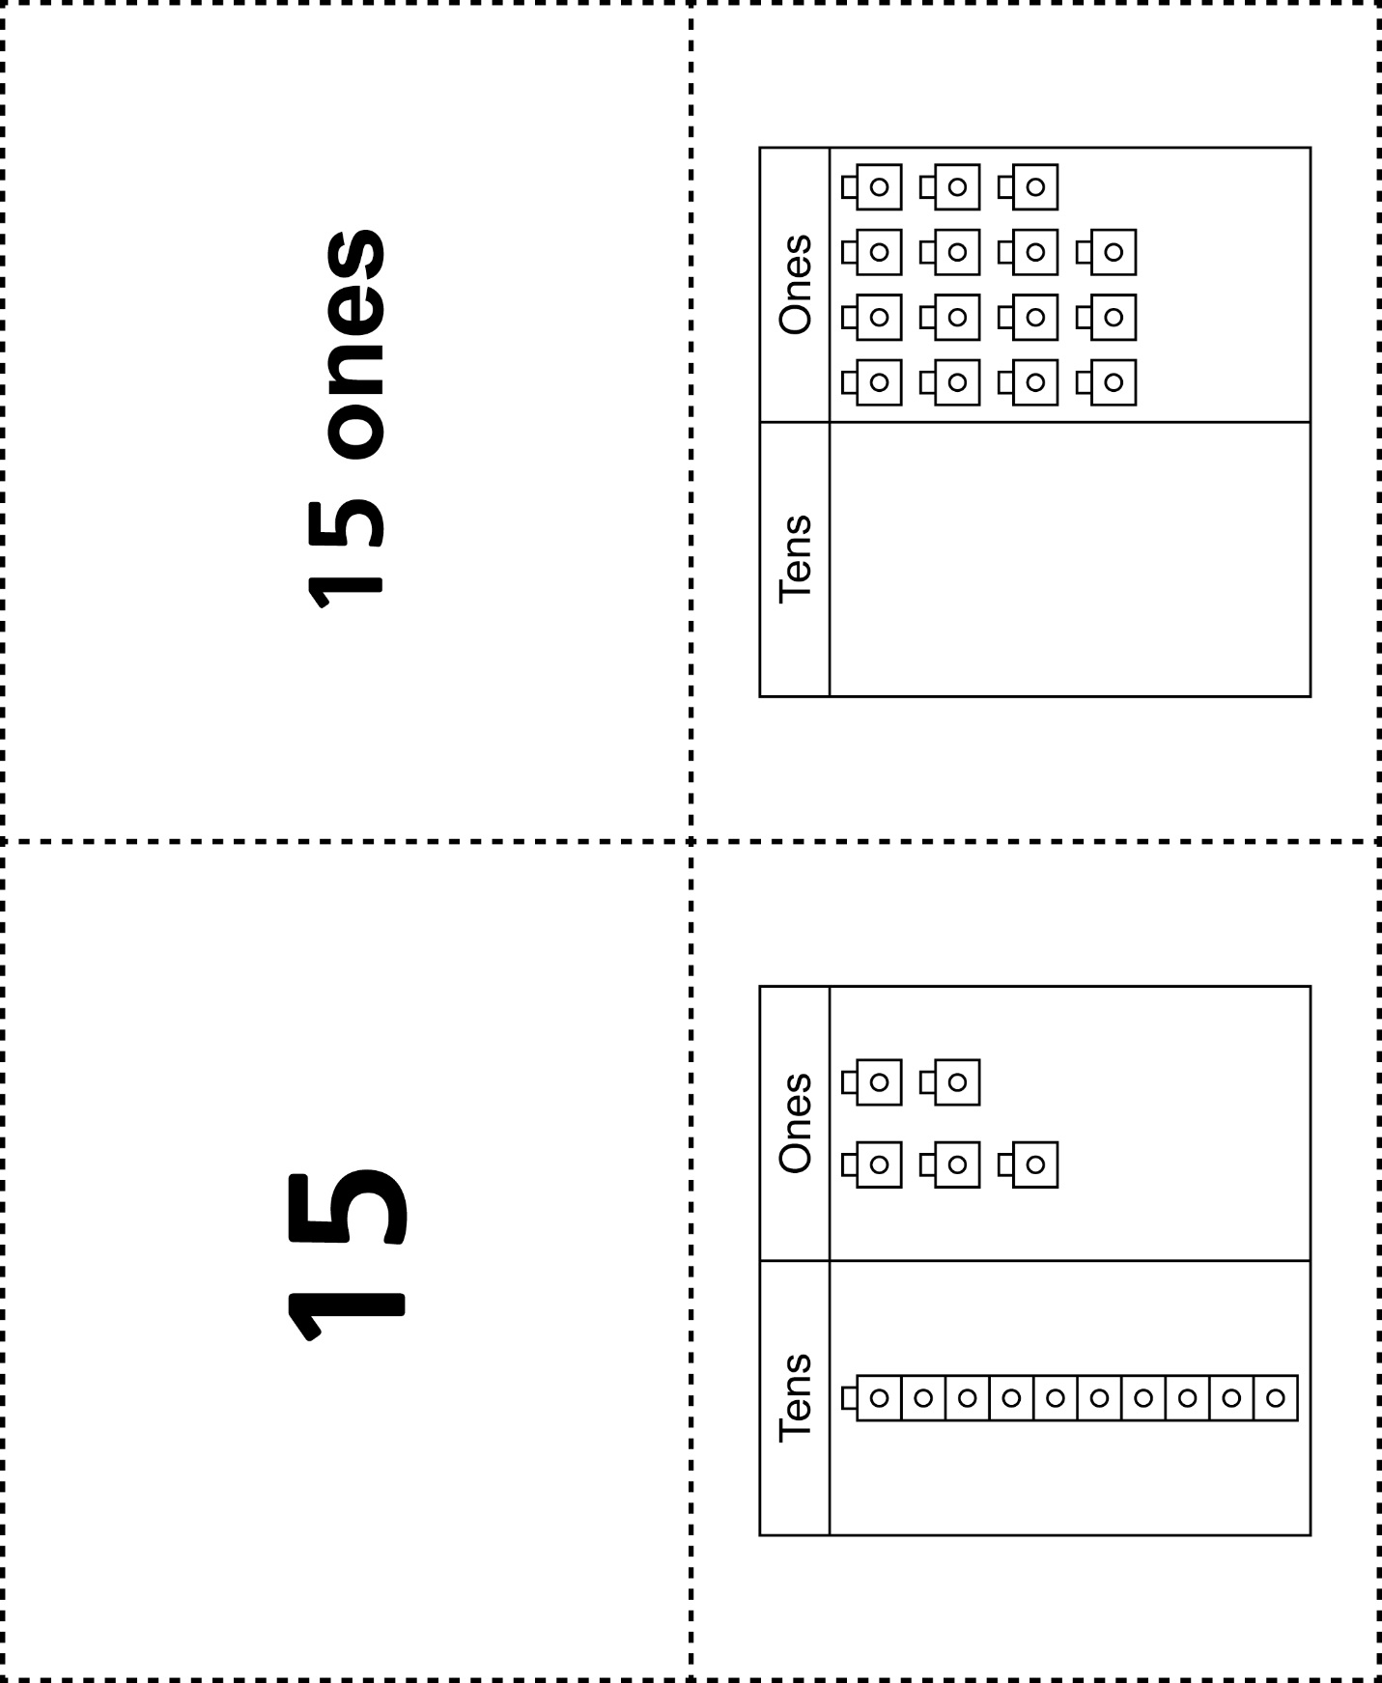

**Matching Cards**

**Master 69d**

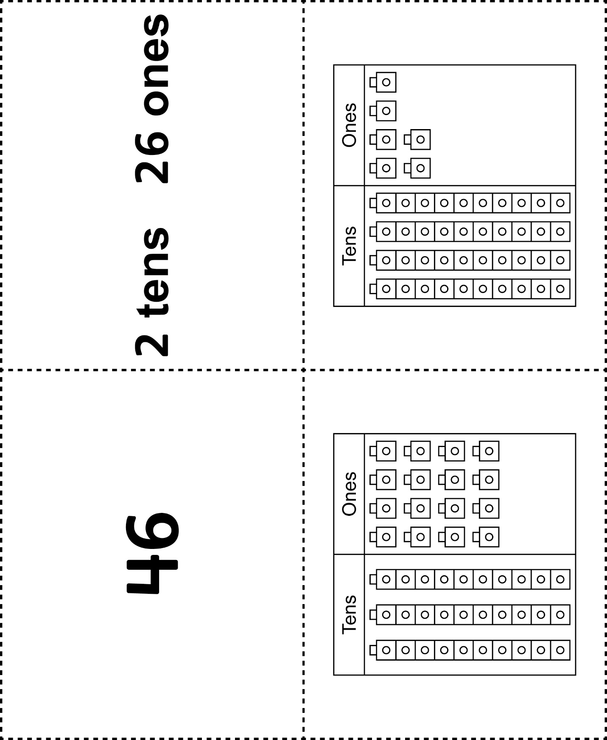



**Matching Cards**

**Master 69e**

|  |  |
| --- | --- |
|  |  |
|  |  |

