**Seed Cards (0–20)**

**Master 80a**

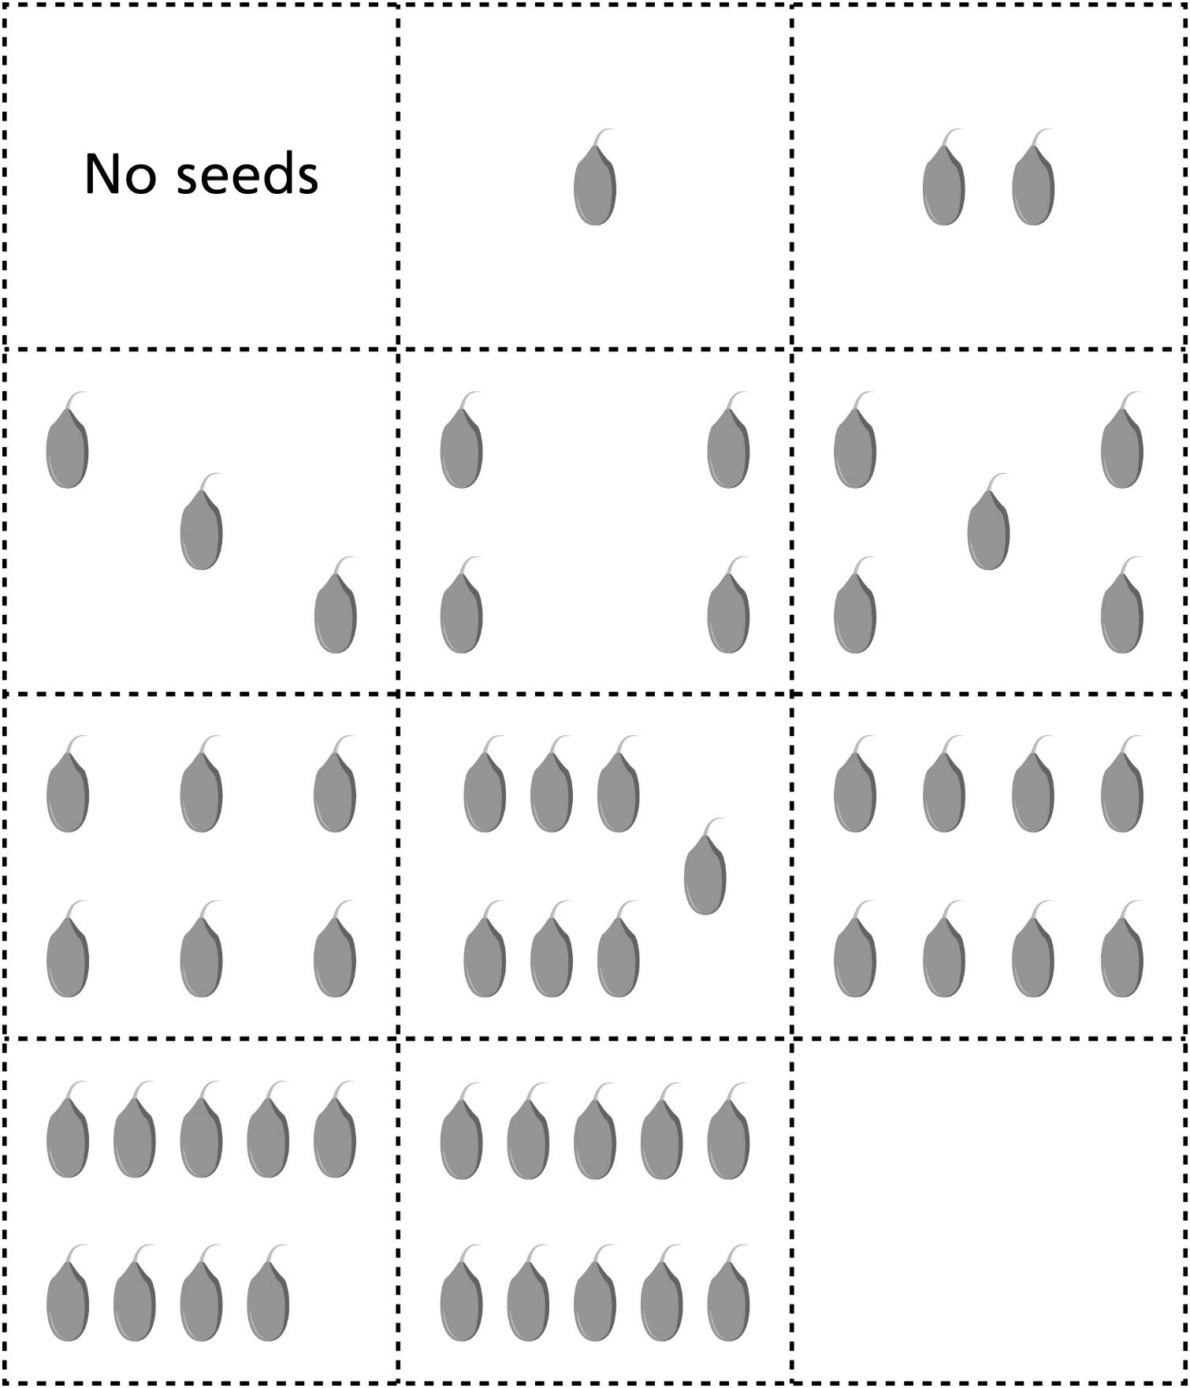

**Seed Cards (0–20)**

**Master 80b**

**b**

