Part-Part-Whole Cards
Master 104a

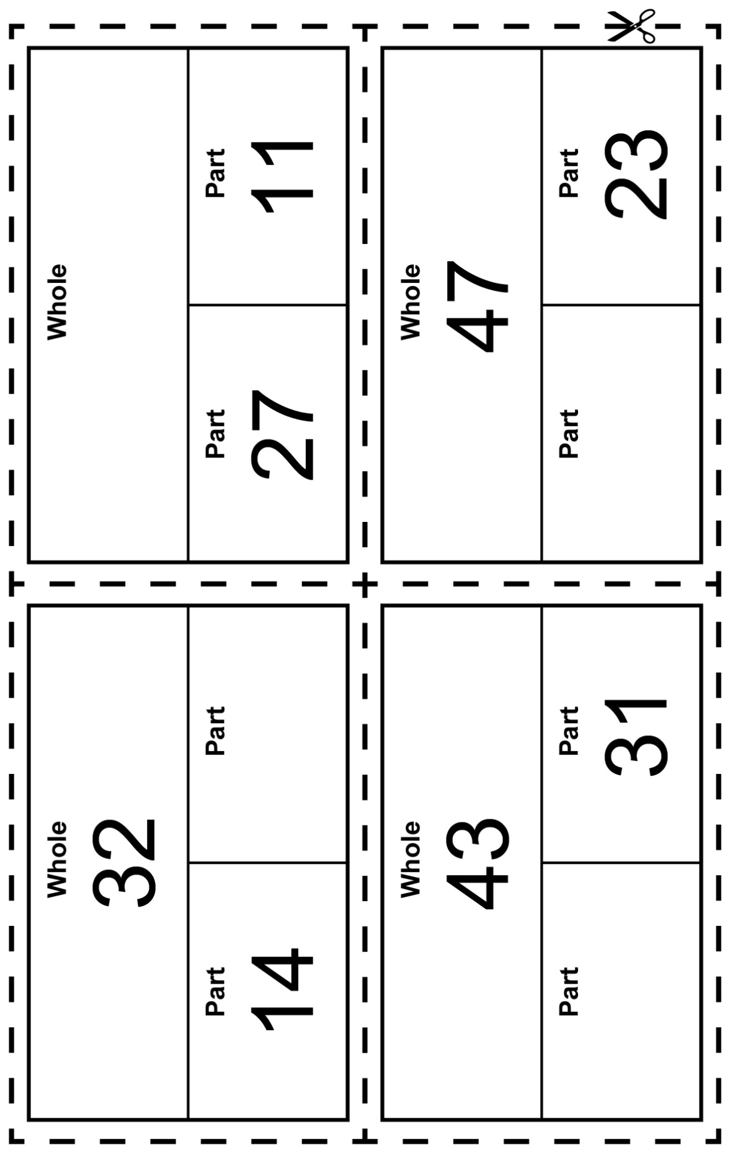
Part-Part-Whole Cards
Master 104b

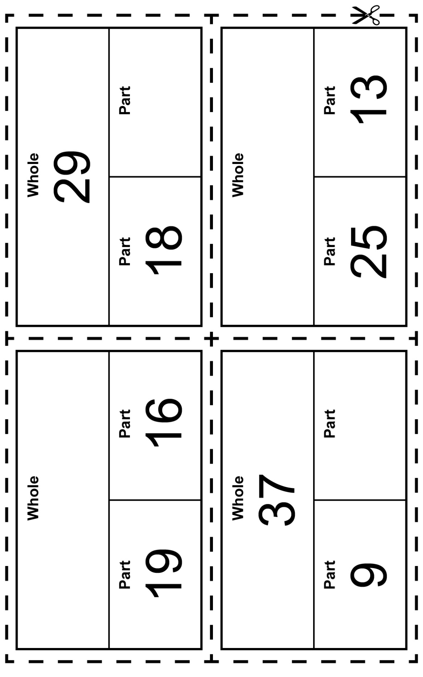
Part-Part-Whole Cards (Accommodation)
Master 104c

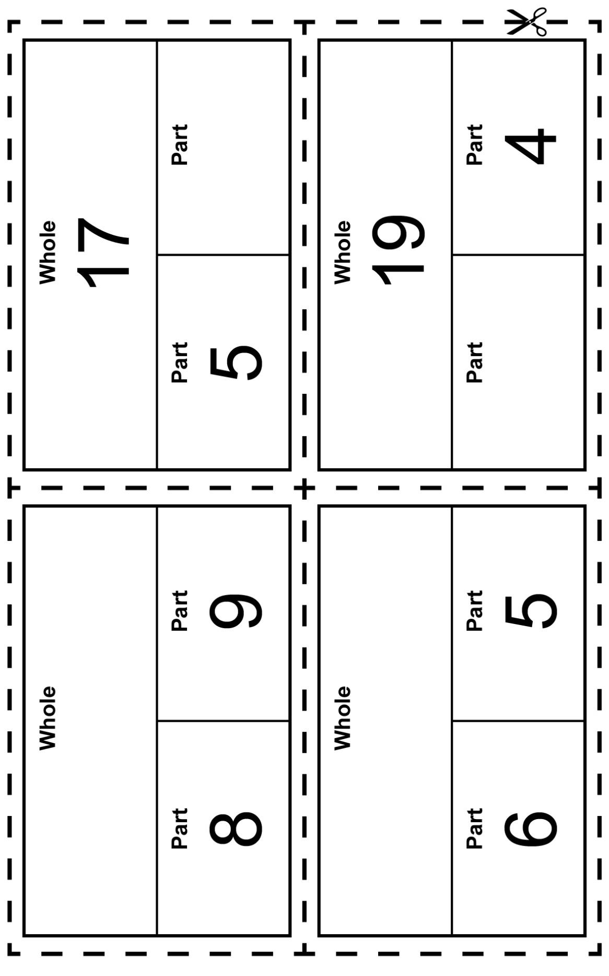
Part-Part-Whole Cards (Accommodation)
Master 104d

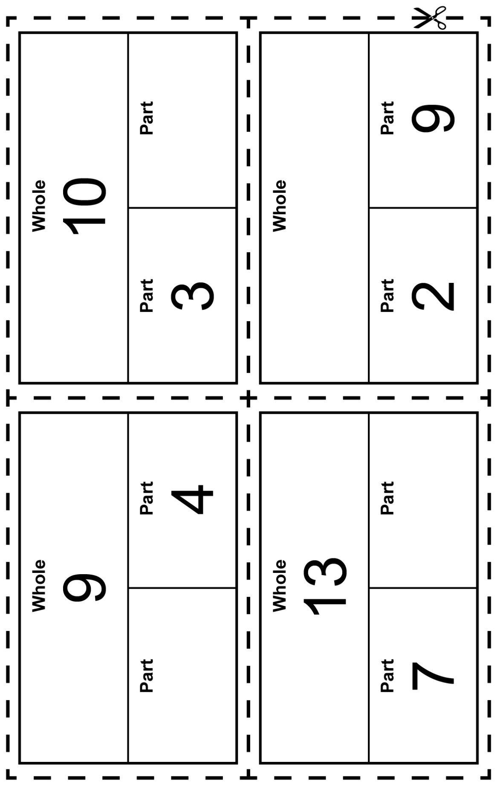
Part-Part-Whole Cards (Combined Grades)
Master 104e

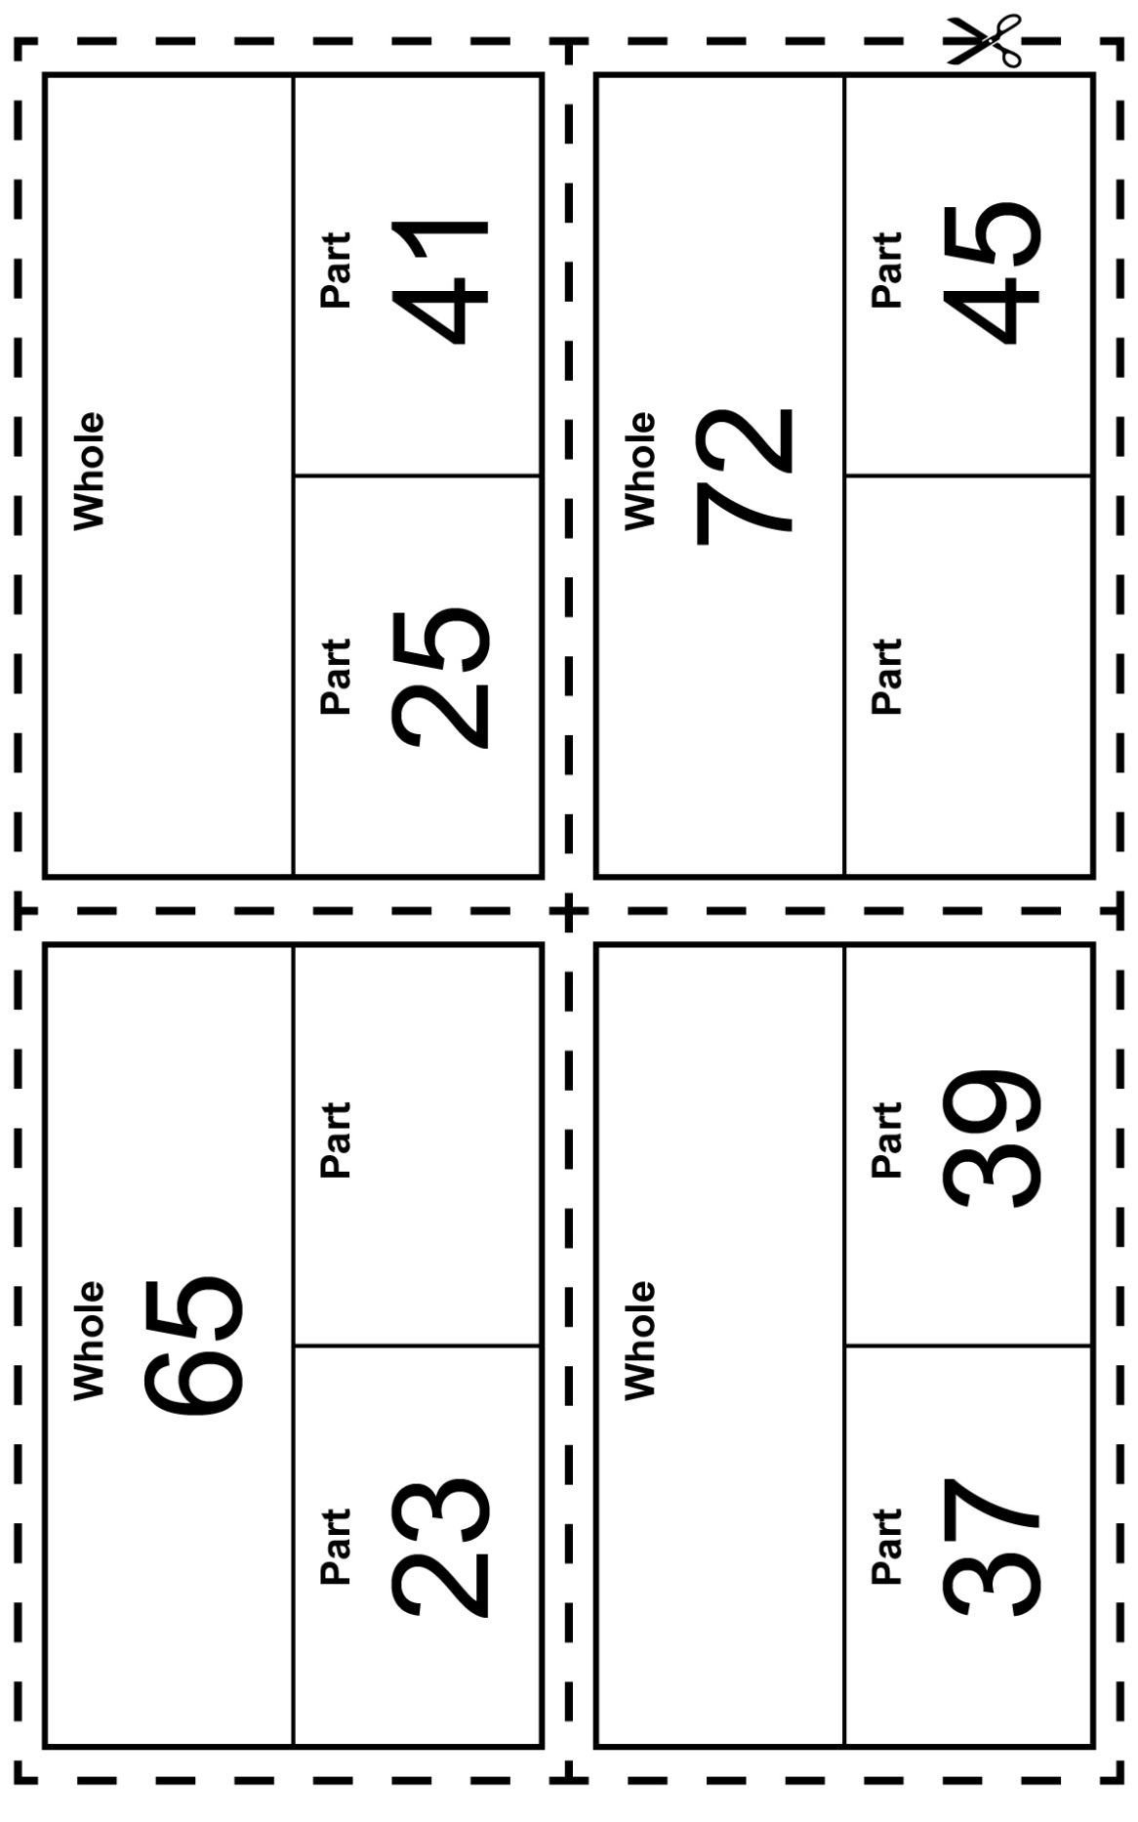
Part-Part-Whole Cards (Combined Grades)
Master 104f

