Adding and Subtracting to 50 Behaviours/Strategies
- Student guesses, then counts to check.  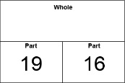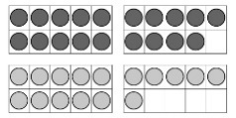  “I think the whole is 40. Let me count by1s to check. No, the whole is 35.” | - Student uses counters to add or subtract.  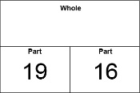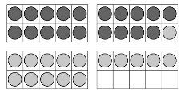  “10, 20, 30, 31, 32, 33, 34, 35. The whole is 35.” | - Student uses a drawing to help add or subtract.  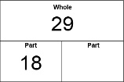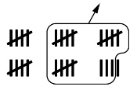  “I drew 29 tally marks then removed 18 of them.  I was left with 11.”
Observations/Documentation
- Student uses part-part-whole thinking to find the unknown.  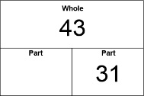  “To find the missing part, I subtract:  41 – 31 = 12.” | - Student uses inverse relationship of addiction and subtraction to find the unknown.  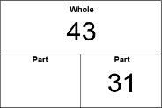  “I rewrote the subtraction sentence as an addition sentence: 31 + ? + 43.” | - Student fluently uses symbols and equations that matches the action in a situation.  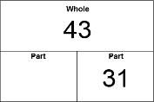  “43 people were on the bus. Some got off at the next stop. 31 people are still on the bus. How many people got off?”
Observations/Documentation

