Equivalent or Not?
Master 21a

Are these pairs of expressions equivalent? Write an = or $≠$ sign in the box. You can use linking cubes and a pan balance to help you.

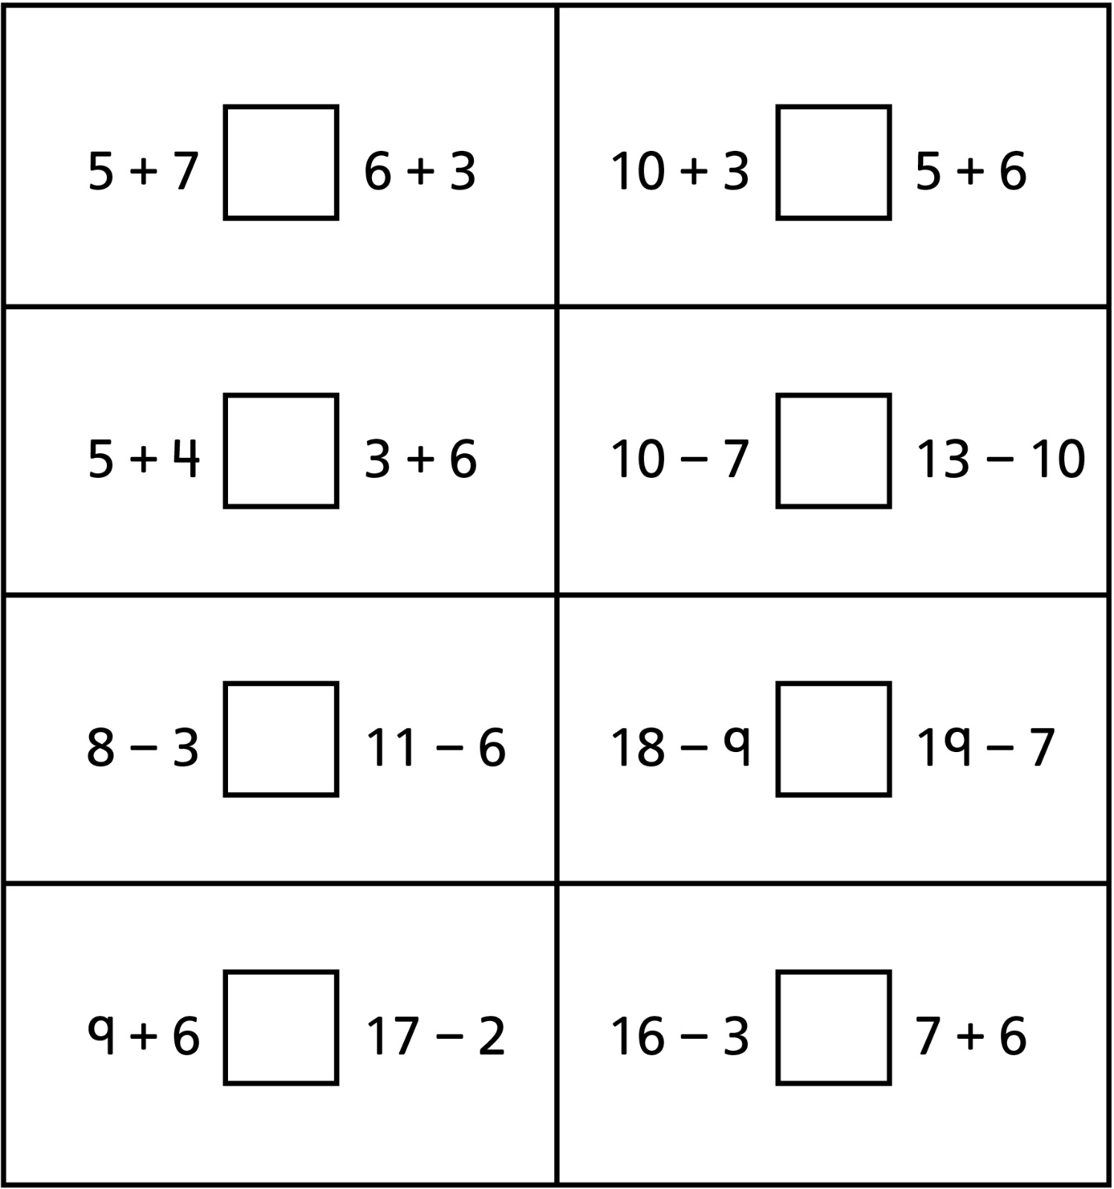

Equivalent or Not?
Master 21b

Are these pairs of expressions equivalent? Write an = or $≠$ sign in the box. You can use linking cubes and a pan balance to help you.

