Making Graphs Behaviours/Strategies
Student has difficulty sorting the objects into three groups. | 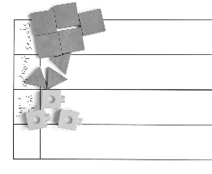  Student places objects or draws pictures in groups on the graph. | 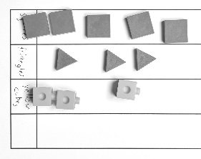  Student sorts in lines, but objects or pictures are not equally spaced and aligned. Pictures may be of different sizes. | 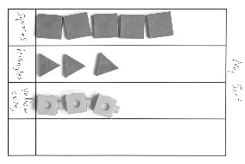  Student sorts in lines, all pictures are about the same size, and objects or pictures are equally spaced and aligned. Graph has a title and labels.
Observations/Documentation
Reading Graphs Behaviours/Strategies
Student has difficulty counting the number of objects in a column. | Student makes a pictograph or concrete graph but has difficulty reading data from the graph (e.g., “Which column has the most pictures or objects?”). | Student reads data from the graph but has difficulty comparing the data. | Student answers “how many” questions about the graph and compares data using terms such as “more,” “fewer,” “most,” and “least.”
Observations/Documentation

Big Idea |  |  |  |  | Indicators From Learning Progression
Curriculum Expectations addressed

Student Names
Student can read and interpret concrete graphs and pictographs.
(Activities 1–4)

Student can sort objects using one attribute.
(Activities 2, 4)

Student can collect and organize data.
(Activities 2–4)

Student can display collected data on pictographs or concrete graphs.
(Activities 2–4)

Student can formulate and answer questions about their graphs.
(Activities 1–4)

Student can compare data shown on graphs.
(Activities 1–4)

Student can use math language when describing and comparing data.
(Activities 1–4)

Name: _______________________

 | Not Observed | Sometimes | Consistently
Reads and interprets concrete graphs and pictographs.
(Activities 1–4)

Sorts objects using one attribute.
(Activities 2, 4)

Collects and organizes data.
(Activities 2-4)

Displays collected data on pictographs or concrete graphs.
(Activities 2-4)

Formulates and answers questions about graphs.
(Activities 1–4)

Compares data shown on graphs.
(Activities 1–4)

Uses math language when describing and comparing data.
(Activities 1–4)

Strengths:

Next Steps:

