Sorting Solids Behaviours/Strategies
Student is unable to select a solid based on the needed attribute. | 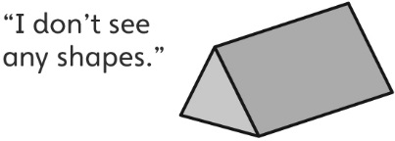  Student focuses on one shape and doesn’t realize that more than one shape can be a face of a solid. | 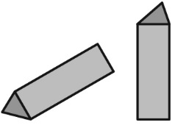  Student identifies some faces but doesn’t rotate the solid to see the different faces (shapes).
Observations/Documentation
Student recognizes some shapes but doesn’t recognize a shape when it doesn’t match her or his mental image of the shape.  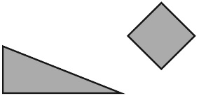 | 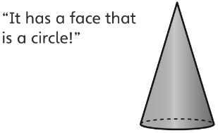  Student can only sort a solid in one way. | Student can sort solids with ease.
Observations/Documentation

Big Idea |  |  |  |  | Indicators From Learning Progression
Curriculum Expectations addressed

Student Names
Student can identify a 3-D solid from a given description.
(Activity 7)
Student can describe a
3-D solid using geometric language.
(Activities 7–10)
Student can identify and name the faces of 3-D solids.
(Activities 7–10)
Student can describe similarities and differences between an everyday object and a
3-D solid. (Activity 7)
Student can sort 3-D solids using a single attribute.
(Activities 8, 9, 10)
Student can sort solids using a single attribute in more than one way.
(Activities 8, 10)
Student can identify the sorting rule for a
pre-sorted set of 3-D solids. (Activities 9, 10)
Student uses geometric language to explain a sorting rule.
(Activities 9, 10)

Name: _______________________

 | Not Observed | Sometimes | Consistently
Identifies a 3-D solid from a given description.
(Activity 7)
Describes a
3-D solid using geometric language.
(Activities 7–10)
Identifies and names the faces of 3-D solids.
(Activities 7–10)
Describes similarities and differences between an everyday object and a 3-D solid. (Activity 7)
Sorts 3-D solids using a single attribute.
(Activities 8, 9, 10)
Sorts 3-D solids using a single attribute in more than one way.
(Activities 8, 10)
Identifies the sorting rule for a pre-sorted set of 3-D solids. (Activities 9, 10)
Uses geometric language to explain a sorting rule.
(Activities 9, 10)

Strengths:

Next Steps:

