***Find the Shapes* Designs**

**Master 25a**

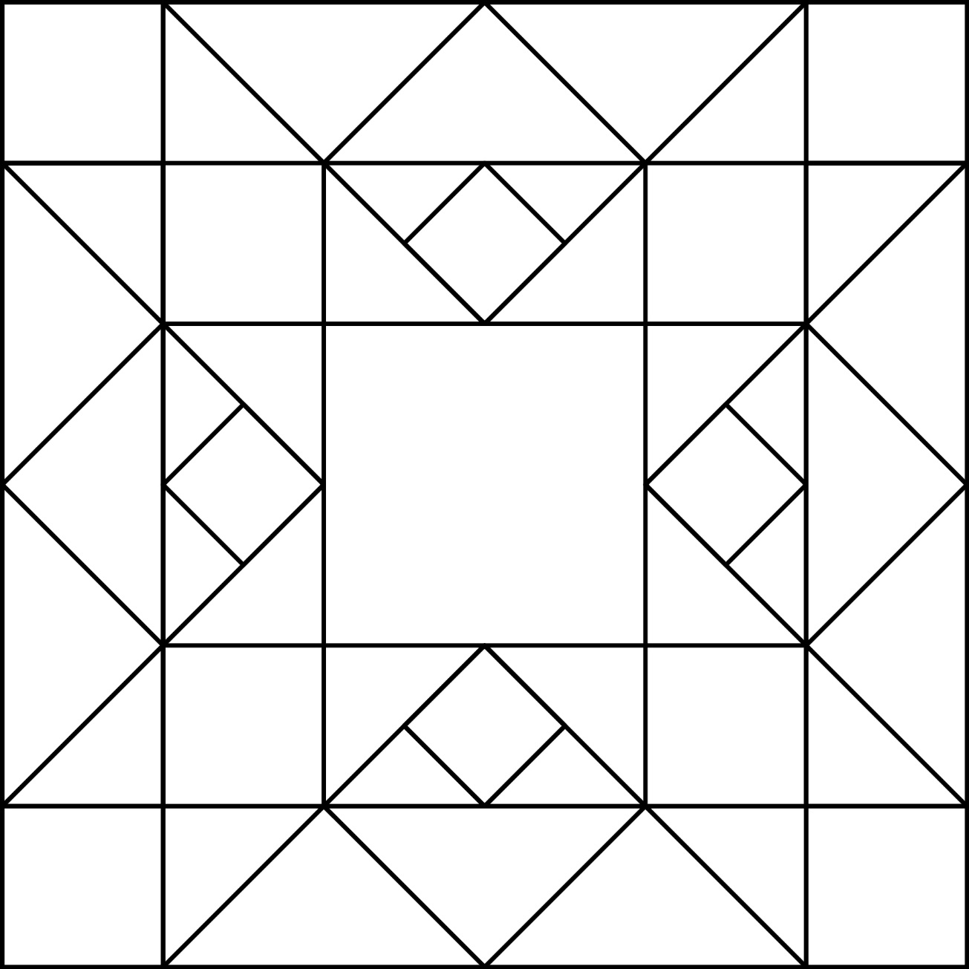

***Find the Shapes* Designs**

**Master 25b**

