**Exploring Lines of Symmetry**

**Master 32a**



**Exploring Lines of Symmetry**

**Master 32b**



**Exploring Lines of Symmetry**

**Master 32c**

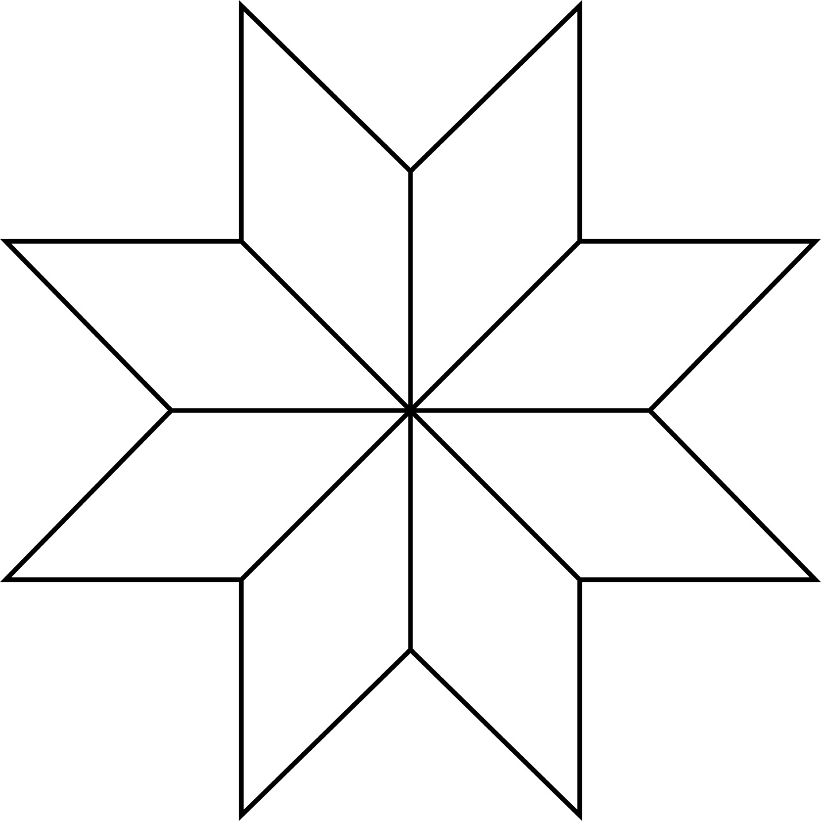

**Exploring Lines of Symmetry**

**Master 32d**

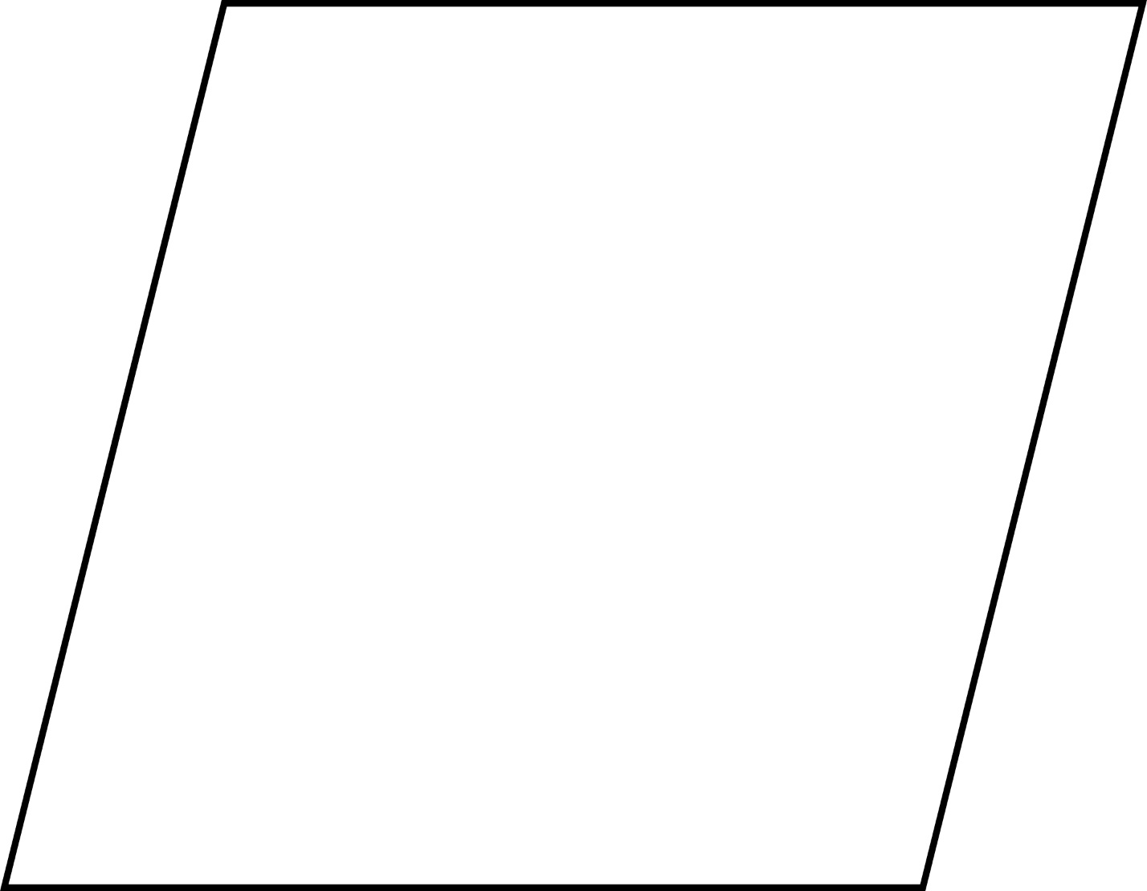

**Exploring Lines of Symmetry**

**Master 32e**

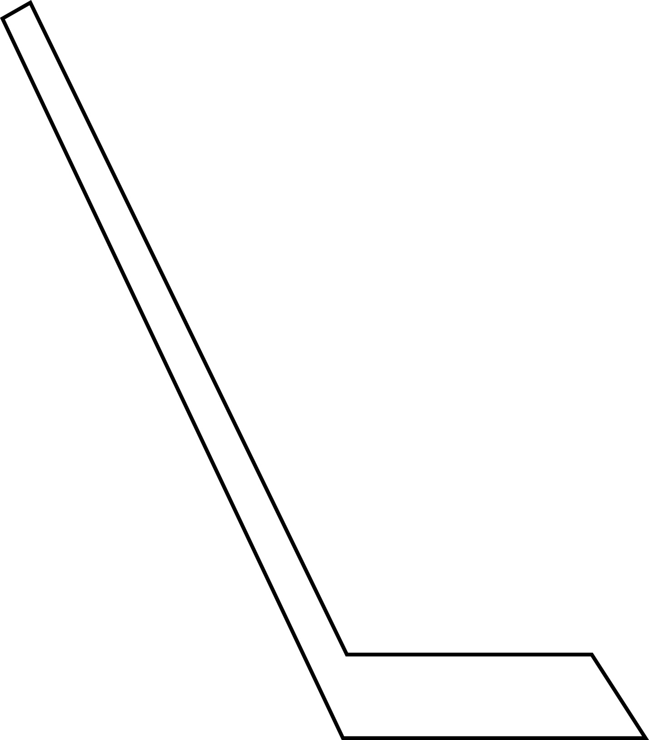

**Exploring Lines of Symmetry**

**Master 32f**

