**Symmetrical Images**

**Master 33a**

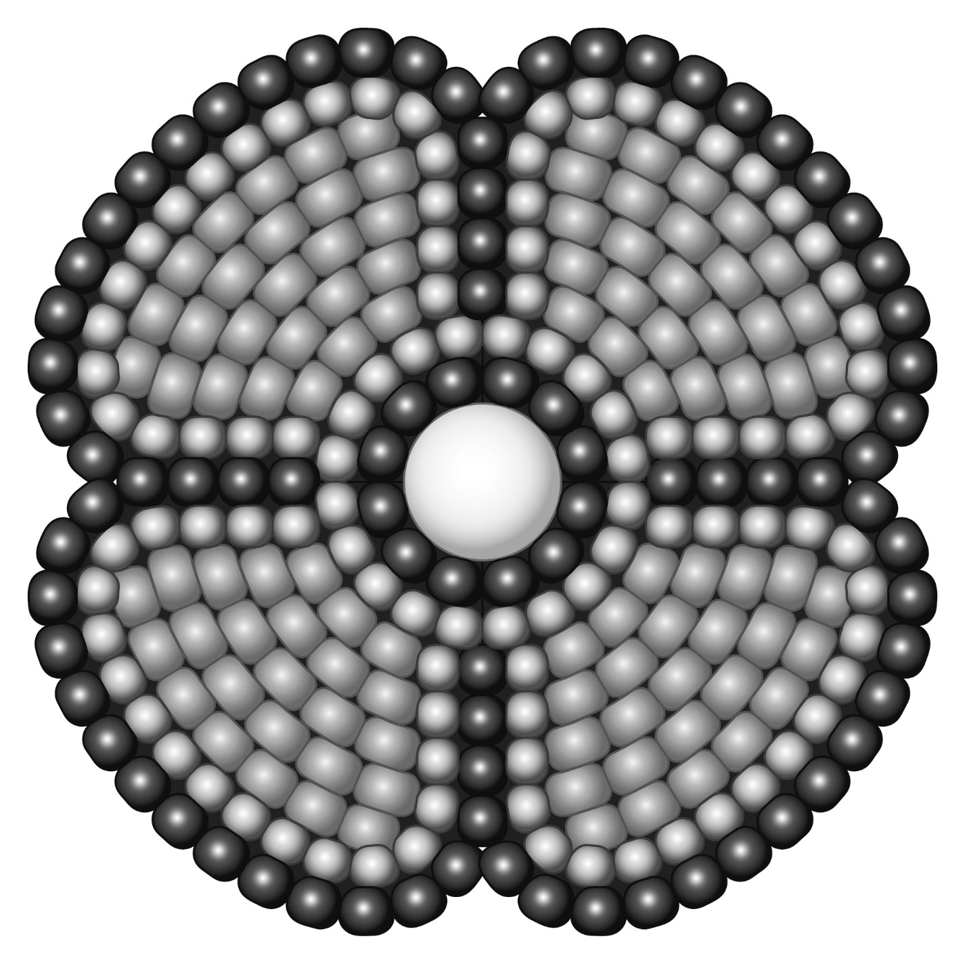

**Symmetrical Images**

**Master 33b**

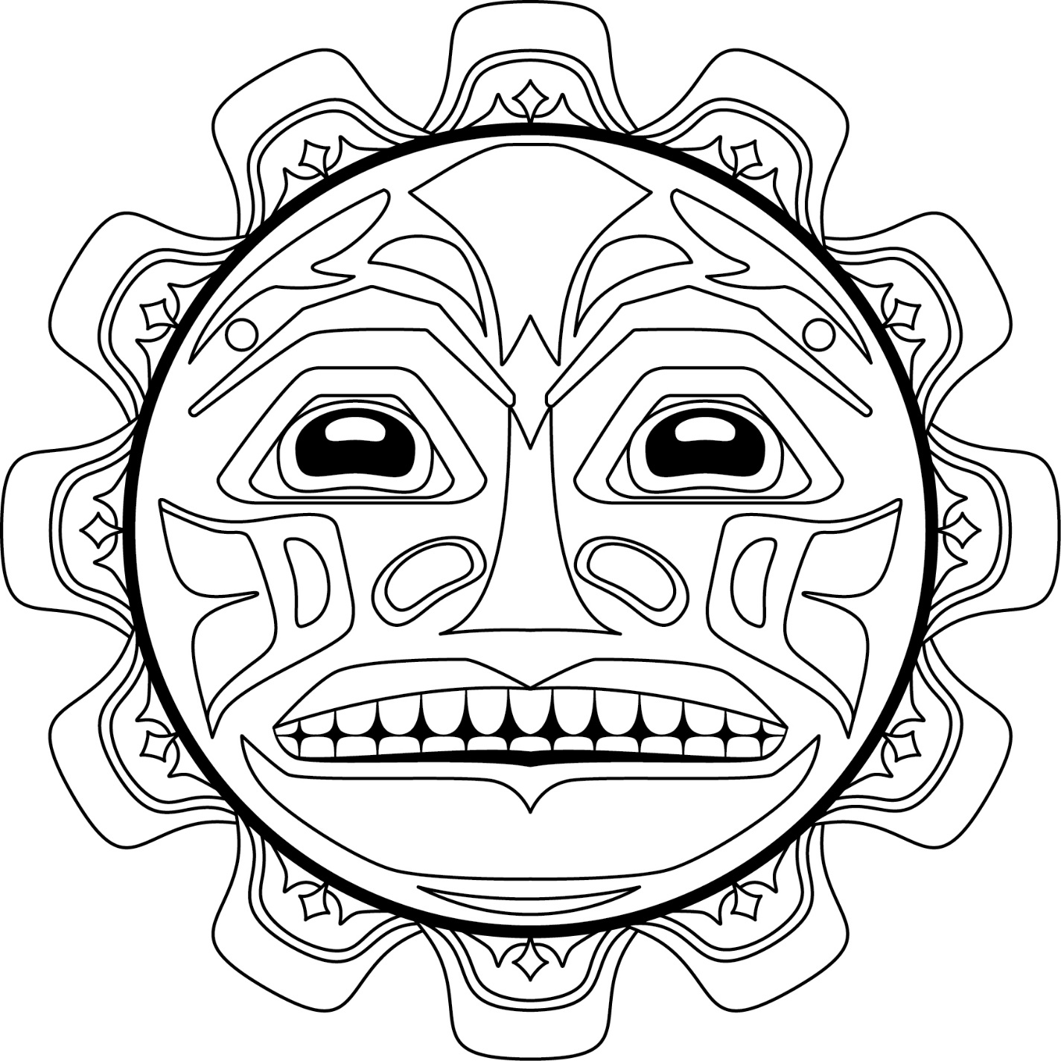

**Symmetrical Images**

**Master 33c**



**Symmetrical Images**

**Master 33d**



**Symmetrical Images**

**Master 33e**

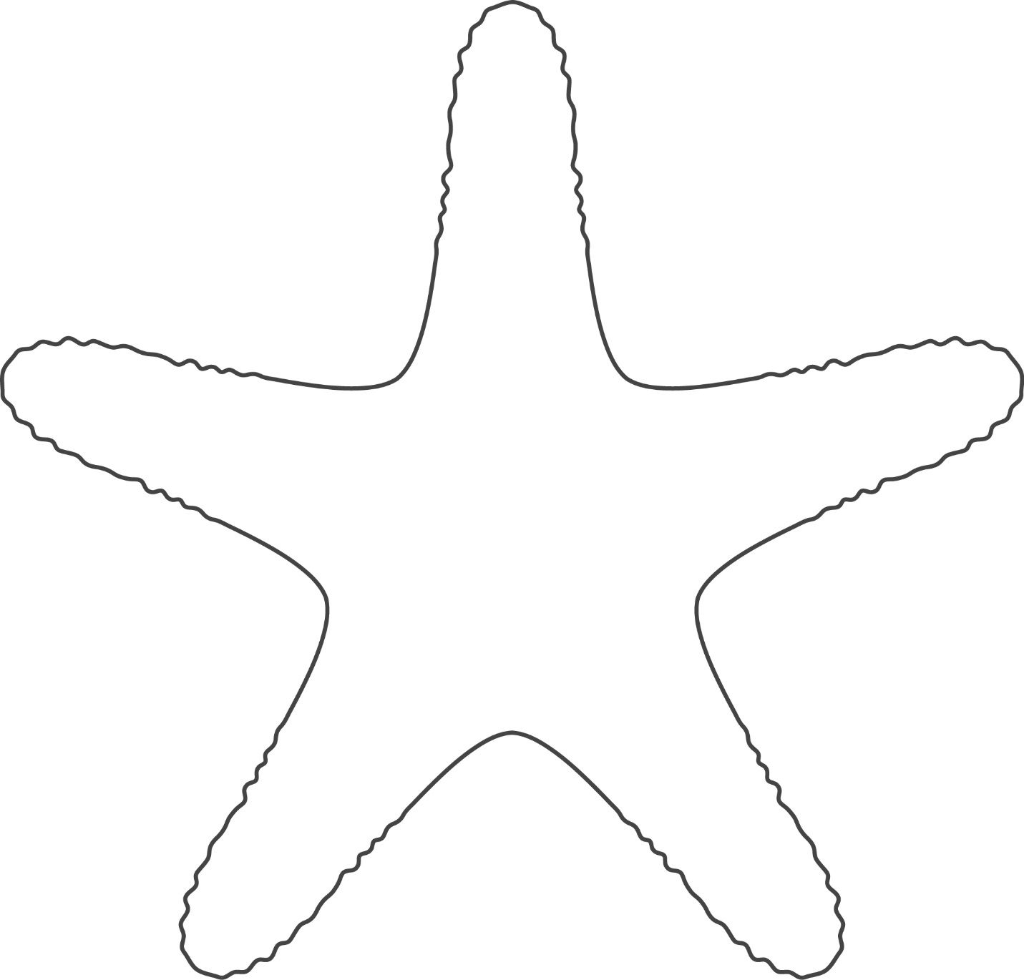

**Symmetrical Images**

**Master 33f**

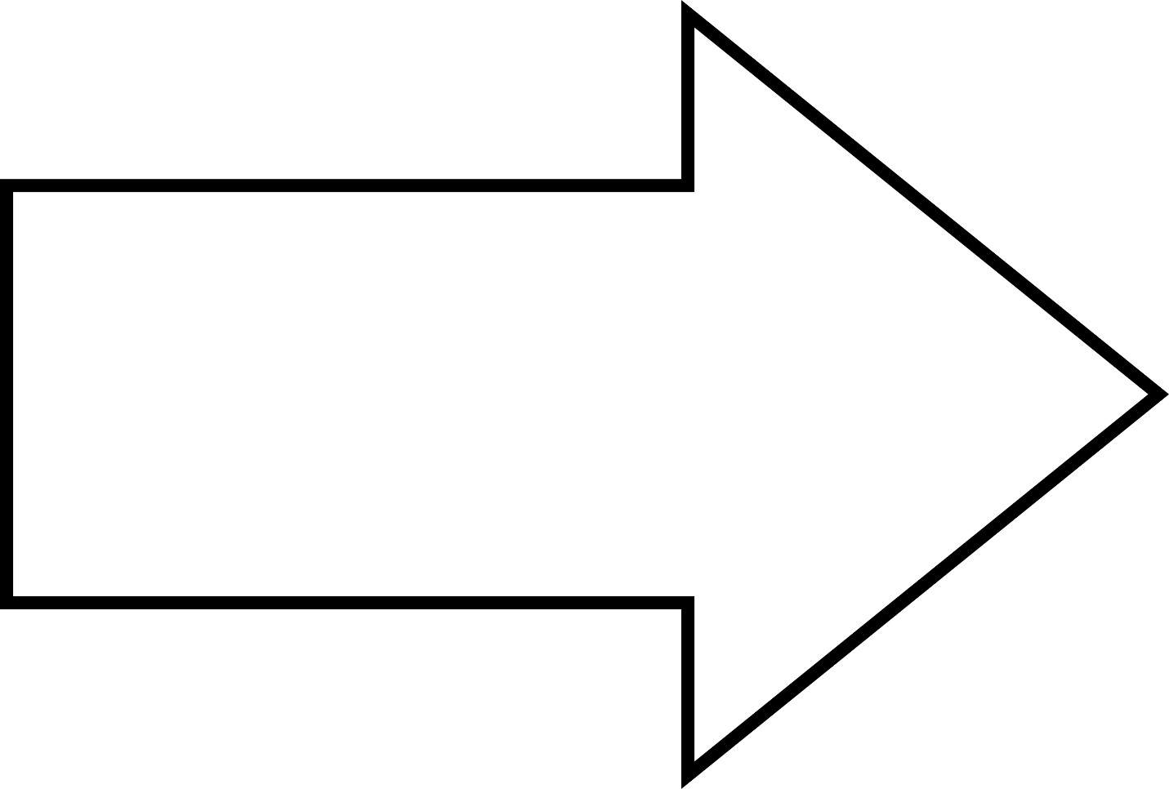

**Symmetrical Images**

**Master 33g**



**Symmetrical Images**

**Master 33h**

