Creating a Symmetrical Necklace/Bracelet Behaviours/Strategies
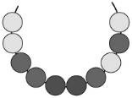  Student randomly places beads on the string, not giving any thought to symmetry. | 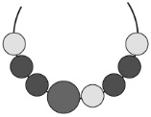  Student places more beads on one side of the large bead than on the other. | Student creates a design on one side of the large bead, then copies the design on the other side without making a mirror image.  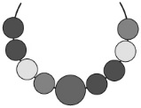
Observations/Documentation
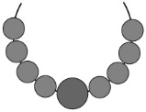  Student makes a symmetrical necklace/bracelet but uses only one colour, making it unclear if symmetry was considered. | 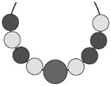  Student places most beads correctly but mixes up the order of a couple of beads. | 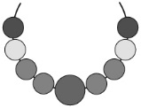  Student makes a symmetrical necklace/bracelet and explains why it is symmetrical with ease.
Observations/Documentation

Big Idea |  |  |  |  | Indicators From Learning Progression
Curriculum Expectations addressed

Student Names
Student understands that a design is symmetrical if it has two parts that match exactly.
(Activities 16–18)

Student can identify 2-D shapes and pictures that have symmetry.
(Activity 16)

Student can find the line of symmetry in pictures/designs by folding, cutting, using a Mira, and/or matching parts.
(Activities 16–18)

Student can complete a symmetrical design with concrete materials (Pattern Blocks).
(Activity 17)

Student can create a symmetrical design (necklace/bracelet) using concrete materials.
(Activity 18)

Student uses math language to explain how he or she knows a design/picture is symmetrical.
(Activities 16–18)

Name: _______________________

 | Not Observed | Sometimes | Consistently
Understands that a design is symmetrical if it has two parts that match exactly.
(Activities 16–18)

Identifies 2-D shapes and pictures that have symmetry.
(Activity 16)

Finds the line of symmetry in pictures/designs by folding, cutting, using a Mira, and/or matching parts.
(Activities 16–18)

Completes a symmetrical design with concrete materials (Pattern Blocks).
(Activity 17)

Creates a symmetrical design (necklace/bracelet) using concrete materials.
(Activity 18)

Uses math language to explain how he or she knows a design/picture is symmetrical.
(Activities 16–18)

Strengths:

Next Steps:

