Comparing Area Behaviours/Strategies
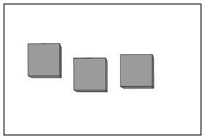  Student leaves gaps or overlaps. | Student lines the squares up along one side of the rectangle but does not consider the full surface area. | Student covers the rectangular surfaces with no gaps or overlaps but has difficulty determining which of two surfaces has the greater area.
Observations/Documentation
Student covers the rectangular surfaces with no gaps or overlaps but has difficulty ordering the surfaces from greatest to least area. | Student correctly orders the rectangular surfaces but has difficulty using measurement language to compare the areas. | Student correctly orders the rectangular surfaces and uses measurement language to compare the areas.
Observations/Documentation

