Measuring with Hand Spans Behaviours/Strategies
Student has difficulty tracing hands. | 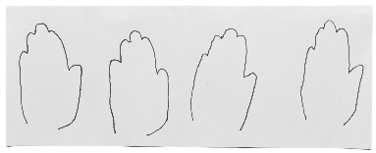  Student leaves gaps or overlaps when tracing hands (hands are not end-to-end or side-to-side). | Student traces hands but has difficulty counting the number of handprints.
Observations/Documentation
Student counts handprints but doesn’t realize that the last number said represents the total. | Student expects a greater count when bigger hands are traced. | Student accurately measures the paper strip using handprints and understands that the smaller the hand, the greater the number of hands needed to fill the paper strip.
Observations/Documentation

