Measuring Length Behaviours/Strategies
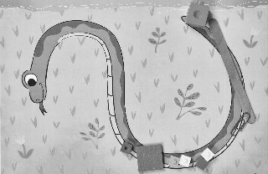  Student uses a random assortment of items/units to measure the snake. | 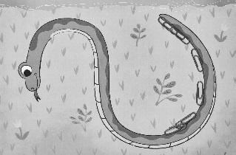  Student places items along the length of the snake but leaves gaps or makes overlaps. | 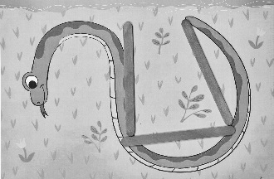  Student chooses an item that doesn’t accommodate the curves of the snake.
Observations/Documentation
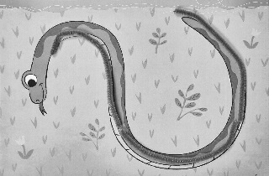  Student chooses an item that accommodates the curves of the snake and makes a good measure. | Student believes that the longer the unit, the higher the count and/or the shorter the unit, the lower the count. | Student realizes that when the unit of measure is longer, fewer items will be needed.
Observations/Documentation

