Estimating and Measuring Area Behaviours/Strategies
Student does not line up the squares side-to-side and leaves gaps or overlaps. | Student lines the squares up along the length of the construction paper but doesn’t consider the full surface of the rectangle. | 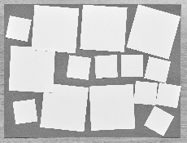  Student uses both large and small squares.
Observations/Documentation
Student struggles with the idea that the smaller the squares, the more are needed to cover the construction paper. | Student counts the squares by 1s to find the total. | Student covers the construction paper with squares of the same size  (tiling the surface), lined  up side-to-side. Student  also understands the inverse  relationship between the size  of the squares and the number  of squares needed to cover  the construction paper.
Observations/Documentation

