**Clock Cards**

**Master 39a**

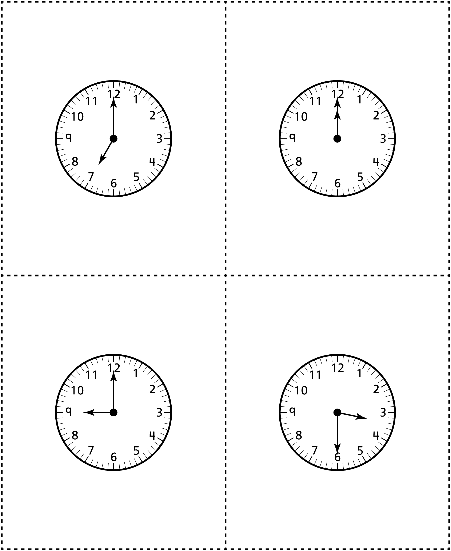



**Clock Cards**

**Master 39b**

