***Hopping On* Game Boards**

**Master 8a**

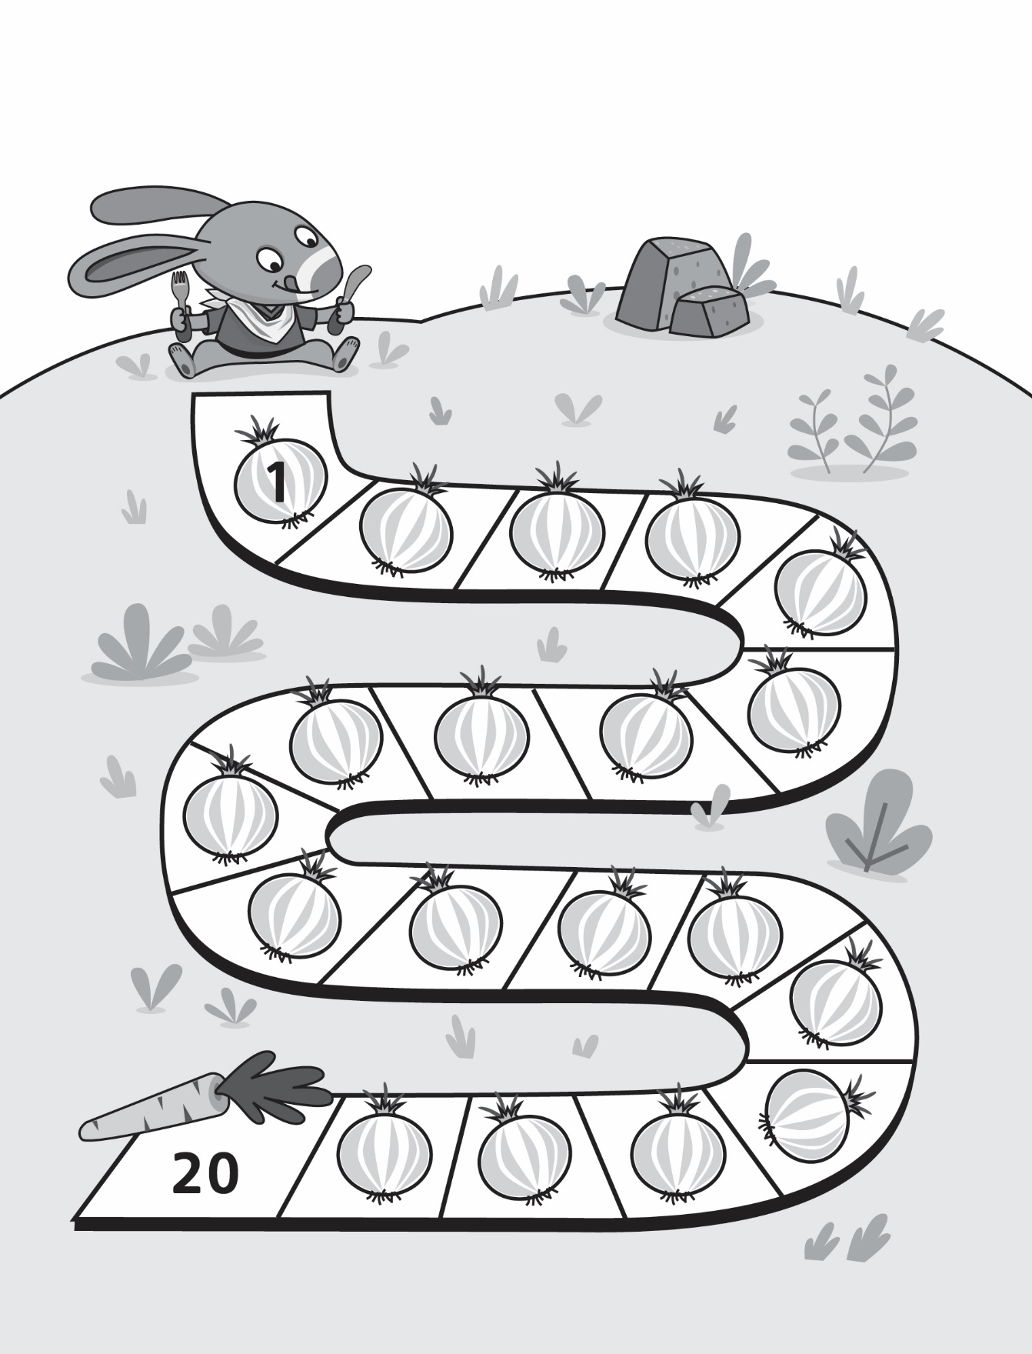

***Hopping On* Game Boards**

**Master 8b**

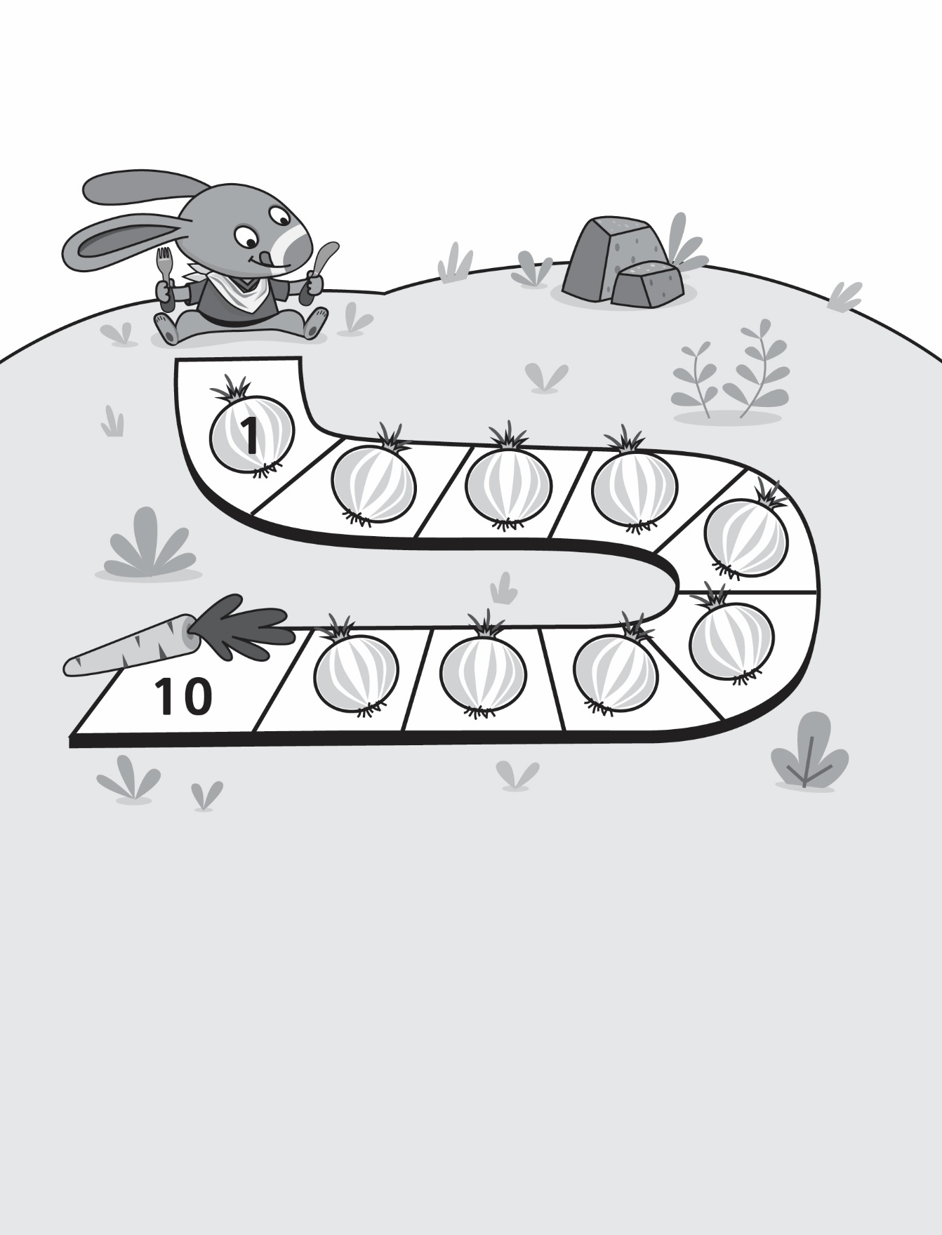

***Hopping On* Game Boards**

**Master 8c**

