Counting On and Counting Back Behaviours/Strategies
Student mixes up the number sequence when counting forward.  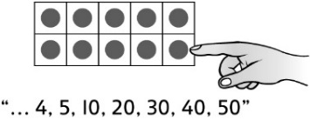 | Student adds or removes counters, then recounts from one to find how many, rather than counting on or counting back. | Student mixes up the number sequence when counting back.  “19, 18, 16, 14, 15”
Observations/Documentation
Student has difficulty keeping track of the number counted on or back (how many have been added or removed, and the numbers in the counting sequence).  “5, 6, 7, 8…  Did I count enough?” | 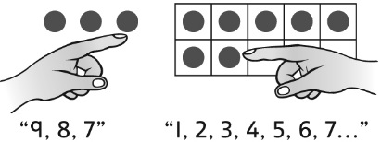  Student counts on or back, then counts from 1 to check. | Student counts on or back with ease.  “20, 19, 18, 17, 16”
Observations/Documentation

Big Idea |  |  |  |  | Indicators From Learning Progression
Curriculum Expectations addressed

Student Names
Student can say the counting numbers in the correct order, both forward and backward.
(Activities 1, 2, 3, 5)
Student can bridge teens when counting forward and backward.
(Activities 2, 3, 5)
Student can count the number of objects in a set using one-to-one correspondence.
(Activities 1, 2, 3, 5)
Student realizes that the last number said tells how many (cardinality).
(Activities 1, 2, 3, 5)
Student realizes that the number of objects stays the same no matter how they are arranged (conservation).
(Activities 1, 2, 5)
Student can count on and back from a given number.
(Activities 1, 2, 3, 5)
Student can print numbers to 10 in words. (Activity 1)
Student can use ordinal numbers to tenth to describe position.
(Activity 4)

Name: _______________________

 | Not Observed | Sometimes | Consistently
Says the counting numbers in the correct order, both forward and backward.
(Activities 1, 2, 3, 5)
Bridges teens when counting forward and backward.
(Activities 2, 3, 5)
Counts the number of objects in a set using one-to-one correspondence.
(Activities 1, 2, 3, 5)
Realizes that the last number said tells how many (cardinality).
(Activities 1, 2, 3, 5)
Realizes that the number of objects stays the same no matter how they are arranged (conservation).
(Activities 1, 2, 5)
Counts on and back from a given number.
(Activities 1, 2, 3, 5)
Prints numbers to 10 in words.
(Activity 1)
Uses ordinal numbers to tenth to describe position.
(Activity 4)

Strengths:

Next Steps:

