**Banana Cards**

**Master 27a**

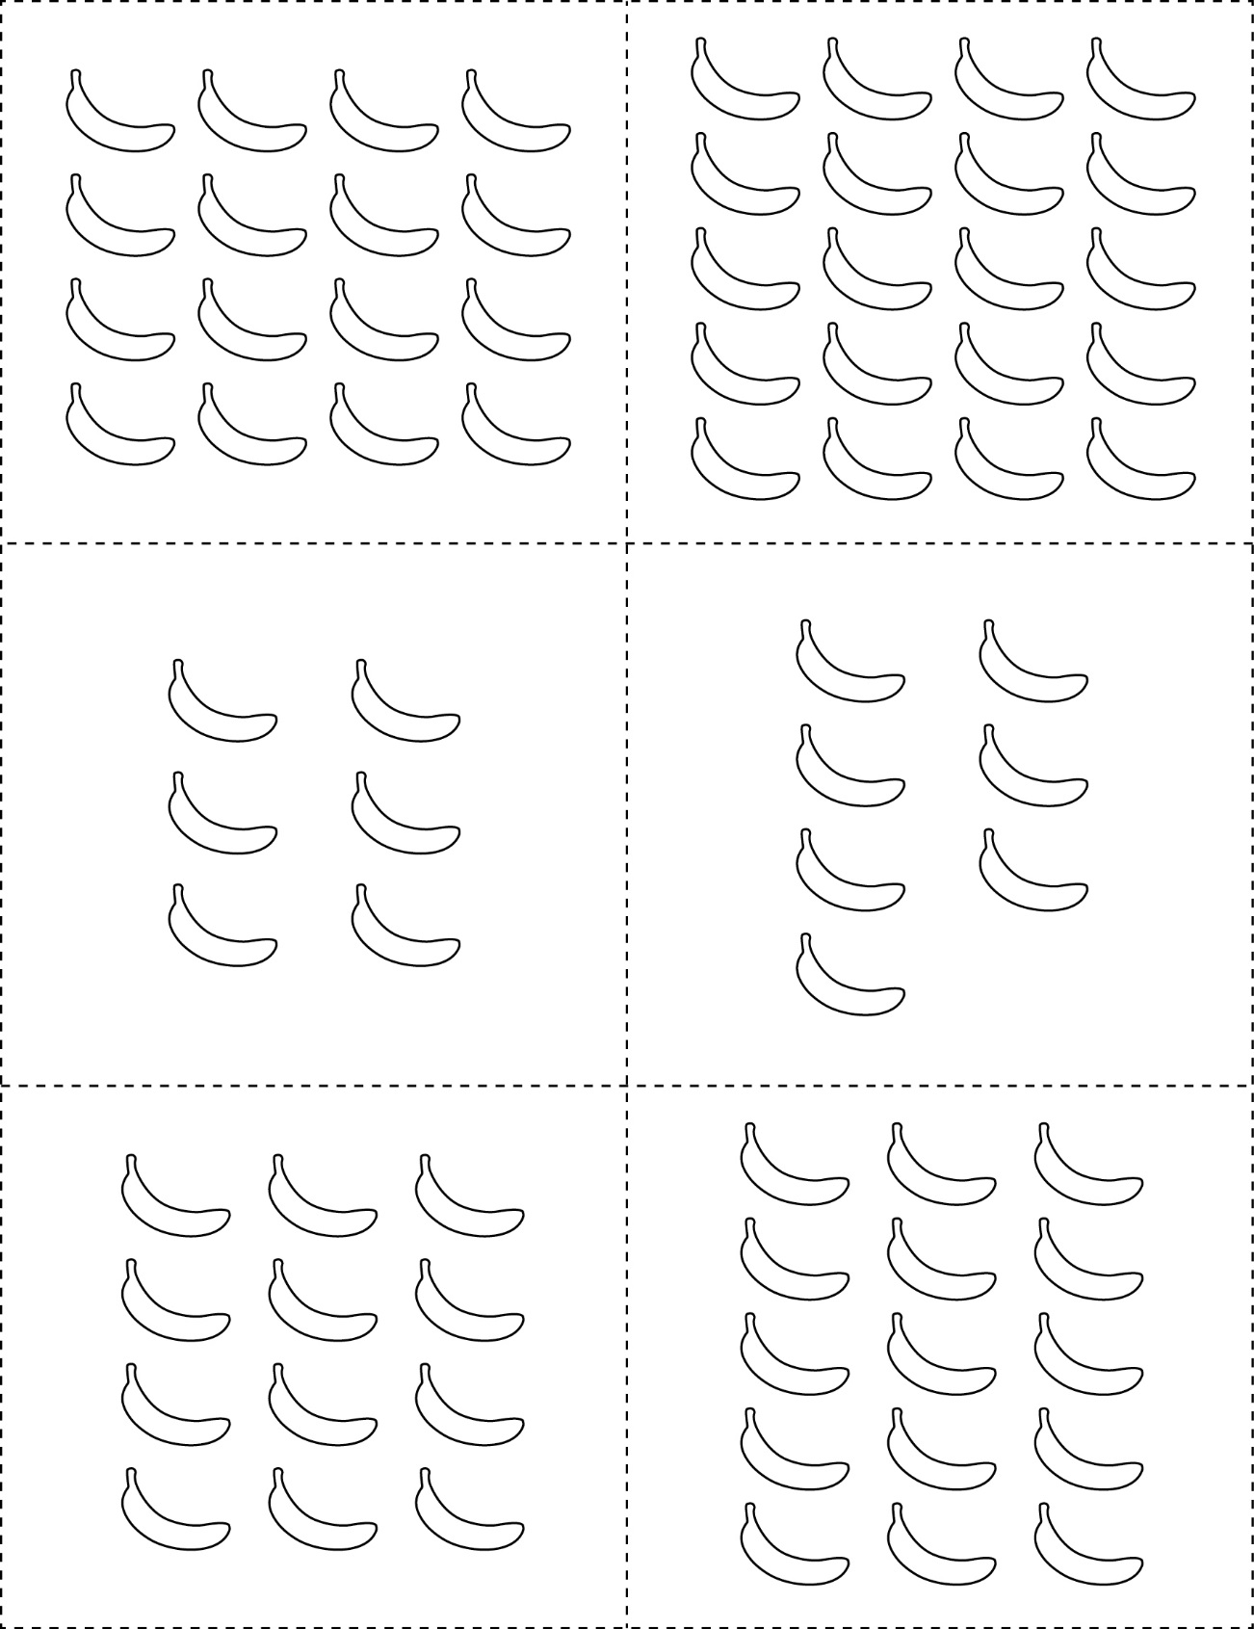



**Banana Cards**

**Master 27b**





**Banana Cards**

**Master 27c**



