Activity Cards
Master 35

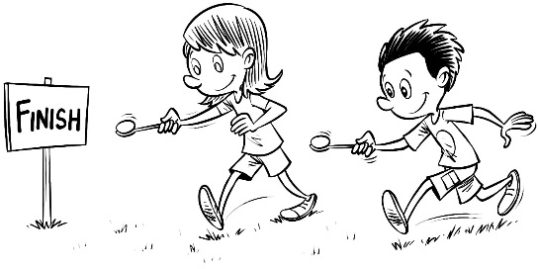  Egg and Spoon Race |  | Egg and Spoon Race
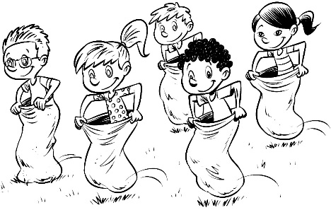  Sack Race |  | Sack Race
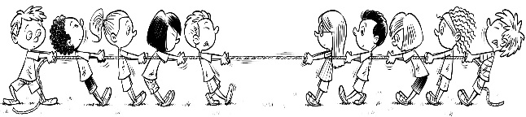  Tug of War |  | Tug of War

