Skip-Counting with Leftovers Behaviours/Strategies
Student does not arrange the counters into groups of the correct size. | Student mixes up or does not know the number to skip-count by. | Student mixes up the numbers in the skip-counting sequence.  “5, 10, 20, 30, 40”
Observations/Documentation
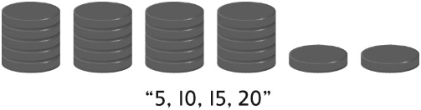  Student skip-counts but does not include the leftovers in the total. | 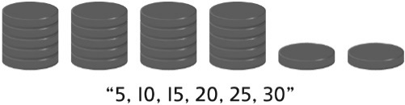  Student continues to skip-count by the same number to count the leftover counters. | 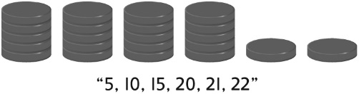  Student sees groups of counters as one unit, fluently skip-counts by the unit, then counts on by 1s to find the total.
Observations/Documentation

