Skip-Counting Behaviours/Strategies
Student mixes up or does not know the number to skip-count by. | Student mixes up the numbers in the skip-counting sequence.  “2, 4, 8, 6, 10, …” | 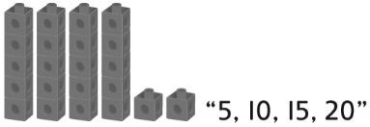  Student skip-counts but does not include the leftovers in the total.
Observations/Documentation
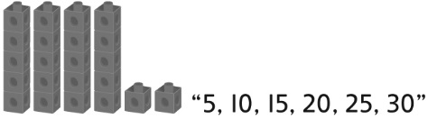  Student continues to skip-count by the same number to count the cubes in the dump truck. | Student skip-counts but doesn’t realize that the total number of cubes when 10-cube towers are made will be the same when 5-cube towers are made. | 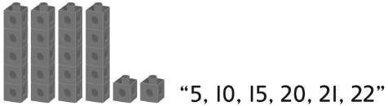  Student sees groups of cubes as one unit, fluently skip-counts by the unit, then counts on by 1s to find the total.
Observations/Documentation

Big Idea |  |  |  |  | Indicators from Learning Progression
Curriculum Expectations addressed

Student Names
Student can relate the skip-counting number to a quantity.
(Activities 13, 14, 16)

Student can skip-count forward by 2s, 5s,
and 10s.
(Activities 13, 14, 16)

Student knows that the last number said when skip-counting tells
how many.
(Activities 13, 14, 16)

Student realizes that the number of objects will be the same whether they are counted by 1s, 2s, 5s, or 10s.
(Activities 13, 14, 16)

Student can skip-count backward by 2s and 5s.
(Activities 15, 16)

Student can count a collection of objects by arranging objects into equal groups, skip-counting by the unit, then counting on by 1s to get the total.
(Activities 14, 16)

Name: _______________________

 | Not Observed | Sometimes | Consistently
Relates the skip-counting number to a quantity.
(Activities 13, 14, 16)
Skip-counts forward by 2s, 5s, and 10s.
(Activities 13, 14, 16)
Knows that the last number said when skip-counting tells how many.
(Activities 13, 14, 16)
Realizes that the number of objects will be the same whether they are counted by 1s, 2s, 5s, or 10s.
(Activities 13, 14, 16)
Skip-counts backward by 2s and 5s.
(Activities 15, 16)
Counts a collection of objects by arranging objects into equal groups, skip-counting by the unit, then counting on by 1s to get
the total.
(Activities 14, 16)

Strengths:

Next Steps:

