Counting Behaviours/Strategies
Student repeatedly counts to confirm (does not trust that the number of counters remains the same when partitioned in different ways). | 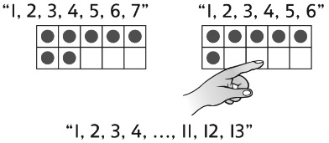  Student counts three times to check the number of counters. | 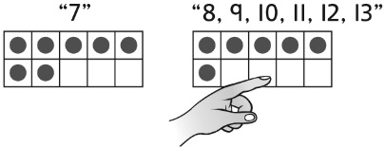  Student counts on from the number of counters in the first ten-frame.
Observations/Documentation
Composing and Decomposing Numbers Behaviours/Strategies
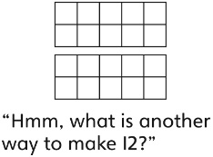  Student removes all counters and starts fresh each time to represent numbers in different ways. | 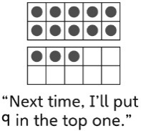  Student moves counters from one ten-frame to the other to represent numbers in different ways. | Student uses patterns and systematically moves counters from one ten-frame to the other to represent numbers in different ways.  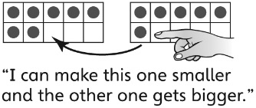
Observations/Documentation

