**Math Problem Cards**

**Master 75a**

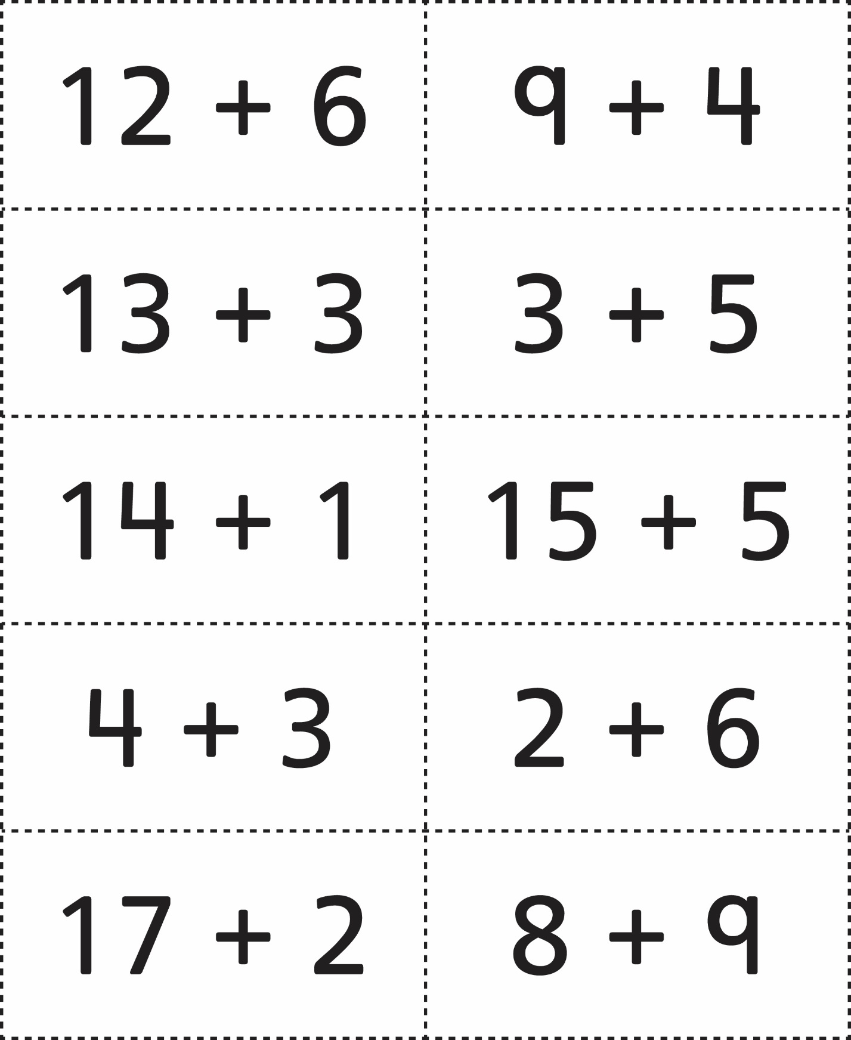



**Math Problem Cards**

**Master 75b**

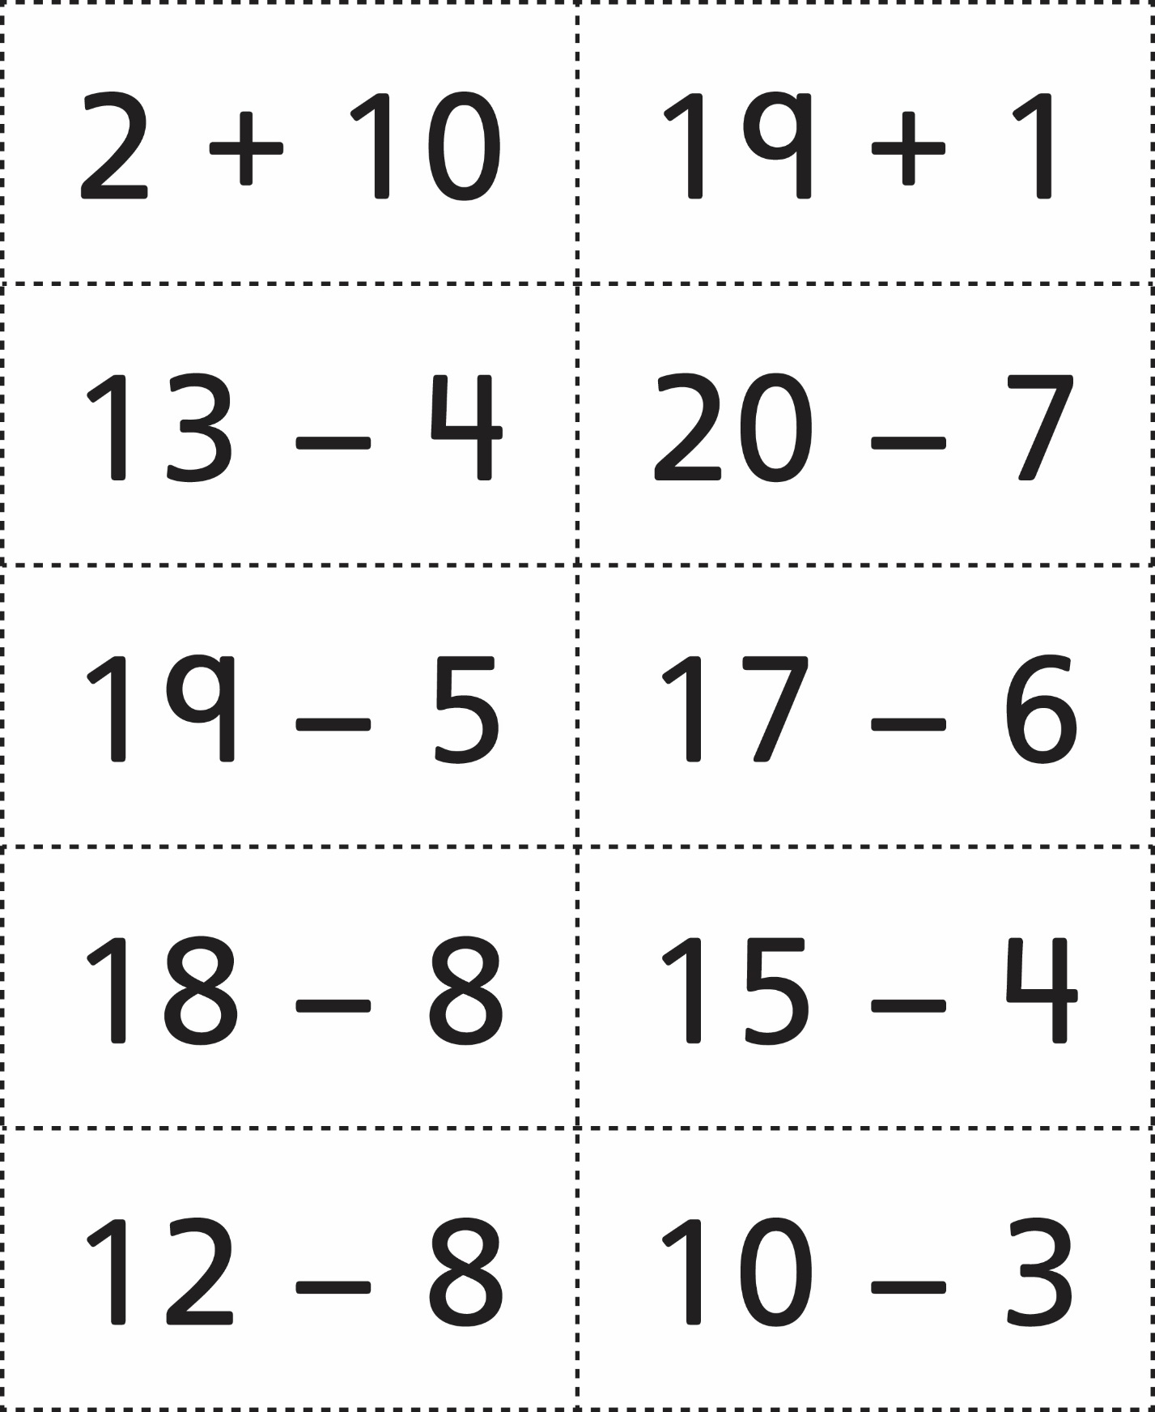



**Math Problem Cards**

**Master 75c**

