**Object Pictures**

**Master 93a**

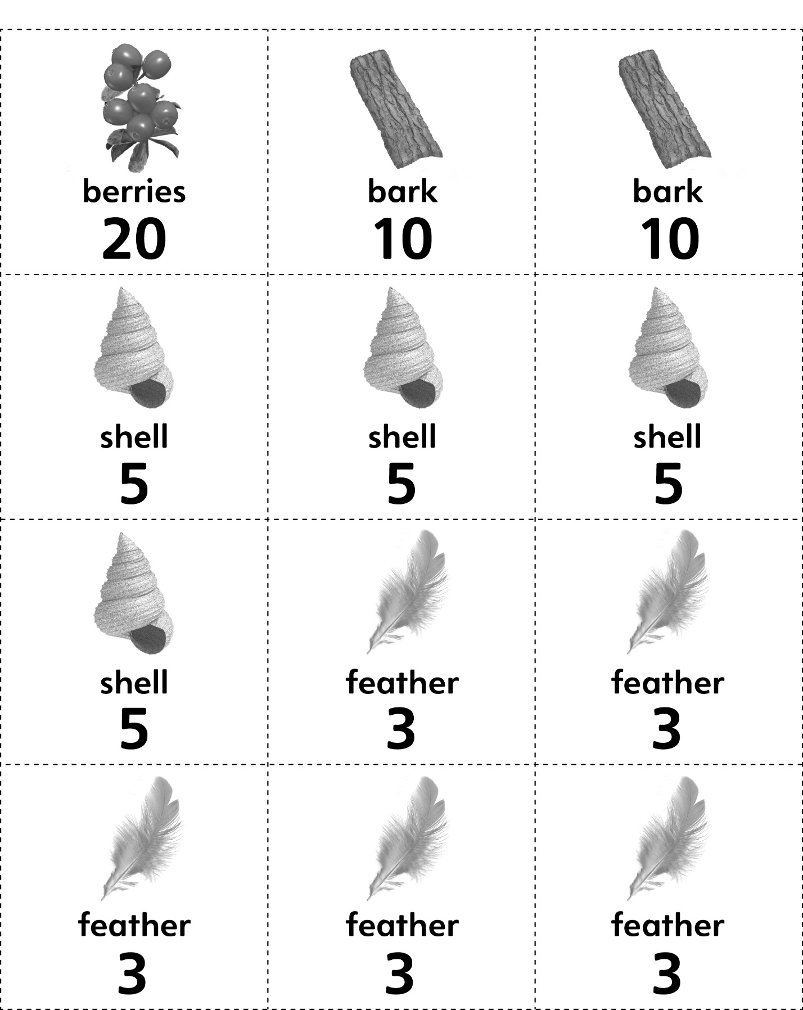



**Object Pictures**

**Master 93b**



