Translating Patterns Behaviours/Strategies
Student has difficulty selecting objects to make another pattern. | Student has difficulty using the given pattern core to make another pattern using different materials. | Student uses the given core in letters to create the pattern.  Pattern Core: ABB  Student’s Pattern: ABBABBABB
Observations/Documentation
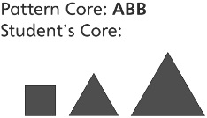  Student uses objects that are not exactly the same to represent the same letter. | 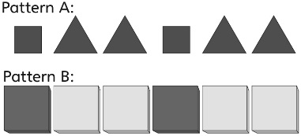  Student thinks that two patterns that look/sound different have a different core. | Student represents a pattern in different ways and understands how the patterns are alike or different.
Observations/Documentation

