Midnight and Snowfall Line Master 1
(Assessment Master)
Name: _____________________________

Identify and Describe Repeating Patterns | Not observed | Sometimes | Consistently
Identifies the repeating unit (core) of a pattern
Distinguishes between repeating and non-repeating sequences
Extends repeating patterns
Describes and represents a pattern in different ways
Identifies missing elements of a pattern
Compare and Create Patterns
Identifies similarities and differences among patterns
Sorts patterns
Creates and describes patterns
Strengths:

Next Steps:

Connecting Home and School Line Master 2–1

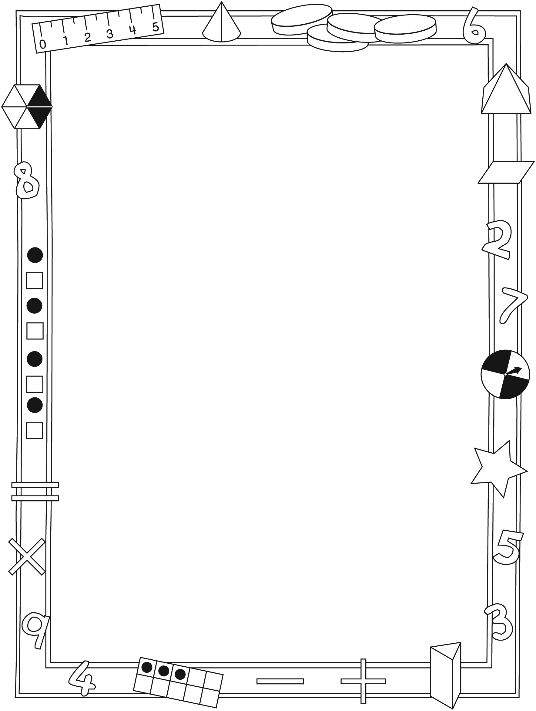

NOTE TO THE TEACHER

You may wish to send families a Midnight and Snowfall letter outlining a familiar activity or two they can do at
home with their children.

Create a letter using this template and select one or two activities from the suggestions on the next page. Simply delete these instructions and cut and paste the activities you have selected, adapting them to fit your needs.

Connecting Home and School Line Master 2–2

Dear Family:

We have been working on Midnight and Snowfall, which engages children in conversations, investigations, and activities that help to develop their understanding of the big math idea that “Patterns can be described mathematically.” Particular focus is placed on identifying, describing, comparing, and creating repeating patterns. Try this activity at home with
your child.
– – – – – – – – – – – – – – – – – – – – – – – – – – – – – – – – – – – – – – – – – –
Reading the Story: As you read the story, enjoy talking about the different animals and whether the fur, skin, scales, or feathers form patterns. Look at the page borders. Point to the shapes and chant them aloud together. Choose actions and/or sounds to match different shapes. For example, on pages 8–9, clap twice for the 2 squares, and then touch your shoulders for the rectangle. Use the book as a starting point for a pattern search in your home. Where can you find patterns? Can you wear clothing with patterns?
– – – – – – – – – – – – – – – – – – – – – – – – – – – – – – – – – – – – – – – – – –
Create a Name Grid Pattern: Your child is bringing home a sheet with 6 × 6 grids. Invite your child to print her/his name over and over with one letter placed in each square. Do the same with your name on another grid. Colour the letters different colours. Talk about how your name grid patterns compare. Do they look the same, or are they different from each other? Use the other sheet of grids to create patterns of other family members’ names, or simply invite your child to colour the grid in a pattern.
– – – – – – – – – – – – – – – – – – – – – – – – – – – – – – – – – – – – – – – – – –
What Is Underneath? Work together to create a pattern using small objects such as buttons (alternating colours), craft sticks (using different positions), coins (using different values), or other items. Describe the pattern. For example, using coins you might read it as nickel, nickel, dime; nickel, nickel, dime; nickel, nickel, dime; … or 5¢, 5¢, 10¢; 5¢, 5¢, 10¢; 5¢, 5¢, 10¢; …. Have your child cover her/his eyes as you place your hand over some of the items in the pattern. Ask: What is now underneath? Reveal to check your child’s response. Your child can then take a turn to cover part of the pattern for you to identify.
– – – – – – – – – – – – – – – – – – – – – – – – – – – – – – – – – – – – – – – – – –
Sincerely,

___________________________

Midnight and Snowfall Line Master 3
Math Mat

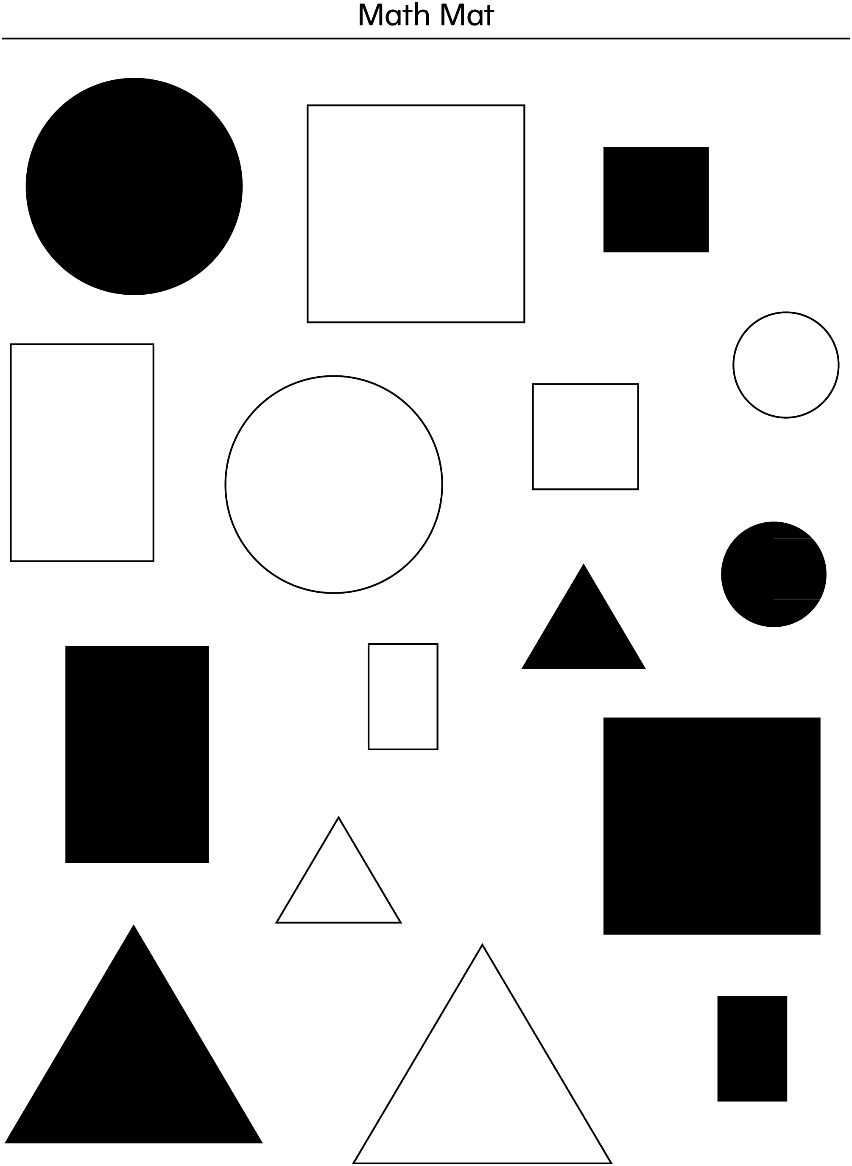

Shape Cutouts Line Master 4–1

Shape Cutouts Line Master 4–2

Shape Cutouts Line Master 4–3

Shape Cutouts Line Master 4–4

Shape Cutouts Line Master 4–5

Pattern Recording Sheet Line Master 5

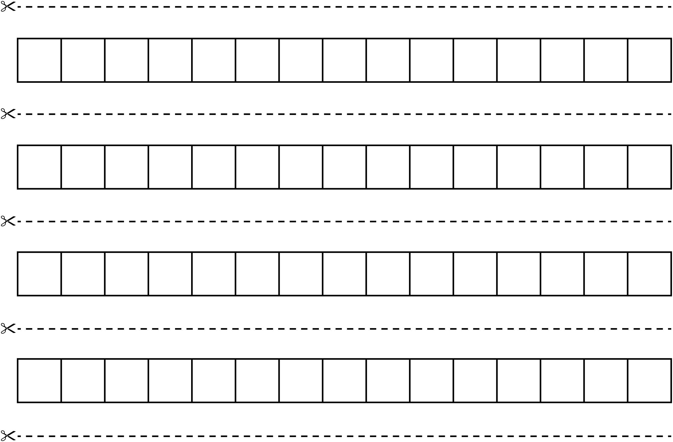

Pattern Starters Line Master 6–1

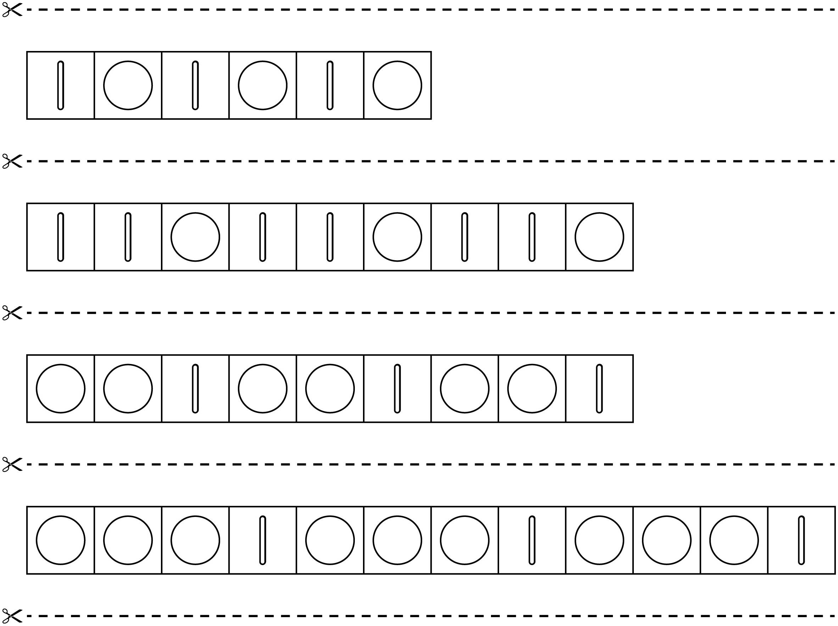

Pattern Starters Line Master 6–2

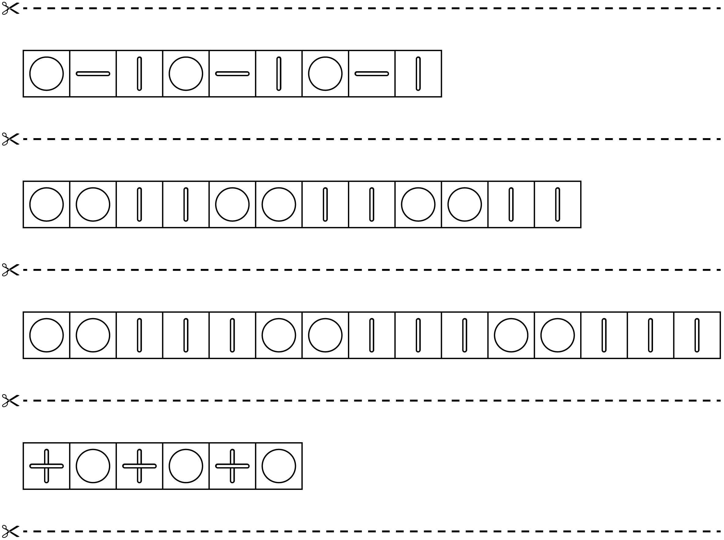

Pattern Challenges Line Master 7

Pattern Challenge  Use 5 blue cubes and 10 red cubes.  What pattern can you make?  Record your pattern. | Pattern Challenge  Use 6 green cubes and 18 yellow cubes.  What pattern can you make?  Record your pattern.
Pattern Challenge  Use 8 orange cubes and 12 white cubes.  What pattern can you make?  Record your pattern. | Pattern Challenge  Use 5 blue cubes, 5 yellow cubes, and 10 red cubes.  What pattern can you make?  Record your pattern.
Pattern Challenge  Use 6 black cubes and 12 white cubes.  What pattern can you make?  Record your pattern. | Pattern Challenge  Use 4 blue cubes, 8 orange cubes, and 12 yellow cubes.  What pattern can you make?  Record your pattern.

Pattern Problems Line Master 8–1

– – – – – – – – – – – – – – – – – – – – – – – – – – – – – – – – – – – – – – – – – – – – – – – – – – – – – – – – – – – –
What is missing in this pattern? Draw the shapes.

– – – – – – – – – – – – – – – – – – – – – – – – – – – – – – – – – – – – – – – – – – – – – – – – – – – – – – – – – – – –
What is missing in this pattern? Draw the shapes.

– – – – – – – – – – – – – – – – – – – – – – – – – – – – – – – – – – – – – – – – – – – – – – – – – – – – – – – – – – – –
What is missing in this pattern? Draw the shapes.

– – – – – – – – – – – – – – – – – – – – – – – – – – – – – – – – – – – – – – – – – – – – – – – – – – – – – – – – – – – –

Pattern Problems Line Master 8–2

– – – – – – – – – – – – – – – – – – – – – – – – – – – – – – – – – – – – – – – – – – – – – – – – – – – – – – – – – – – –
What is next? Draw the shape.

– – – – – – – – – – – – – – – – – – – – – – – – – – – – – – – – – – – – – – – – – – – – – – – – – – – – – – – – – – – –
What is next? Draw the shape.

– – – – – – – – – – – – – – – – – – – – – – – – – – – – – – – – – – – – – – – – – – – – – – – – – – – – – – – – – – – –
What is next? Draw the shape.

– – – – – – – – – – – – – – – – – – – – – – – – – – – – – – – – – – – – – – – – – – – – – – – – – – – – – – – – – – – –

