**Nutty and Wolfy** **Line Master 1** (Assessment Master)

**Name:** _____________________________

|  |  |  |  |
| --- | --- | --- | --- |
| **Equality and Inequality** | **Not observed** | **Sometimes** | **Consistently** |
| Recognizes equal and unequal sets |  |  |  |
| Models and describes equality and inequality |  |  |  |
| Makes unequal sets equal by adding, subtracting, or rearranging |  |  |  |
| Recognizes and understands the  = symbol |  |  |  |
| **Compare Quantities to 20** |  |  |  |
| Compares groups or sets using the terms *more, fewer, equal to/the  same as* |  |  |  |
| Creates a set that is more than, less than, or equal to a given set |  |  |  |

**Strengths:**

**Next Steps:**

**Connecting Home and School Line Master 2–1**

**NOTE TO THE TEACHER**

You may wish to send families a ***Nutty and Wolfy*** letter outlining a familiar activity or two they can do at home with their children.

Create a letter using this template and select one or two activities from the suggestions on the next page. Simply **delete these instructions and cut and paste the activities you have selected**, adapting them to fit your needs.

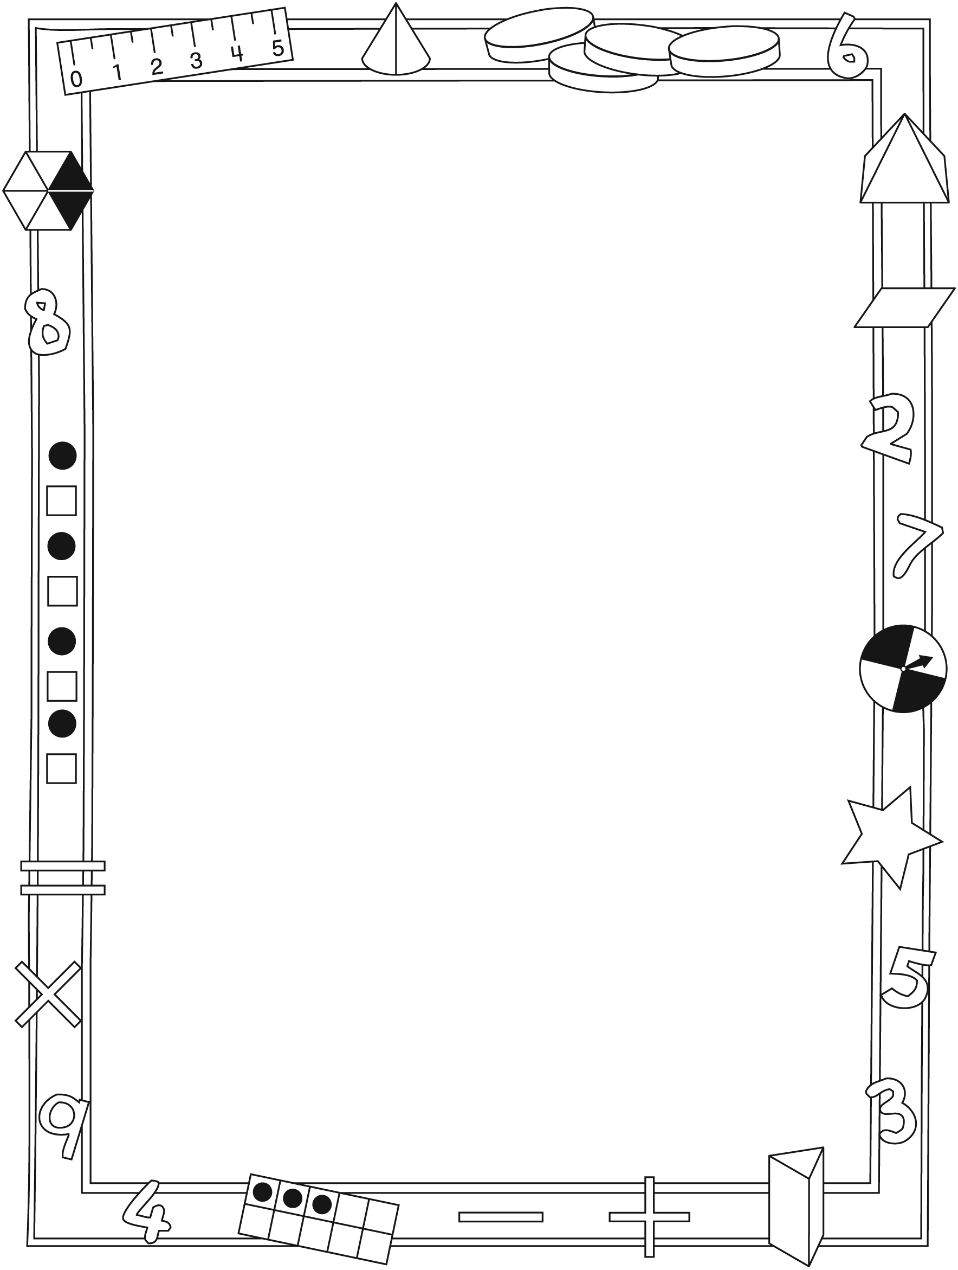

**Connecting Home and School Line Master 2–2**

Dear Family:

We have been working on ***Nutty and Wolfy***, which focuses on modelling and describing equality and inequality, as well as comparing quantities. Try this activity at home with your child.

✂ – – – – – – – – – – – – – – – – – – – – – – – – – – – – – – – – – – – – – – – – – –

**Reading the Story:** As you read, count and talk about the acorns in the baskets. Compare the numbers of acorns in the baskets (more, fewer, the same). What happens to the yoke when there are more acorns in one basket than in the other basket? (it tilts) When the same number is in both baskets? (it lies flat) After reading, find all the pictures that show equal and then not equal sets. You can use 20 small objects (same shape and mass) and the mat on the inside back cover of the book to retell the story.

✂ – – – – – – – – – – – – – – – – – – – – – – – – – – – – – – – – – – – – – – – – – –

**Balance It!** Use 20 small objects and the Math Mat on the inside back cover of the book. Place a set of objects in one basket and ask your child to balance the baskets—to place the same number of objects in the other basket. Ask your child how he/she knows the same number of objects is on both sides (match, count). Switch roles.

✂ – – – – – – – – – – – – – – – – – – – – – – – – – – – – – – – – – – – – – – – – – –

**Make Them Equal!** Use up to 40 small objects and the Math Mat on the inside back cover of the book. Each player places some objects in one of the baskets. Compare the sets. If the sets are equal, remove the objects and start again. If they are not equal, determine which set has more and which set has less. Work together to make the same number of objects in each set (by adding to one set, subtracting from one set, or taking from one set and placing them in the other set). Once you agree the sets are equal, remove the objects and start again.

✂ – – – – – – – – – – – – – – – – – – – – – – – – – – – – – – – – – – – – – – – – – –

Sincerely,

___________________________

***Nutty and Wolfy* Math Mat Line Master 3**

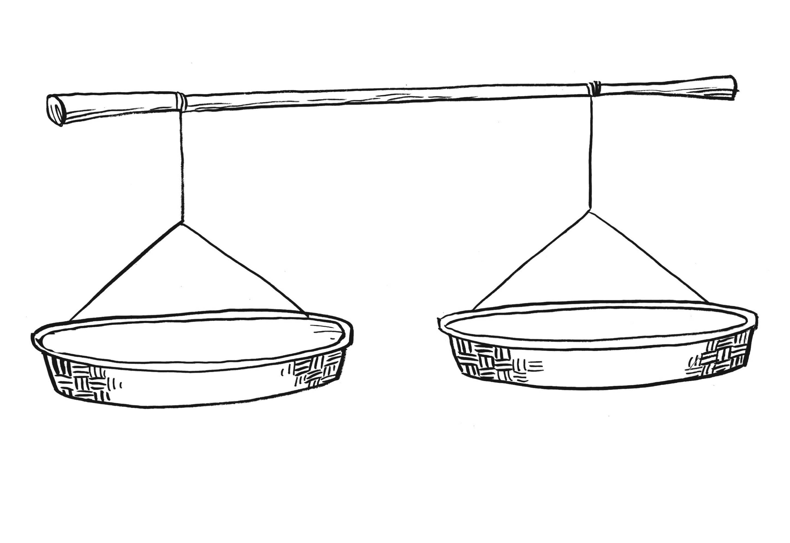

**Balance Scale Line Master 4**

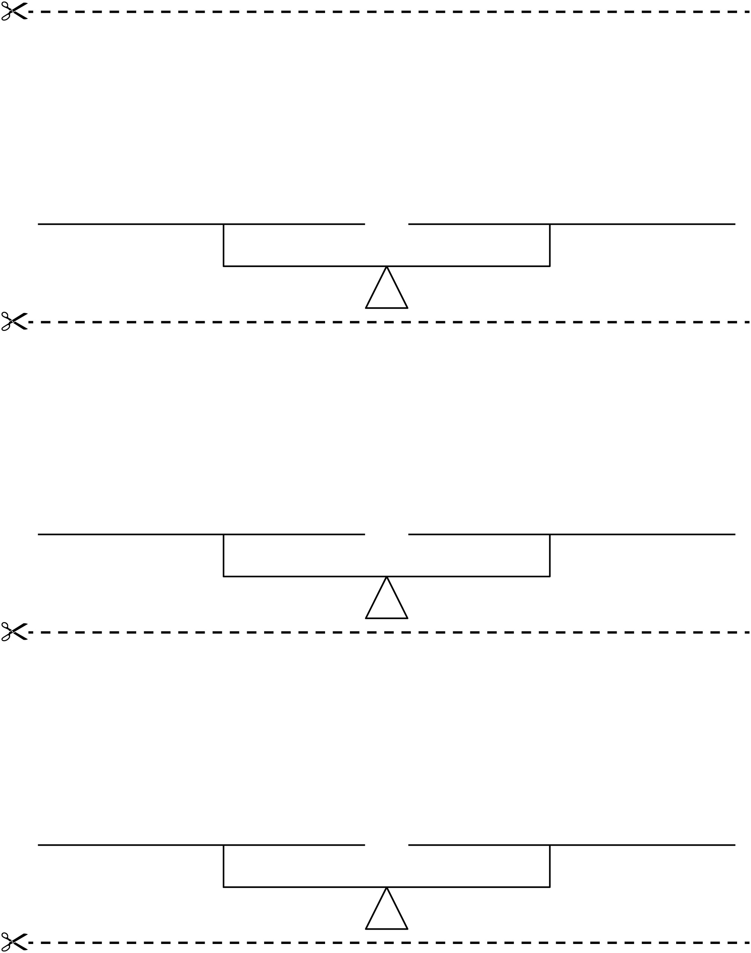

**Make It Balance Line Master 5**

I can make different combinations that equal _______. **Name:** _____________________________

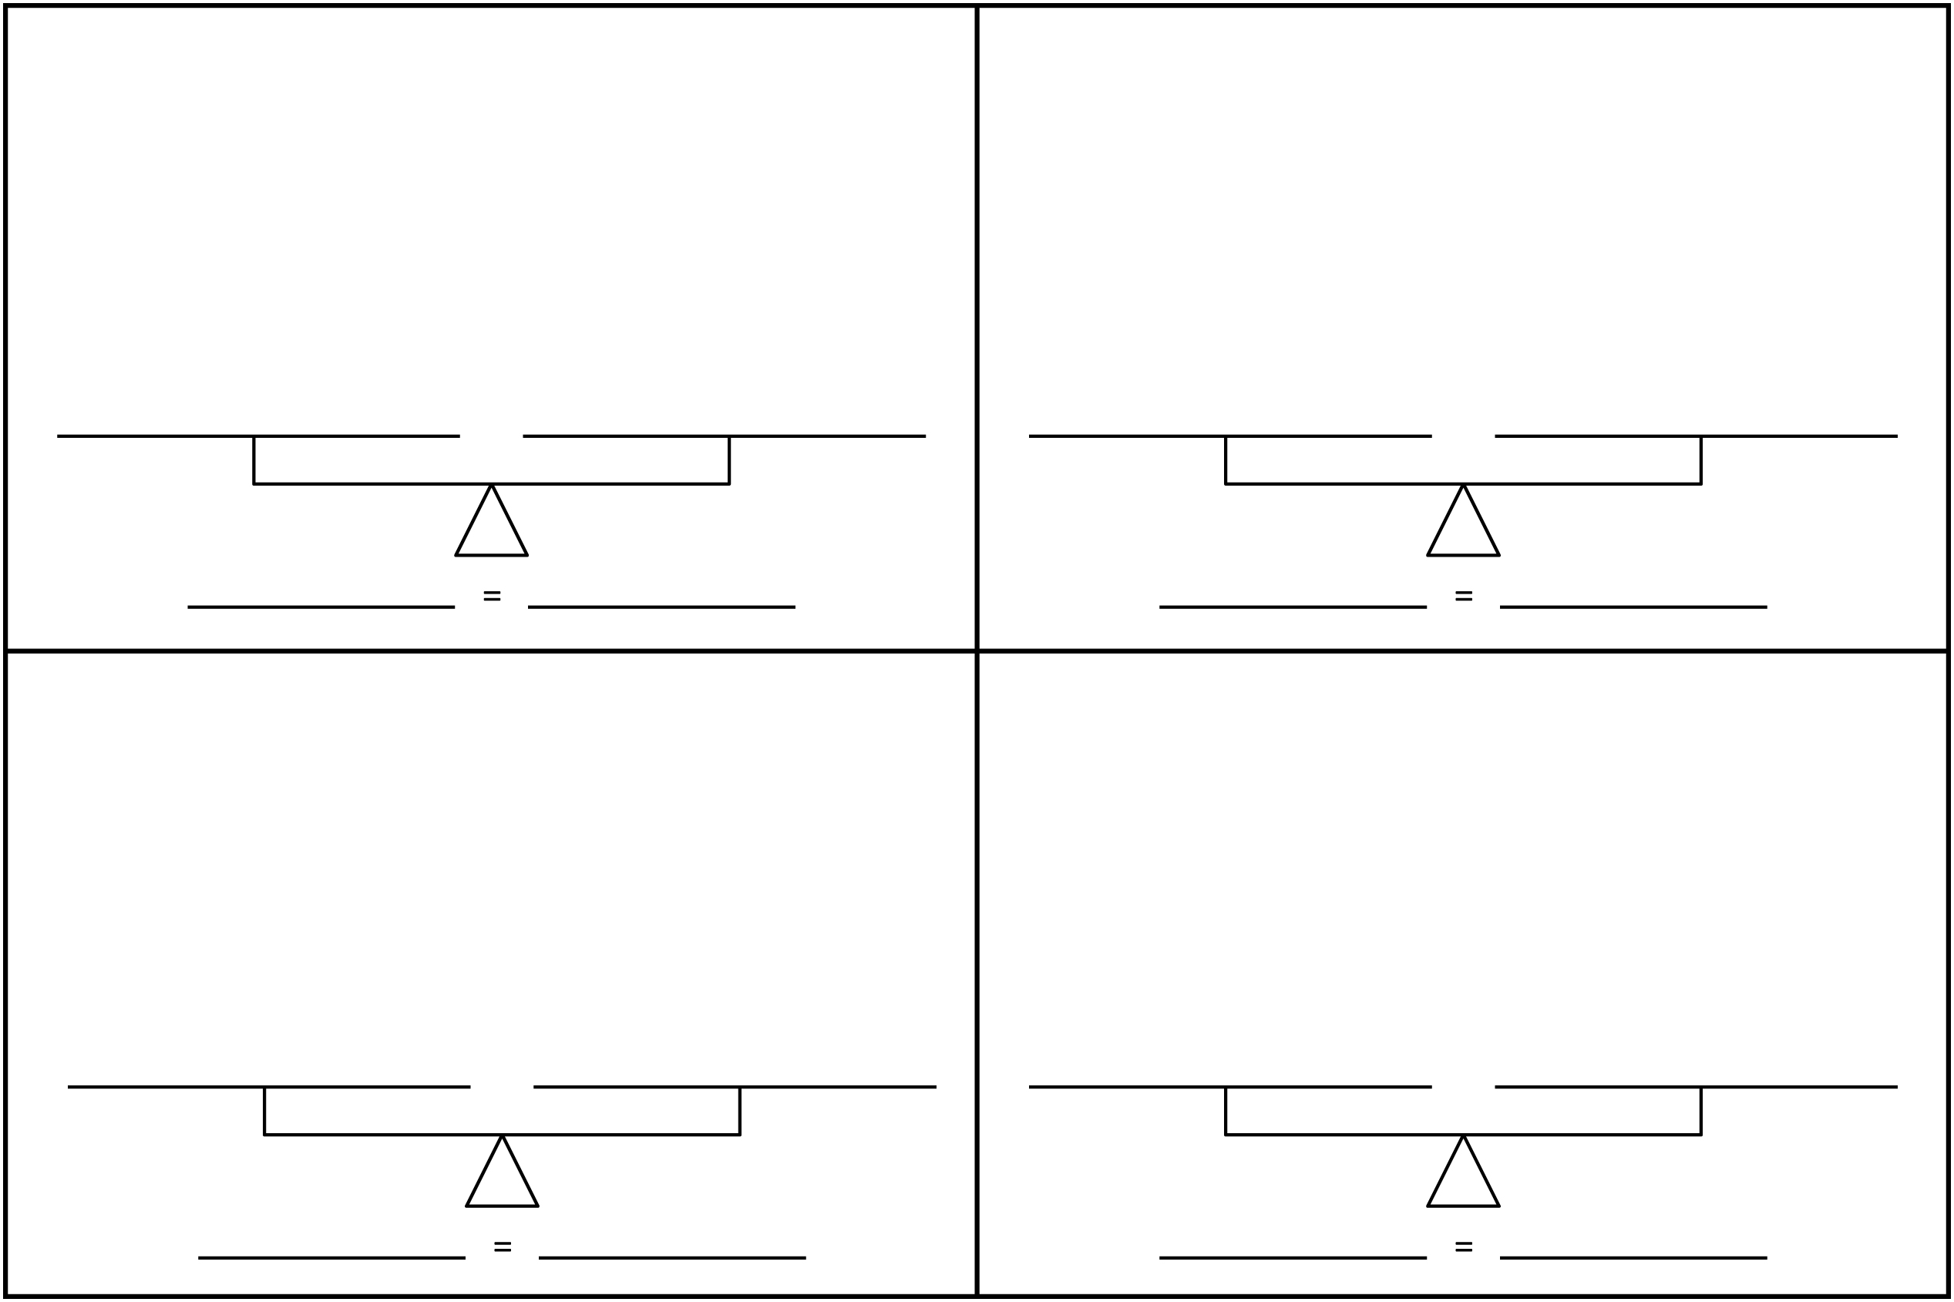

**Make Equal Sets Line Master 6**

**Name:** _____________________________

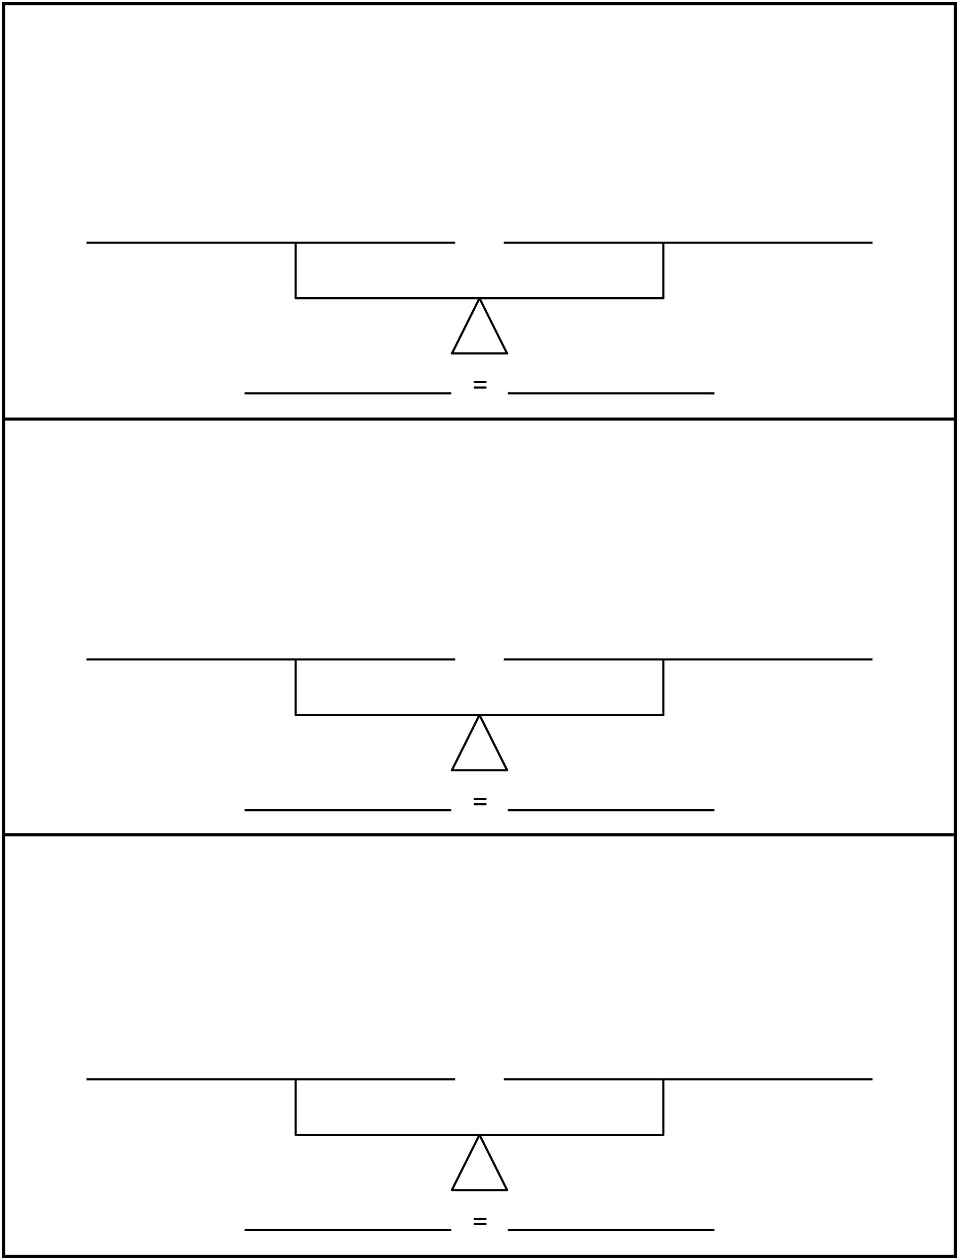

**Ten-Frames Line Master 7**

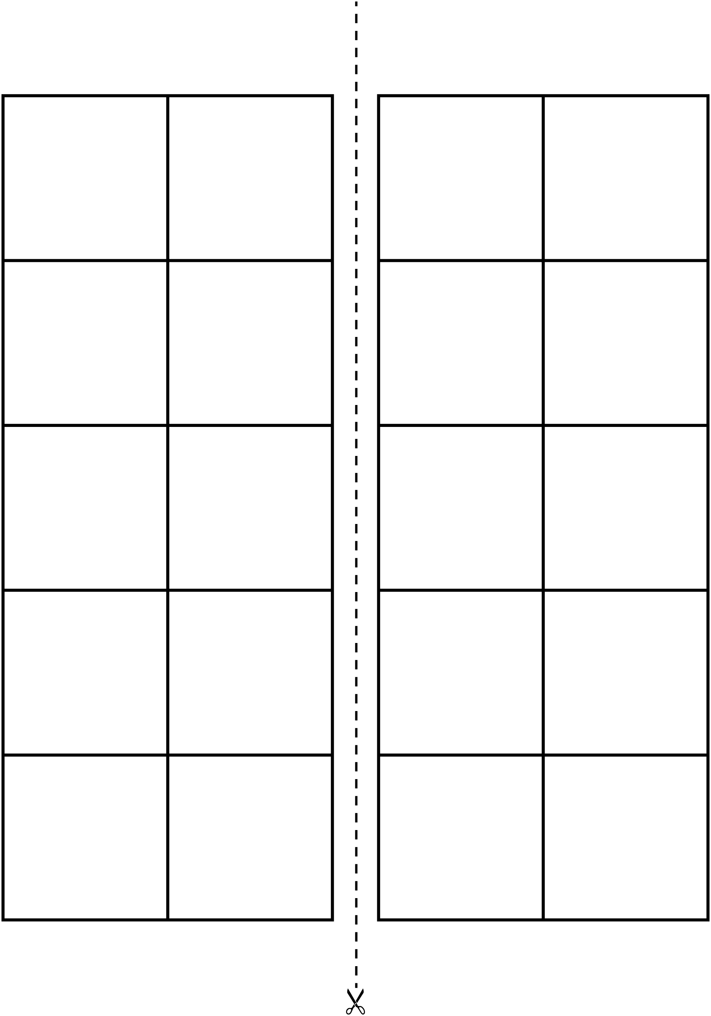

**Are They Equal? Line Master 8**

|  |  |  |
| --- | --- | --- |
| Name:___________________________ | Name:___________________________ | **Are They Equal?** |
|  |  | **Yes**  **No** |
|  |  | **Yes**  **No** |
|  |  | **Yes**  **No** |
|  |  | **Yes**  **No** |
|  |  | **Yes**  **No** |
|  |  | **Yes**  **No** |

**Path to the Chicken House Gameboard Line Master 9**

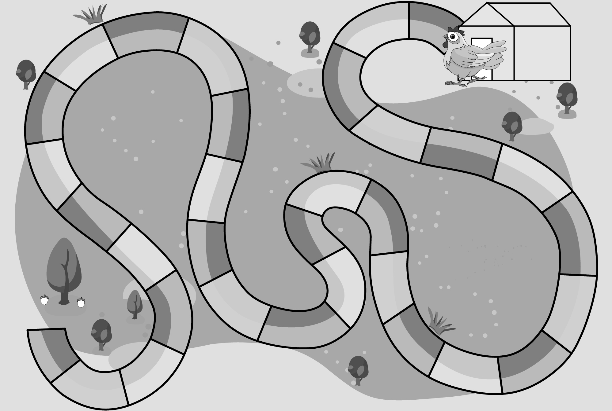

**Statement Cards Line Master 10–1**

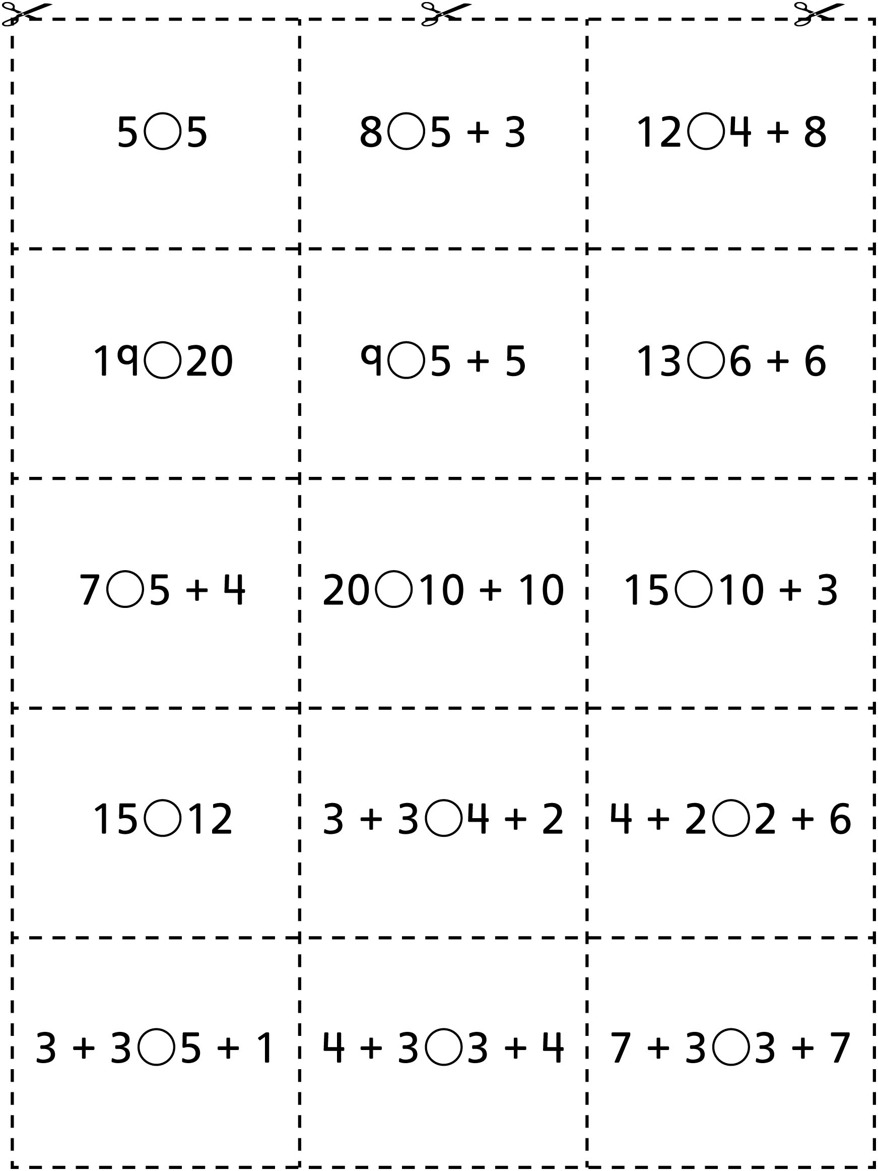

**Statement Cards Line Master 10–2**

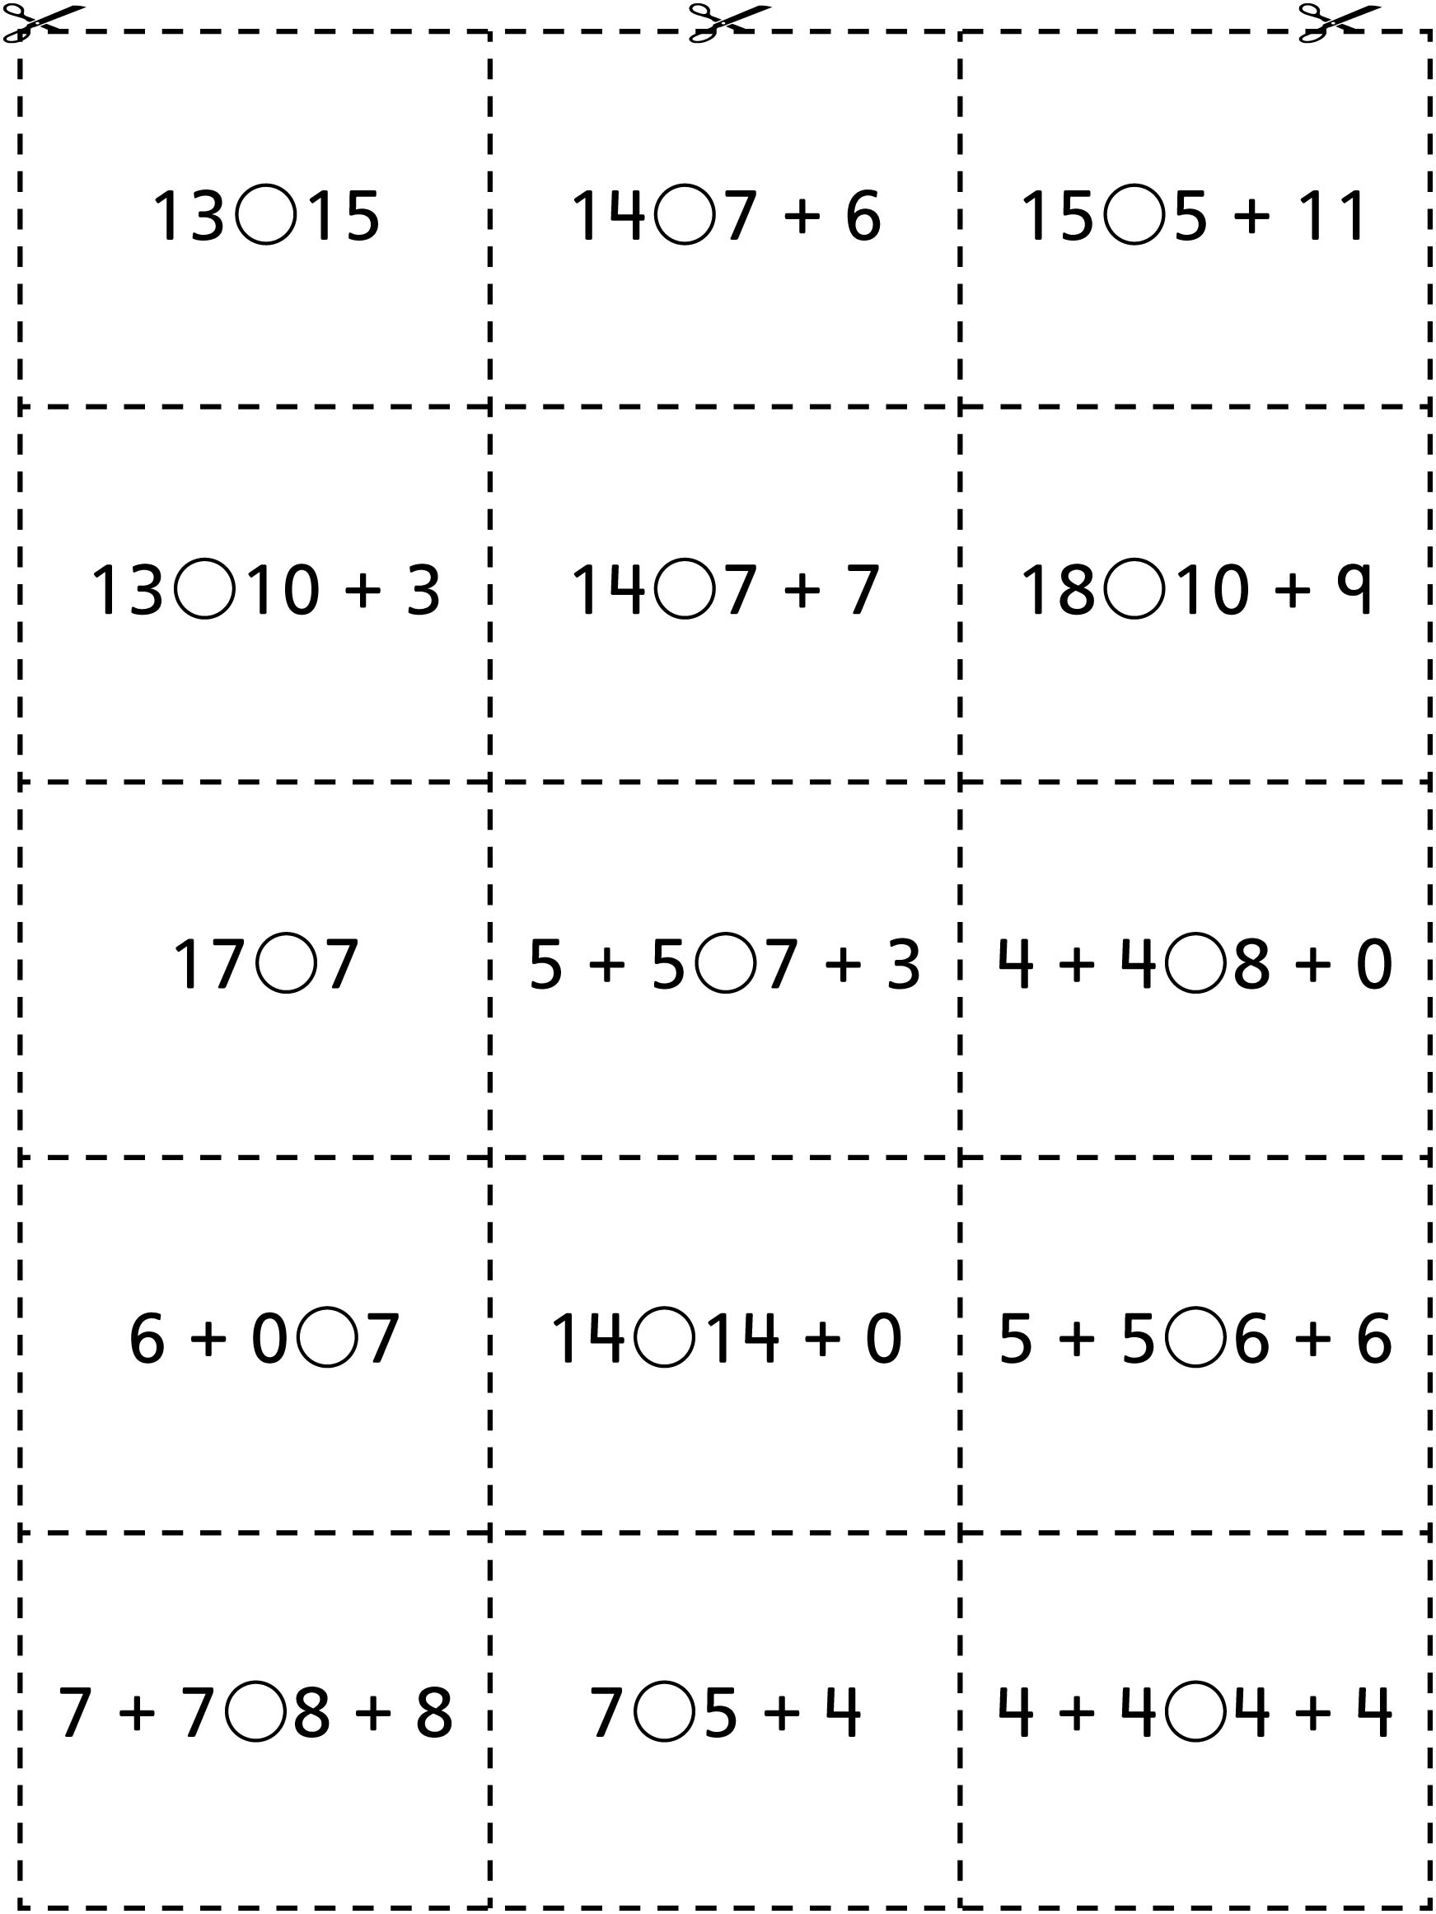

**My Yoke Book Line Master 11–1**



|  |  |
| --- | --- |
| **My Yoke Book**  **by ______________________________________** |  |

**My Yoke Book Line Master 11–2**



|  |  |
| --- | --- |
|  |  |

**Make True Statements Line Master 12**

✂ – – – – – – – – – – – – – – – – – – – – – – – – – – – – – – – – – – – – – – – – – –

____________ is equal to _______________________________________

✂ – – – – – – – – – – – – – – – – – – – – – – – – – – – – – – – – – – – – – – – – – –

____________ is not equal to _______________________________________

✂ – – – – – – – – – – – – – – – – – – – – – – – – – – – – – – – – – – – – – – – – – –

____________ is more than _______________________________________

✂ – – – – – – – – – – – – – – – – – – – – – – – – – – – – – – – – – – – – – – – – – –

____________ is less than _______________________________________

✂ – – – – – – – – – – – – – – – – – – – – – – – – – – – – – – – – – – – – – – – – – –

____________ is the same as _______________________________________

✂ – – – – – – – – – – – – – – – – – – – – – – – – – – – – – – – – – – – – – – – – – –