Canada’s Oldest Sport Line Master 1
(Assessment Master)
Name: _____________________________

Add and subtract to 20 | Not observed | Sometimes | Consistently
Uses a variety of strategies to add and subtract
Uses +, –, =, to symbolize addition and subtraction
Adds and subtracts to 20
Compare and order quantities to 20
Compares quantities by matching or counting to determine more/less or equal quantities
Determines how many more/less one quantity is compared to another
Orders three or more quantities to
20 using sets
Strengths:

Next Steps:

Connecting Home and School Line Master 2–1

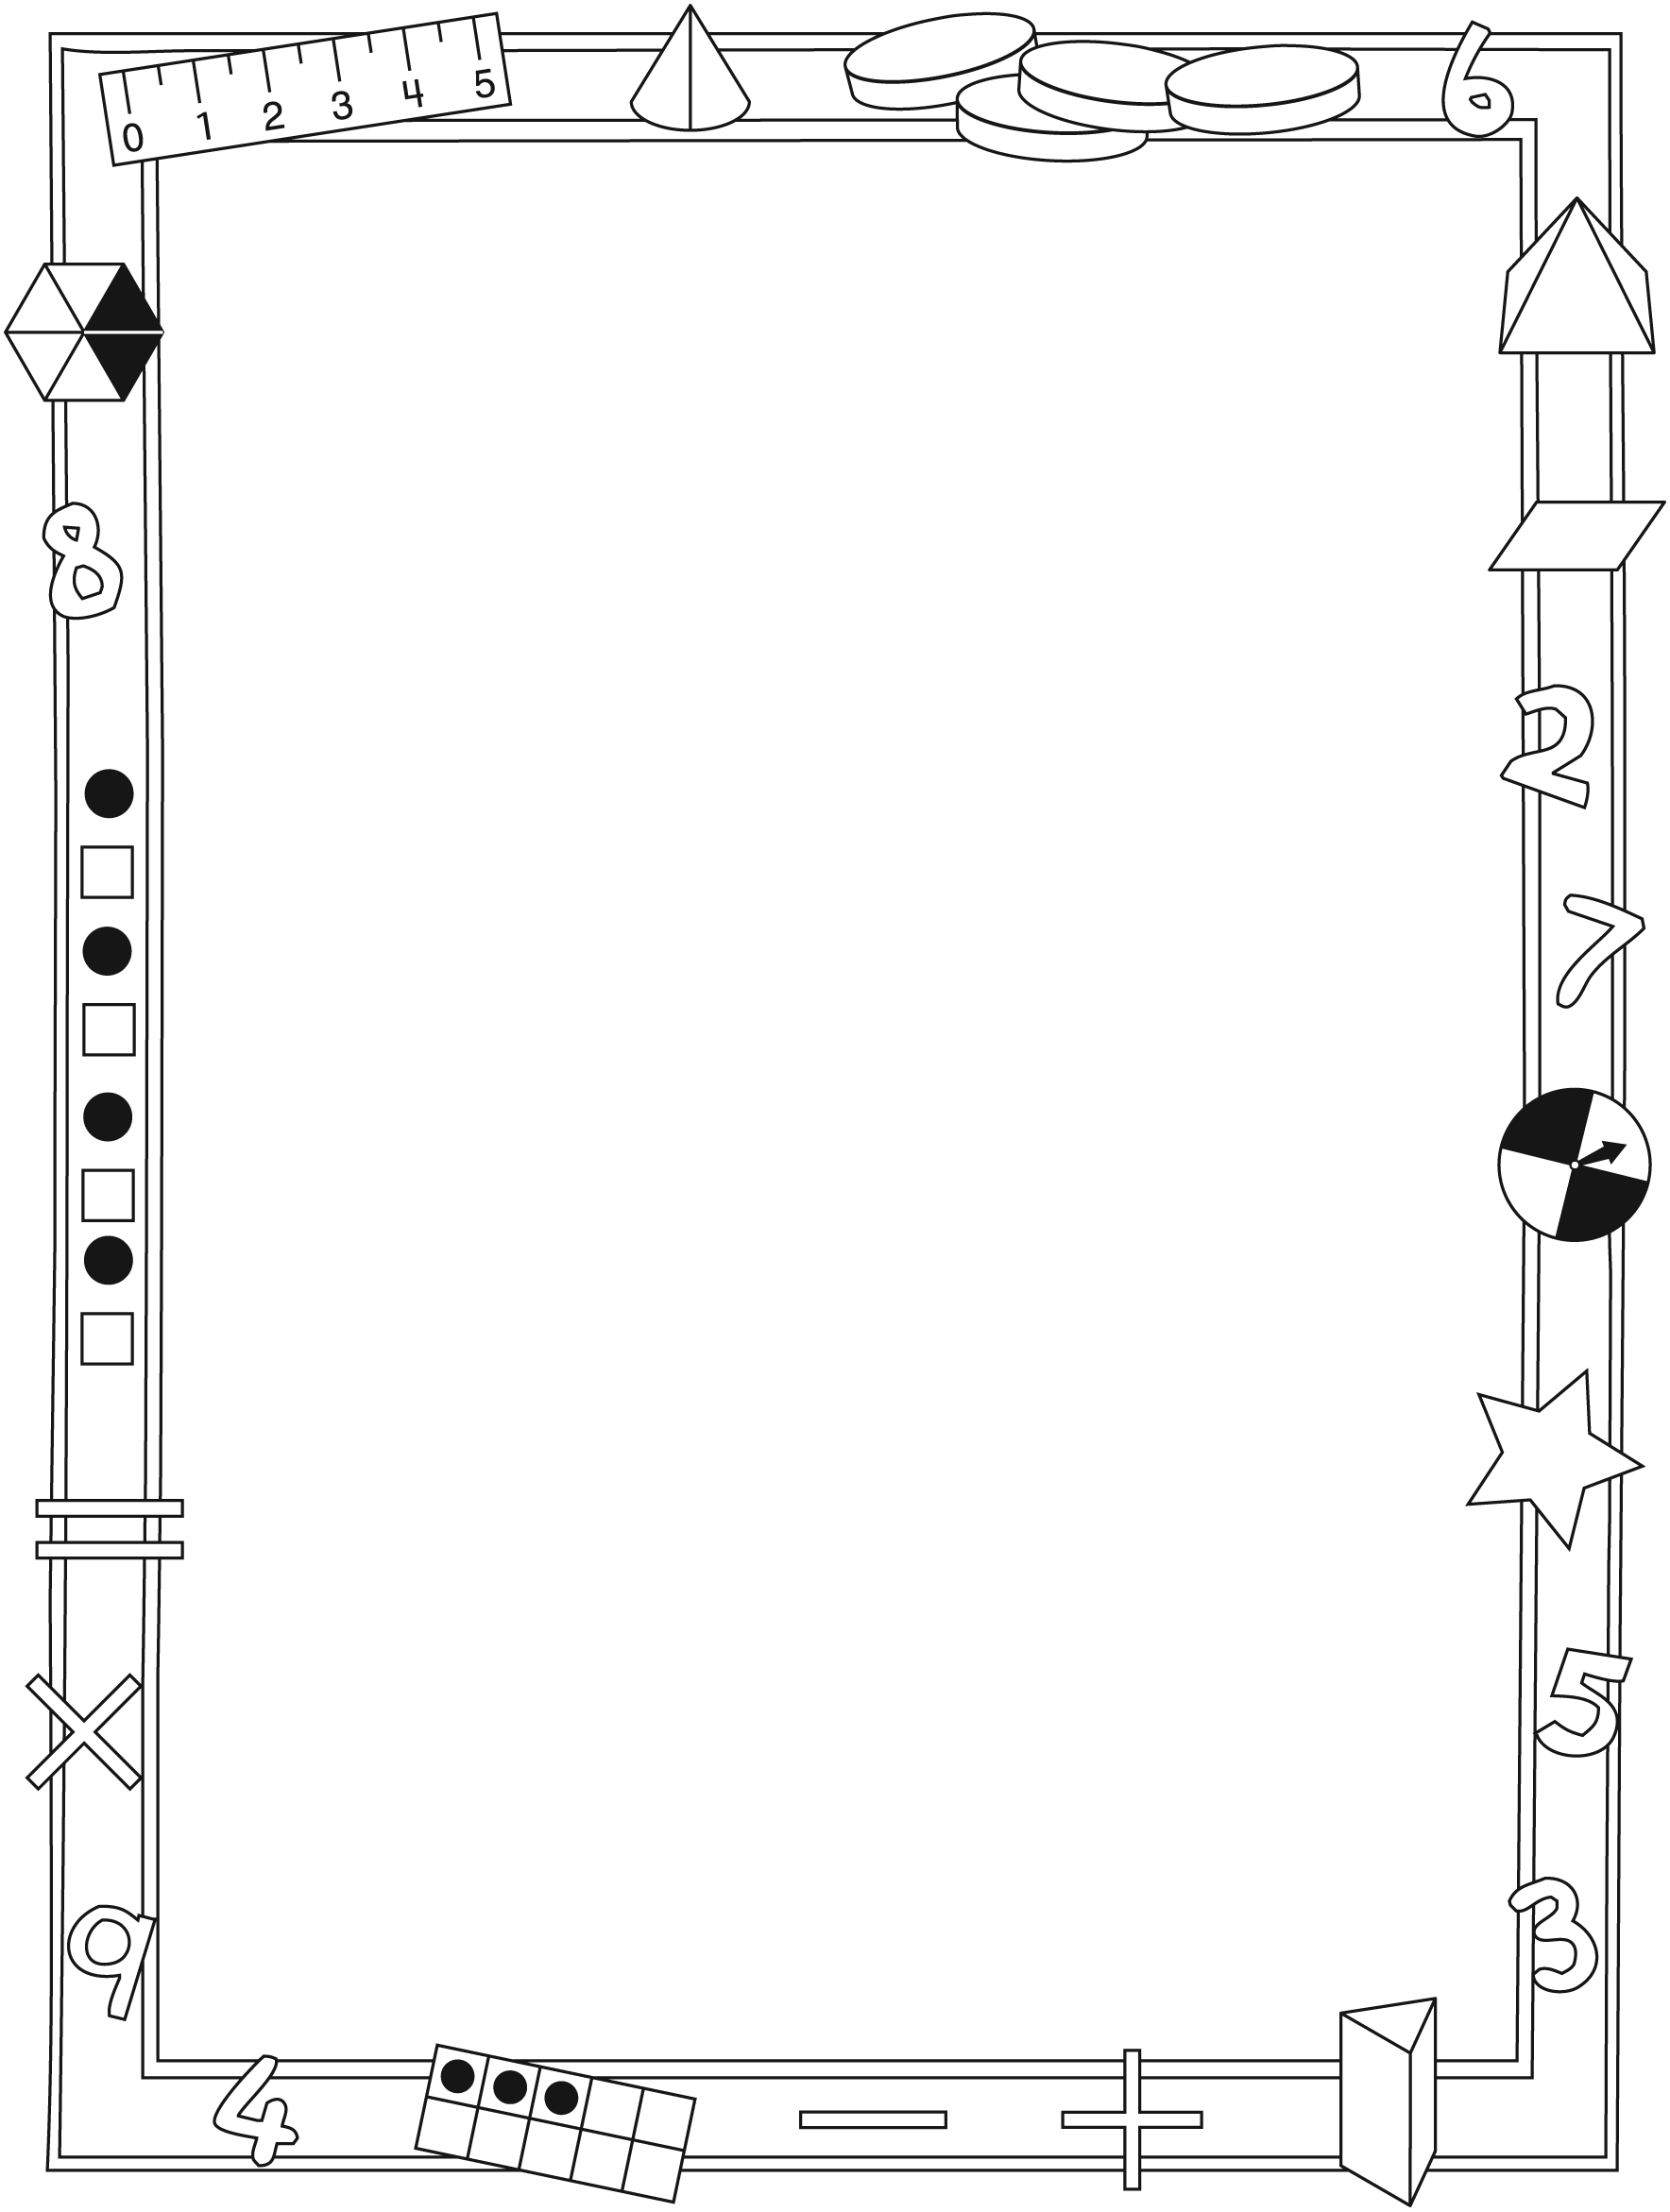

NOTE TO THE TEACHER

You may wish to send families a Canada’s Oldest Sport letter outlining a familiar activity or two they can do at home with their children.

Create a letter using this template and select one or two activities from the suggestions on the next page. Simply delete these instructions and cut and paste the activities you have selected, adapting them to fit your needs.

Connecting Home and School Line Master 2–2

Dear Family:

We have been working on Canada’s Oldest Sport!, which focuses on Add and Subtract to 20 and Compare and Order Sets to 20. Try this activity at home with your child.

– – – – – – – – – – – – – – – – – – – – – – – – – – – – – – – – – – – – – – – – – –
Reading the Story: As you read the story, enjoy counting the fans and players on various pages. What are they doing? What are they wearing? After you read, use simple objects such as buttons or bread tags and use the mat on the inside back cover to re-create the story or to play your own game.
– – – – – – – – – – – – – – – – – – – – – – – – – – – – – – – – – – – – – – – – – –
Comparing Coins: Collect an assortment of coins (nickels, dimes, quarters, loonies, toonies) and put them in a bag or box. Have each player pull out
5 coins, without looking, and order them from least value to greatest value. Then compare coins with the other player’s coins. The player whose coin has the greatest value wins a point. The player whose coin has the least value wins a point. Ties give each player a point. Play for several rounds and then see who has the most points.
– – – – – – – – – – – – – – – – – – – – – – – – – – – – – – – – – – – – – – – – – –
Rolling Math Facts: First player rolls 2 number cubes and finds the number they represent. The player rolls again to find a second number and uses the
2 numbers to create an addition question. Second player takes a turn. The player with the higher sum wins a point. Next round, the players roll again and find how much one number is greater than the other. The player with the greater difference wins a point. A similar activity would be: Write each of the numbers 1–12 in the bottom of the sections of an egg carton. Put 2 buttons (or coins, or bread tags) inside and close it. One player shakes it a few times and lifts the lid to get 2 numbers to use in the addition or finding the difference problem. Try putting in 3 buttons to create more challenging questions.
– – – – – – – – – – – – – – – – – – – – – – – – – – – – – – – – – – – – – – – – – –

Sincerely,

___________________________

Ten-Frame Line Master 3

Double Ten-Frame Line Master 4

Numeral Cards Line Master 5
Name: _________________________________________

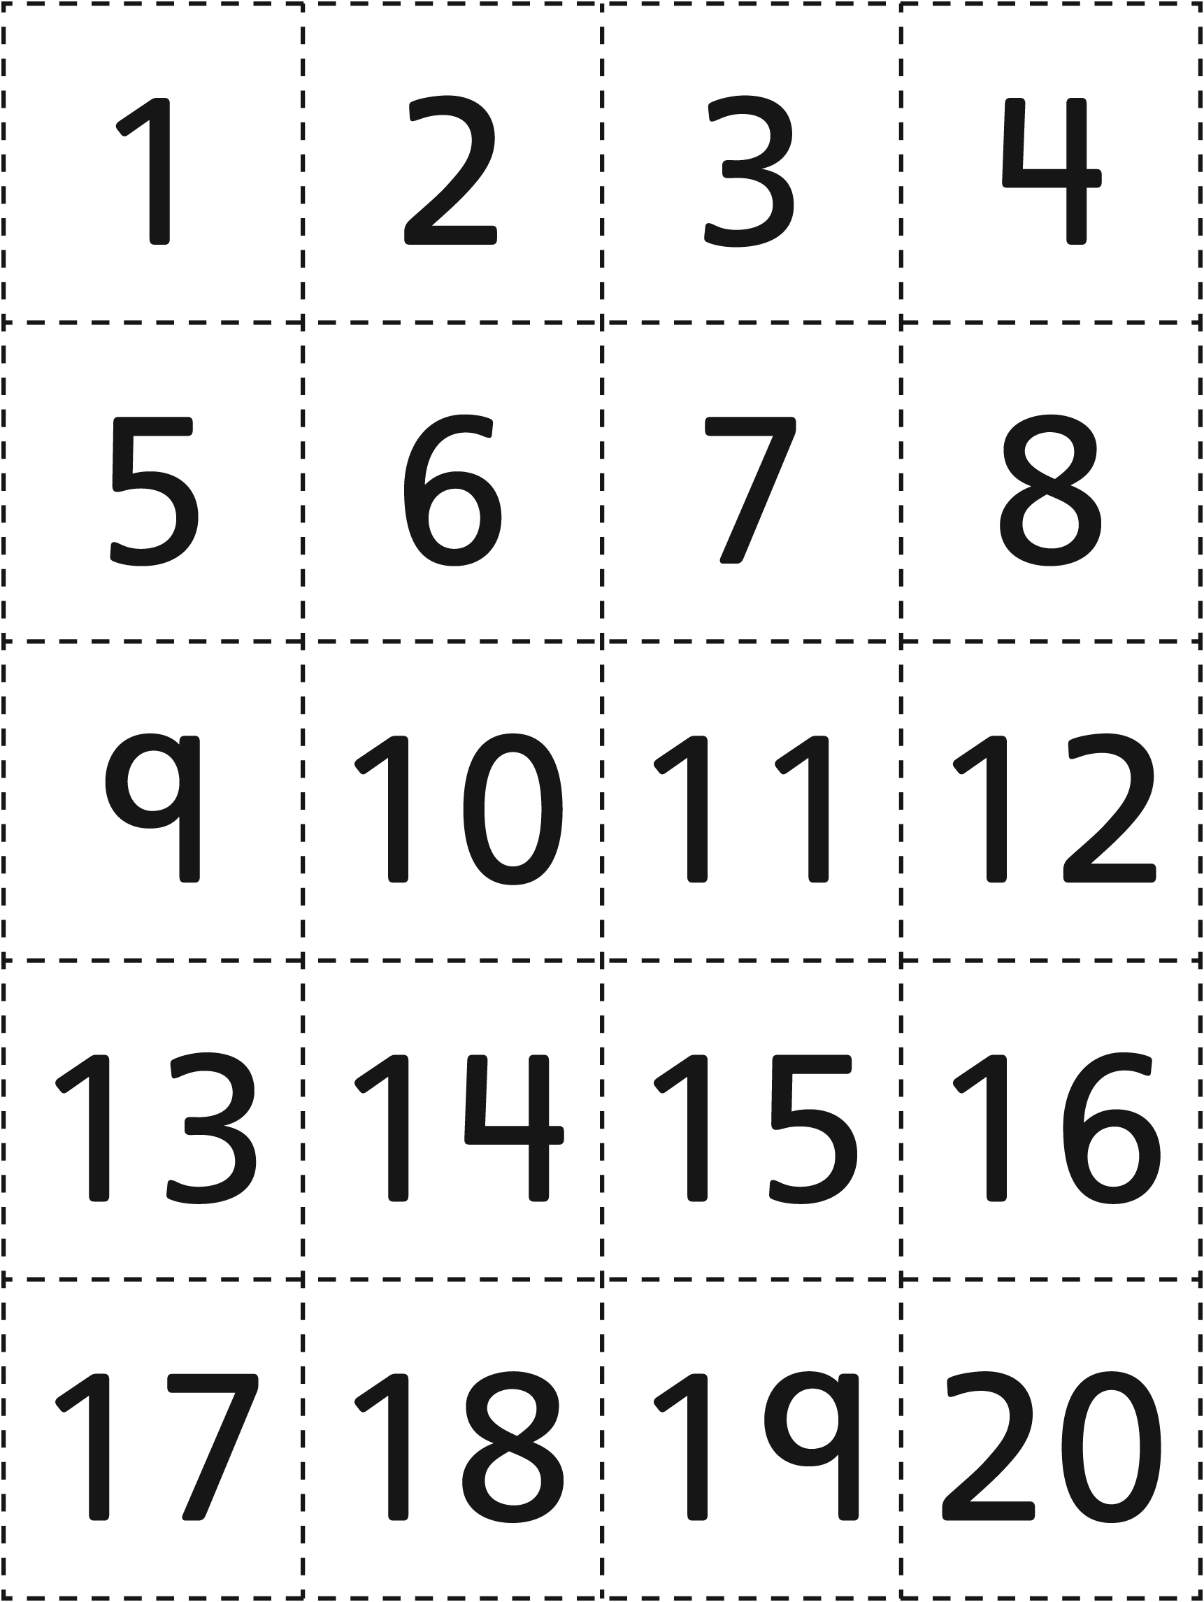

Ordering Rows Recording Sheet Line Master 6

Name: _________________________________________

Your names:
___________________ ___________________ ___________________
What numbers did you choose?
___________________ ___________________ ___________________
Put the rows in order from least to greatest.
___________________ ___________________ ___________________
What numbers did you choose?
___________________ ___________________ ___________________
Put the rows in order from least to greatest.
___________________ ___________________ ___________________
What numbers did you choose?
___________________ ___________________ ___________________
Put the rows in order from least to greatest.
___________________ ___________________ ___________________

Which Team Wins? Line Master 7

How to Play:
• Each player selects a gameboard with a team name (Bears/Eagles).
• Player 1 rolls a number cube and tallies the number in Period 1.
• Player 2 rolls the same number cube and tallies the number in Period 1.
• Players repeat for the other 2 periods of the game.
• Players total the number for the 3 periods to determine the winning team.

Bears
Period 1 | Period 2 | Period 3
Total Number of Goals:

Eagles
Period 1 | Period 2 | Period 3
Total Number of Goals:

Compare Your Numeral Cards Line Master 8
Name: _________________________________________

My number is ________________  ________________ =  is less than ________________  is greater than _____________ | My number is ________________  ________________ =  is less than ________________  is greater than _____________
My number is ________________  ________________ =  is less than ________________  is greater than _____________ | My number is ________________  ________________ =  is less than ________________  is greater than _____________
Order your numbers:
___________ ___________ ___________ ___________
Least Greatest

Sporting Math Line Master 9
Name: _________________________________________

My Sport: _____________________________

Here is a question about my picture:

How Many? Line Master 10

– – – – – – – – – – – – – – – – – – – – – – – – – – – – – – – – – – – – – – – – – –

10 children are warming up for the lacrosse game.
Some are practising shots. More are running.
Draw the children.

How many children are running? ___________________
How many children are practising shooting? ___________________

– – – – – – – – – – – – – – – – – – – – – – – – – – – – – – – – – – – – – – – – – –

There are fans watching in the stands.
Fewer fans are standing than sitting. Draw the fans.
Then have some fans leave (put an X on them).

How many standing fans did you draw? ___________________
How many fans are sitting? ___________________
How many fans were in the stands? ___________________
How many fans are in the stands after
some fans left? ___________________

– – – – – – – – – – – – – – – – – – – – – – – – – – – – – – – – – – – – – – – – – –

The coach has some balls for lacrosse practice.
Some are blue. Some are red.
There are 2 more red balls than blue balls.
Draw and colour the lacrosse balls.

How many balls did you draw? ___________________
How many balls are red? ___________________
How many balls are blue? ___________________
If three balls get lost, how many balls
will be left? ___________________

