Cats and Kittens! Line Master 1 (Assessment Master)
Name: _____________________________

Add and Subtract to 20 | Not observed | Sometimes | Consistently
Models add-to and take-from to 20
Uses +, −, = to symbolize parts–whole and addition and subtraction
Adds and subtracts to 20
Compare quantities to 20
Compares quantities to 20 by matching or counting
Determines how many more/less
Knows what number is one or two more and one or two less than another number
Strengths:

Next Steps:

Connecting Home and School Line Master 2–1

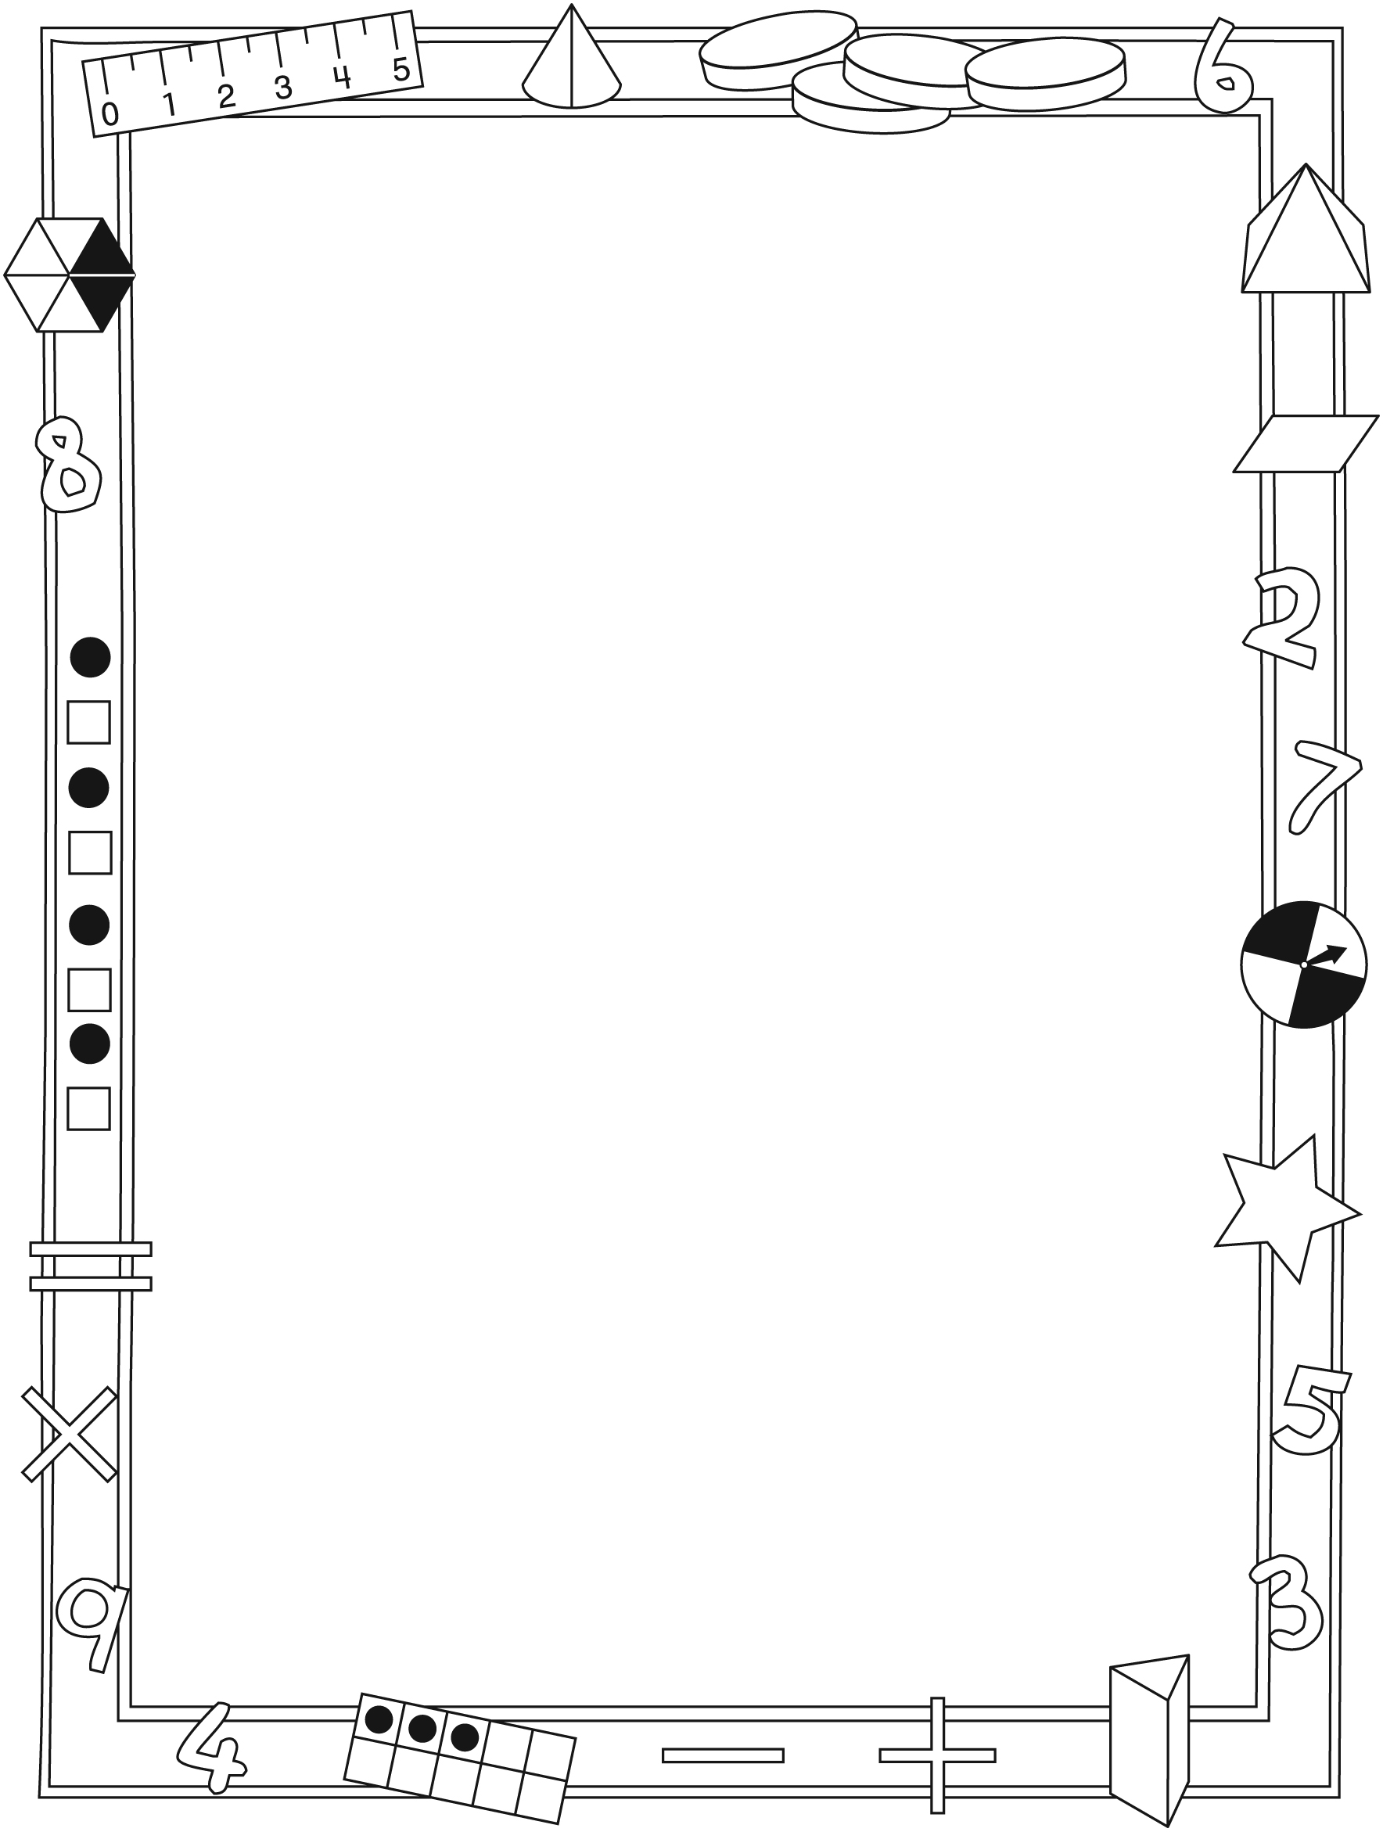

NOTE TO THE TEACHER

You may wish to send families a Cats and Kittens! letter outlining a familiar activity or two they can do at home with their children.

Create a letter using this template and select one or two activities from the suggestions on the next page. Simply delete these instructions and cut and paste the activities you have selected, adapting them to fit your needs.
Connecting Home and School Line Master 2–2

Dear Family:

We have been working on Cats and Kittens! which focuses on Adding and Subtracting to 20 and Comparing Quantities to 20. Try this activity at home with your child.

– – – – – – – – – – – – – – – – – – – – – – – – – – – – – – – – – – – – – – – – – –

Reading the Story: As you read the story, count and talk about the cats and kittens. As kittens are adopted, predict how many are left before you turn the page. Work together to identify the missing, adopted kitten(s). After reading, use 20 small objects and the Math Mat on the inside back cover to re-tell the story (or tell others) by placing an object in each space and then “adopting” (removing) cats and figuring out how many remain.

– – – – – – – – – – – – – – – – – – – – – – – – – – – – – – – – – – – – – – – – – –

Cat Nim: Use 20 small objects and the Math Mat on the inside back cover to play this game. Place an object in every space on the mat. Take turns “adopting cats” by removing 1, 2, or 3 objects. Whoever removes the last counter and so empties the Math Mat, scores 1 point. Then, play to fill the mat by adding 1, 2, or 3 counters. Whoever places the last counter, scores a point. Take turns going first. Have fun!

– – – – – – – – – – – – – – – – – – – – – – – – – – – – – – – – – – – – – – – – – –

How Many 1s? Use small objects to represent cats, and fold a piece of paper to make a hiding spot. Start with about 15 “cats.” Ask your child to turn away while you place (5) “cats” in the hiding spot. Your child then looks at the (10) visible “cats” and predicts how many are hiding. Lift the paper and count to check. Encourage the use of numbers to describe the story. For example, say: “10 and 5—that’s 15 cats.” or “5 cats are hiding and 10 cats are not. That’s 15 cats altogether.” Repeat with other combinations of that number (15) or start with another number. Invite your child to take the lead.

– – – – – – – – – – – – – – – – – – – – – – – – – – – – – – – – – – – – – – – – – –

Sincerely,

___________________________

Cats and Kittens! Math Mat Line Master 3
Name: _____________________________

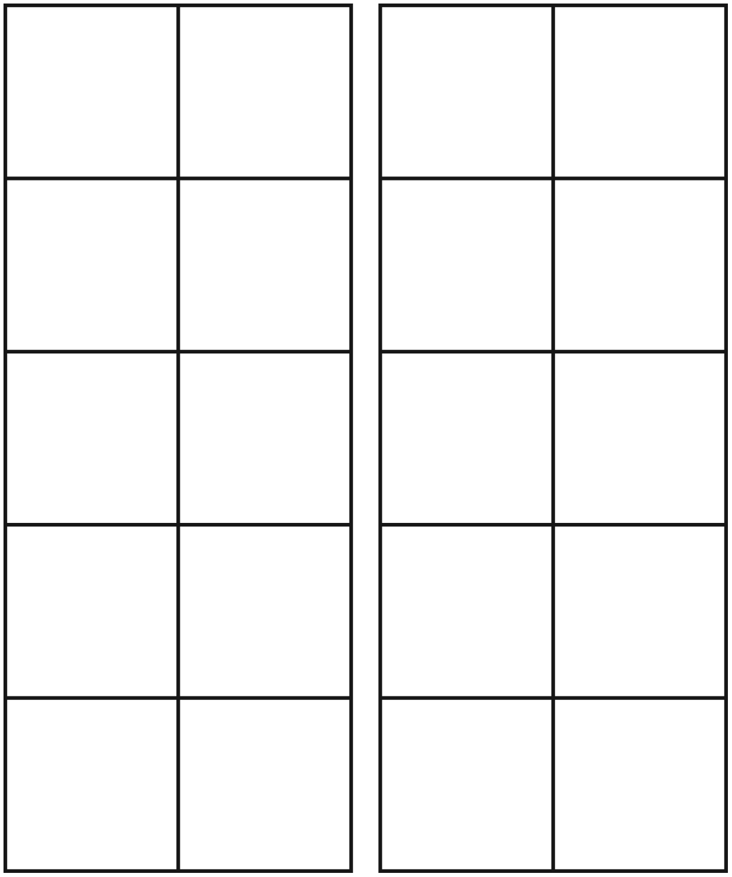

Double Ten-Frame Line Master 4
Recording Sheet
Name: _____________________________

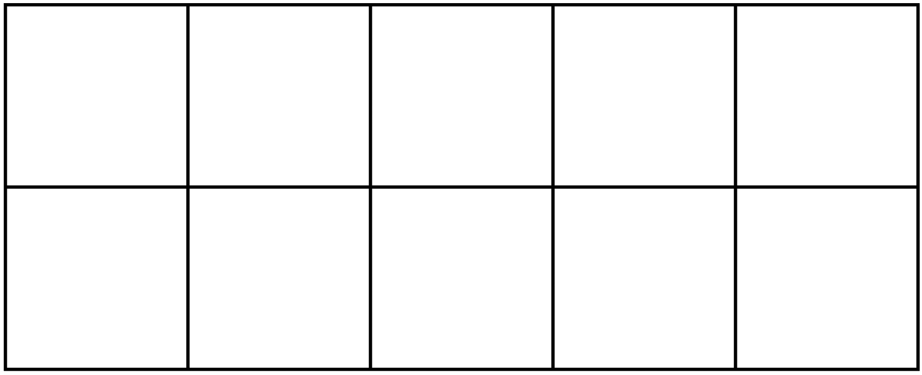

Rolling Number Sentences Line Master 5
Name: _____________________________

Round | My Numbers | My Number Sentences | My Score
1
2
3
4
5

Numeral Cards (1–20) Line Master 6–1
1 | 2 | 3
4 | 5 | 6
7 | 8 | 9
10

Numeral Cards (1–20) Line Master 6–2
11 | 12 | 13
14 | 15 | 16
17 | 18 | 19
20

Hundred Chart Line Master 7

1 | 2 | 3 | 4 | 5 | 6 | 7 | 8 | 9 | 10
11 | 12 | 13 | 14 | 15 | 16 | 17 | 18 | 19 | 20
21 | 22 | 23 | 24 | 25 | 26 | 27 | 28 | 29 | 30
31 | 32 | 33 | 34 | 35 | 36 | 37 | 38 | 39 | 40
41 | 42 | 43 | 44 | 45 | 46 | 47 | 48 | 49 | 50
51 | 52 | 53 | 54 | 55 | 56 | 57 | 58 | 59 | 60
61 | 62 | 63 | 64 | 65 | 66 | 67 | 68 | 69 | 70
71 | 72 | 73 | 74 | 75 | 76 | 77 | 78 | 79 | 80
81 | 82 | 83 | 84 | 85 | 86 | 87 | 88 | 89 | 90
91 | 92 | 93 | 94 | 95 | 96 | 97 | 98 | 99 | 100

To 20 and Back Line Master 8

You Need
20 counters

How to Play
- Decide who will go first. If you go first, add 1, 2, or 3 counters to the mat.
- On your turn, add 1, 2, or 3 more counters to the mat.
- The player who adds the last counter scores 1 point.
- On your turn, remove 1, 2, or 3 counters.
- The player who removes the last counter scores 1 point.
- Start again, but with the other person going first.

Target Numbers Line Master 9
Name: _____________________________

My target number is ________.

My number sentences are:

Sentence Frames Line Master 10–1
– – – – – – – – – – – – – – – – – – – – – – – – – – – – – – – – – – – – – – – – – –

_____ is less than _________.

– – – – – – – – – – – – – – – – – – – – – – – – – – – – – – – – – – – – – – – – – –

_________ is more than _________.

– – – – – – – – – – – – – – – – – – – – – – – – – – – – – – – – – – – – – – – – – –

1 more than_________ is _________.

– – – – – – – – – – – – – – – – – – – – – – – – – – – – – – – – – – – – – – – – – –

1 less than_________ is _________.

– – – – – – – – – – – – – – – – – – – – – – – – – – – – – – – – – – – – – – – – – –

Sentence Frames Line Master 10–2
– – – – – – – – – – – – – – – – – – – – – – – – – – – – – – – – – – – – – – – – – –

2 more than _________ is _________.

– – – – – – – – – – – – – – – – – – – – – – – – – – – – – – – – – – – – – – – – – –

2 less than _________ is _________.

– – – – – – – – – – – – – – – – – – – – – – – – – – – – – – – – – – – – – – – – – –

_________ is the same as _________.

– – – – – – – – – – – – – – – – – – – – – – – – – – – – – – – – – – – – – – – – – –

My Solution IS! Line Master 11–1
Name: _____________________________

Cats and kittens are playing.
There are 4 cats and 8 kittens.
How many cats and kittens are there?
Show your thinking in pictures, numbers, and words.

Cats and kittens are playing.
There are more cats than kittens.
How many cats and kittens are there?
Show your thinking in pictures, numbers, and words.

My Solution IS! Line Master 11–2
Name: _____________________________

Cats and kittens are playing.
There are fewer cats than kittens.
How many cats and kittens are there?
Show your thinking in pictures, numbers, and words.

15 kittens are playing.
There 8 toys. Each kitten needs a toy.
How many more toys are needed?
Show your thinking in pictures, numbers, and words.

