Hockey Time! Line Master 1 (Assessment Master)
Name: _____________________________

Add and Subtract to 20 | Not observed | Sometimes | Consistently
Models add-to and take-from situations to 20
Uses +, −, = to symbolize parts-whole and addition and subtraction
Adds and subtracts to 20
Compose and Decompose to 20
Decomposes quantities to 20 into parts
Composes 2-digit numbers from its parts and decomposes 2-digit numbers into parts
Strengths:

Next Steps:

Connecting Home and School Line Master 2–1

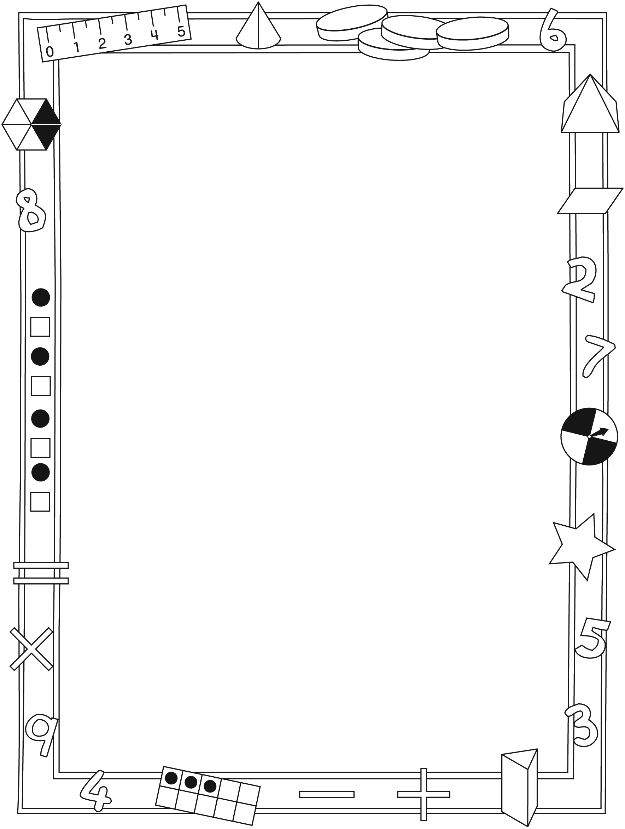

NOTE TO THE TEACHER

You may wish to send families a Hockey Time! letter outlining a familiar activity or two they can do at home with their children.

Create a letter using this template and select one or two activities from the suggestions on the next page. Simply delete these instructions and cut and paste the activities you have selected, adapting them to fit your needs.

Connecting Home and School Line Master 2–2

Dear Family:

We have been working on Hockey Time!, which focuses on Adding and Subtracting to 20 and Composing and Decomposing to 20. Try this activity at home with your child.

– – – – – – – – – – – – – – – – – – – – – – – – – – – – – – – – – – – – – – – – – –
Reading the Story: As you read the story, enjoy counting the players, predicting how many are added, and finding the different ways in which a number is depicted (for example, 12 might be seen as 6 and 6; 4 and 4 and 4; 5 and 7...). After you read, you might gather 20 small objects and use the mat on the inside back cover to re-create some of the different situations from the book. Or, use counters to tell your own add-to or take-from stories. For example: There are 10 players on the rink. 5 more are coming. How many do you think there will be? How can we find out?
– – – – – – – – – – – – – – – – – – – – – – – – – – – – – – – – – – – – – – – – – –
Players on the Rink: Use the inside back cover and 10–20 items to create and describe 2 sets made from 1 larger set. For example, decide together how many players (10–20) are on the rink. Count that many items (e.g., 12). Take turns arranging and describing the (12) items on either side of the centre line. Encourage the use of numbers to describe the story. For example, say “5 and 7—that’s 12 players!” Repeat with other combinations of the same number. After a few examples, you might extend the description to include a vantage point. For example, describe the position of the players from the vantage point of a spectator sitting behind each of the nets (e.g., 10 and 2, and 2 and 10).
– – – – – – – – – – – – – – – – – – – – – – – – – – – – – – – – – – – – – – – – – –
Telling Stories: Take turns rolling 2 number cubes. Use the 2 numbers to tell either an addition story or a subtraction story. For example, for a roll of 2 and 4, the story could be, ‘My team has 4 goals. Then we scored 2 more goals. That’s 6 goals!’
– – – – – – – – – – – – – – – – – – – – – – – – – – – – – – – – – – – – – – – – – –

Sincerely,

___________________________

Hockey Time! Math Mat Line Master 3

Hockey Rink
Recording Sheet Line Master 4
Name: _____________________________

Double Ten-Frame Line Master 5

Score 10 Goals Line Master 6–1

You need:
- coloured counters

How to play:
- In turn, cover 2 numbers that add up to 10.
- The winner is the last one to cover 2 numbers.

Score 10 Goals Line Master 6–2

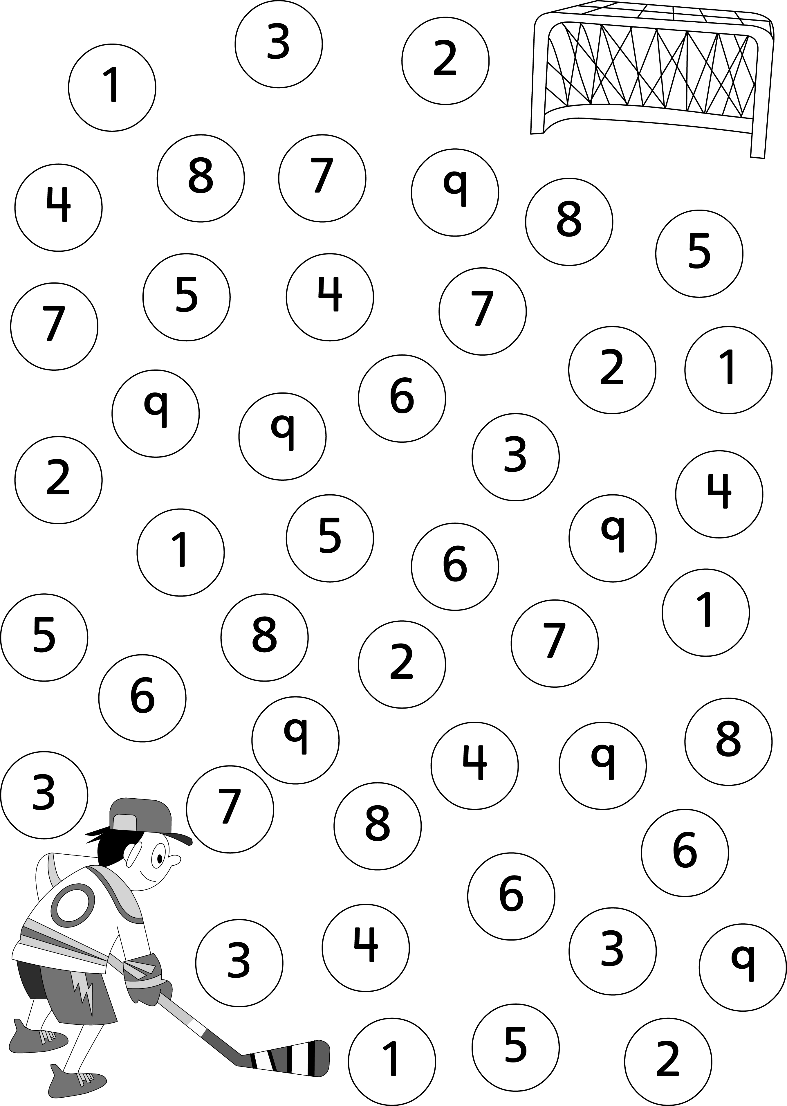

Score 20 Goals Line Master 7–1

You need:
- coloured counters

How to play:
- In turn, cover 2 numbers that add up to 20.
- The winner is the last one to cover 2 numbers.

Score 20 Goals Line Master 7–2

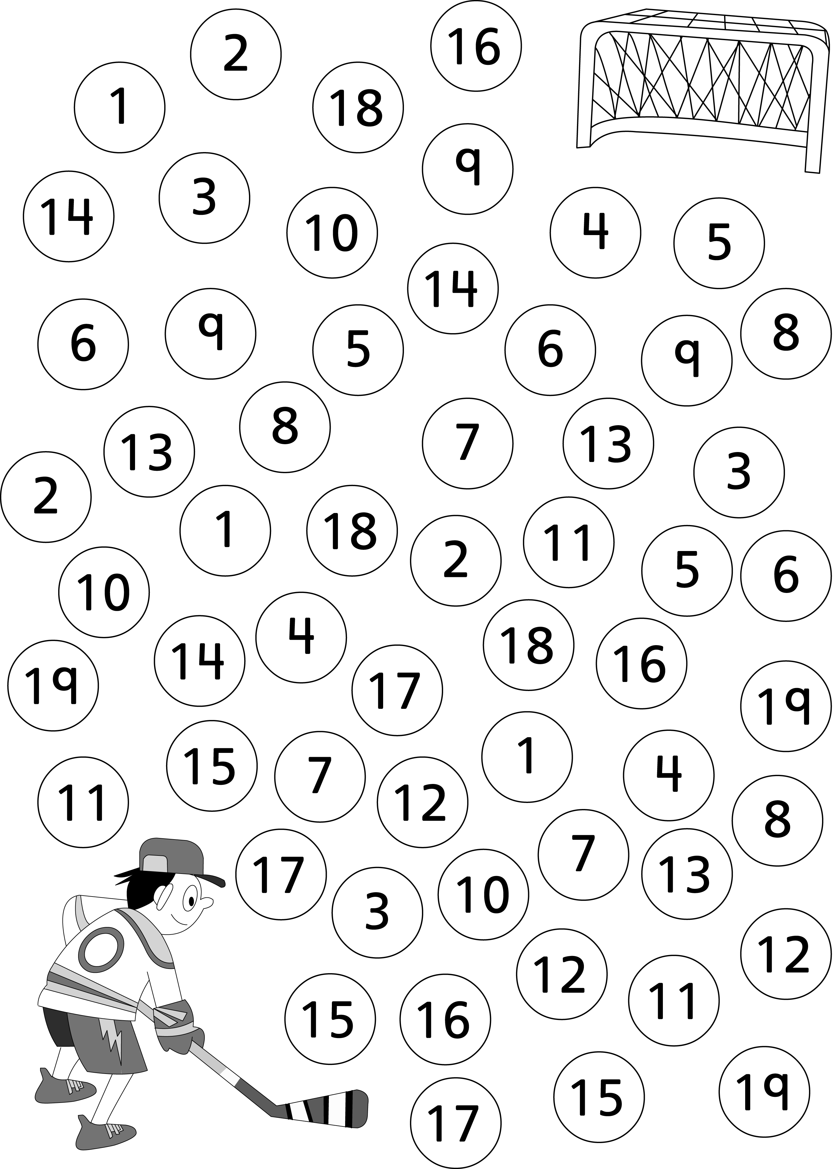

The Same As Line Master 8
Name: _____________________________
These are all _____________

______________________________________________

______________________________________________

______________________________________________

Booklet Template Line Master 9

Comic Template Line Master 10

Addition and Subtraction
Problems Line Master 11–1
Name: _____________________________

It’s time for hockey.
There are 5 children on each team.
How many children are playing?
Show your thinking with pictures, numbers, and words.

Make up your own hockey story about 10 hockey players.
Use pictures, numbers, and words to solve it.

Addition and Subtraction
Problems Line Master 11–2
Name: _____________________________

There are 12 children playing hockey.
Some are wearing scarves and some are not.
What might the team look like?
Show your thinking with pictures, numbers, and words.

Show a different way.

Addition and Subtraction
Problems Line Master 11–3
Name: _____________________________

5 children with red jackets and 5 children with blue jackets are playing hockey.
How many hockey sticks are there?
Show your thinking with pictures, numbers, and words.

The grown-ups are getting water for each of the 12 players.
They have 10 cups. How many more do they need?
Show your thinking with pictures, numbers, and words.

